Moduldokumentation

Modul Verteilte Systeme (vesys)

Simon Wächter

2017

Inhalt

1 Einleitung 6

1.1 Einleitung 6

1.2 Lernziele 6

1.3 Prüfungen 6

2 Woche 1 7

2.1 Definition of Distributed Systems 7

2.1.1 Definitions 7

2.1.2 Classification 7

2.1.3 Pros and Cons 8

2.1.4 Interaction Models 8

2.1.5 Client/Server Model 9

2.1.6 Communication Models 9

2.1.7 Communication Styles 10

2.2 Challenges of Distributed Systems 11

2.2.1 Heterogeneity 11

2.2.2 Latency 11

2.2.3 Security 11

2.2.4 Scalability 12

2.2.5 Failures 12

2.2.6 Concurrency 13

2.2.7 Consistency 13

2.3 Networking 13

2.3.1 Protocol & Network Levels 13

2.3.2 IP Socket Connections 14

2.3.3 IP Addressing 14

2.3.4 TCP/UDP Common Port Numbers 15

2.3.5 InetAddress 15

2.3.6 Network Interfaces 16

2.4 Sockets 16

2.4.1 Sockets 16

2.4.2 TCP Sockets 17

2.4.3 Java Socket 17

2.4.4 Sample Client (Echo) 19

2.4.5 Sample Client (Mailer) 19

2.4.6 ServerSocket 20

2.4.7 Echo Server 21

2.4.8 Concurrent Echo Server 21

2.4.9 Concurrent Echo Server (Threaded) 21

2.4.10 Concurrent Echo Server (Limitierter Threadpool) 22

2.4.11 Concurrent Echo Server (Dynamischer Threadpool) 23

3 Woche 2 25

3.1 Input and Output Streams 25

3.1.1 OutputStream 25

3.1.2 InputStream 25

3.2 Filter Streams 26

3.2.1 FilterOutputStream 26

3.2.2 DataOutputStream 27

3.2.3 DataOutputStream with writeInt 27

3.2.4 DataOutputStream with writeUTF 27

3.2.5 PrintStream 28

3.2.6 FilterInputStream 28

3.2.7 DataInputStream 28

3.2.8 DataInputStream with readFully 29

3.2.9 Filter Streams 29

3.3 Object Streams & Serialization 29

3.3.1 ObjectStream 29

3.3.2 Serialization with ObjectStream 30

3.3.3 Serial Version Number 31

3.3.4 Serialization Customization 32

3.3.5 Serialization Hints 32

3.4 Sending and Receiving Data 33

3.4.1 Framing 33

3.4.2 Example of Framing 33

3.5 Summary 33

3.5.1 Whole Picture of Input Streams 33

3.5.2 Whole Picture of Output Streams 34

3.5.3 Reading and Writing Text (Unicode Strings) 35

3.5.4 Whole Picture of Reader 35

3.5.5 Whole Picture of Writer 35

3.6 Controlling Socket Behaviors 36

3.6.1 Blocking and Timeouts 36

3.6.2 Send and Receive Buffer Size 37

3.6.3 Package Delay 37

3.7 Closing Connections 37

3.7.1 Closing Connections 37

3.7.2 Example of a Close Test 38

3.7.3 Example of a Compression Server 39

3.8 UDP Sockets 39

3.8.1 UDP (User Datagram Protocol) 39

3.8.2 Java Classes for Datagram 40

3.8.3 DatagramSocket 40

3.8.4 DatagramPacket 41

3.8.5 Example of a UDP Server and Client 42

3.8.6 UDP Implementation 42

3.8.7 Reliable UDP 43

4 Woche 3 44

4.1 HTTP Protocol 44

4.1.1 IETF RFC 44

4.1.2 HTTP Protocol 44

4.1.3 HTTP Request 44

4.1.4 HTTP Response 45

4.1.5 HTTP Protocol 45

4.1.6 HTTP Sample 45

4.1.7 HTTP 1.0 Request Methods 47

4.1.8 HTTP Response Codes 47

4.1.9 HTTP Request Headers 47

4.1.10 HTTP Response Headers 48

4.1.11 MIME Types 48

4.1.12 HTTP Request/Response Sample 49

4.1.13 HTTP 1.1 Enhancements 49

4.2 HTTP Web Server 50

4.2.1 A simple Web Server 50

4.2.2 Java internal Web Server 52

4.3 HTML Forms & URL Encoding 53

4.3.1 HTML GET Form 53

4.3.2 URL Encoding 54

4.3.3 HTML POST Form 54

4.4 HTTP Requests from Java 55

4.4.1 URL 55

4.4.2 Sending GET Requests from within Java 55

4.4.3 URLConnection 55

4.4.4 URLConnection Tips & Tricks 56

4.4.5 Sample 1: URLConnection GET 56

4.4.6 Sample 2: URLConnection POST 57

4.4.7 Sample 3: Currency Converter 57

4.4.8 Other Libraries 59

5 Woche 4 60

5.1 Servlets 60

5.1.1 Servlet Specification 60

5.1.2 Dynamic Content 60

5.1.3 Servlets 60

5.1.4 Servlet Packages 60

5.1.5 Servlet Life-Cycle Methods 61

5.1.6 HttpServlet 61

5.1.7 HttpServletRequest 62

5.1.8 HttpServletResponse 62

5.1.9 Servlet Example 62

5.1.10 Webapplication Structure 63

5.1.11 Annotation WebServlet 64

5.1.12 Webapplication Structure 64

5.2 Tomcat Servlet Server 65

5.2.1 Tomcat 65

5.2.2 Tomcat Directory Structure 65

5.2.3 Tomcat Scripts 65

5.2.4 Tomcat Startup Screen 66

5.2.5 Tomcat Managers 66

5.2.6 Debugging 66

5.2.7 Tomcat Architecture 67

5.2.8 Configuration of a Host 67

5.2.9 Configuration of a Context 68

5.2.10 Deployment while development 69

5.2.11 Eclipse and Servlets (JEE Eclipse Version) 69

6 Woche 5 71

6.1 Motivation XML-RPX 71

6.1.1 Services over HTTP (Currency Converter) 71

6.1.2 XML-Remote Procedure Calls 72

6.2 SOAP und JAX-WS 72

6.2.1 SOAP 72

6.2.2 JAX-WS 73

6.2.3 JAX-WS HTTP Request 79

6.2.4 JAX-WS HTTP Response 79

6.2.5 SOAP Message Structure 80

6.2.6 Tools for SOAP 80

6.3 WSDL 81

6.3.1 WSDL 81

6.3.2 WSDL Examples 81

6.3.3 WSDL Structure 81

6.3.4 WSDL Definitions 82

6.3.5 Message Exchange Patterns (MEP) 83

6.3.6 WSDL Definitions 84

6.3.7 Web Service Styles 84

6.3.8 RPC/Encoded 85

6.3.9 RPC/Literal 86

6.3.10 Document/Literal/Bare 87

6.3.11 Document/Literal/Wrapped 88

6.3.12 Web Service Styles 89

6.3.13 Further References 89

7 Woche 6 90

# Einleitung

## Einleitung

Dieses Dokument stellt die Moduldokumentation für das Modul vesys dar. Allfällige Unterlagen sind im Modulordner zu finden.

## Lernziele

Das Modul beinhaltet folgende Lernziele:

* Erstellen einer Verbindung zwischen zwei Rechnern mittels Sockets
* Wissen über http Protokoll und Webserver
* Implementieren einfacher Servlets
* Prinzipien und Programmierung von RMI
* Prinzipien von Webservices und Programmierung mittels JAXWS
* Verwendung von Webservices mittels WSDL
* Prinzipien und Programmierung von REST und deren Unterschiede zu SOA und ROA
* Prinzipien der asynchronen Programmierung mittels JMS und Akka
* Entscheidung, welche der Technologien für eine Situation geeignet ist

## Prüfungen

Die Modulnote setzt sich aus einer Semesterprüfung zu 50% und einer Modulschlussprüfung zu 50% zusammen. Zusätzlich müssen 4 von 8 Übungen erfüllt werden.

# Woche 1

## Definition of Distributed Systems

### Definitions

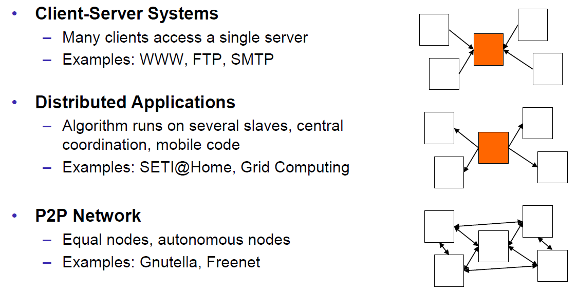

### Classification

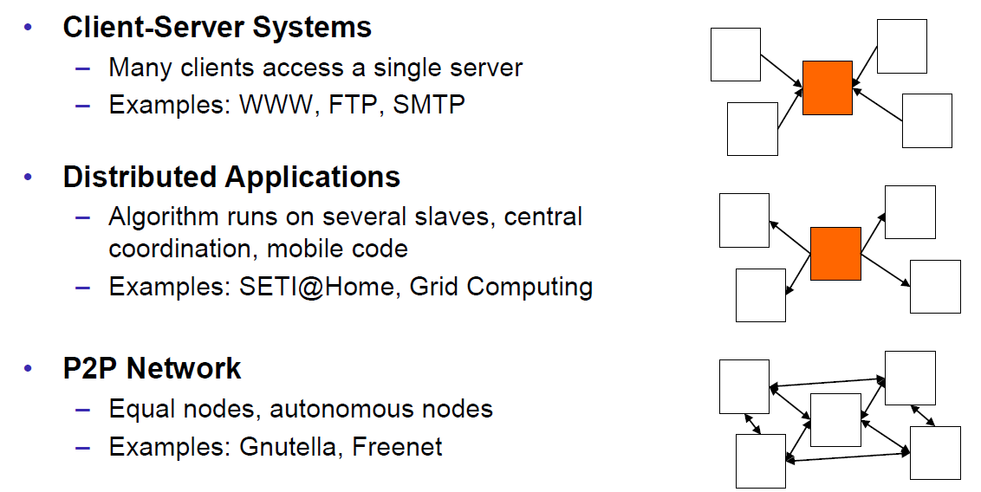

### Pros and Cons

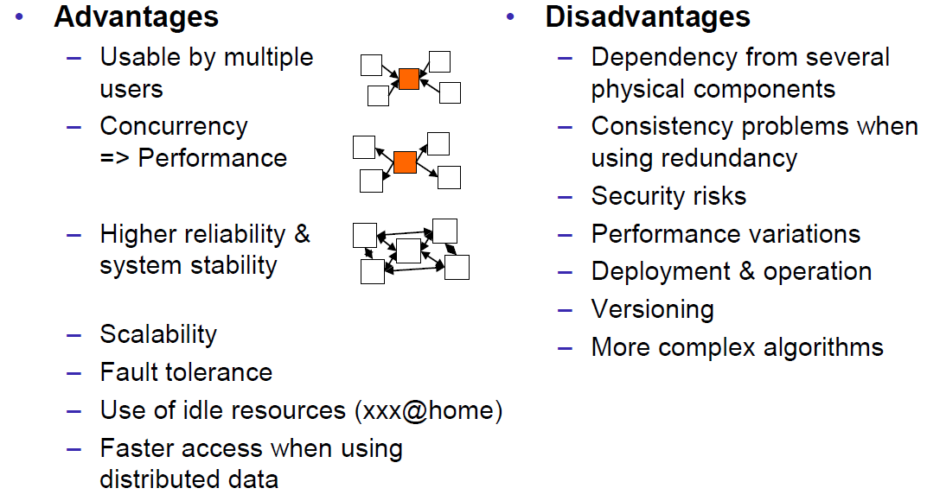

### Interaction Models

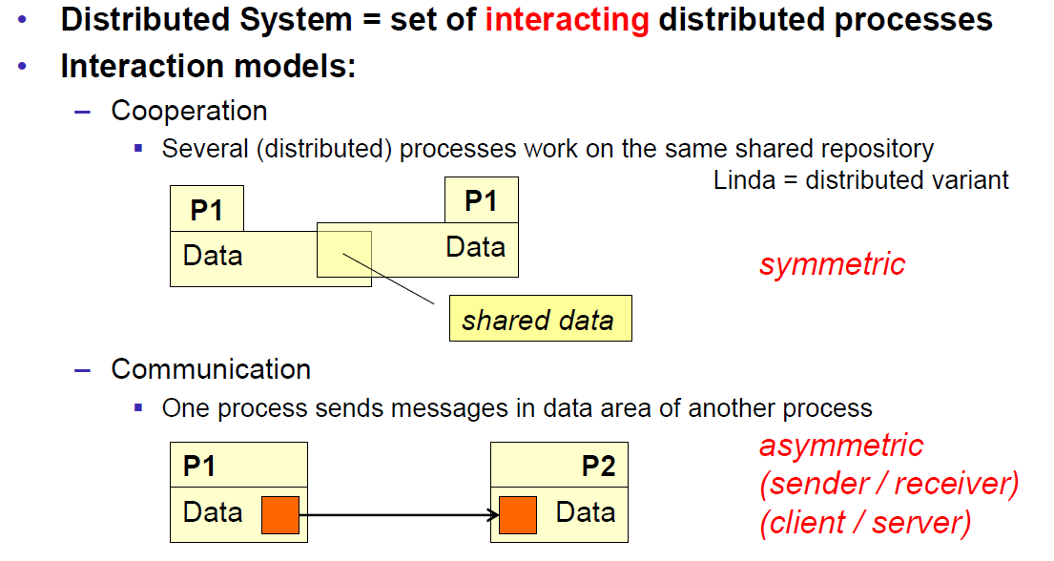

### Client/Server Model

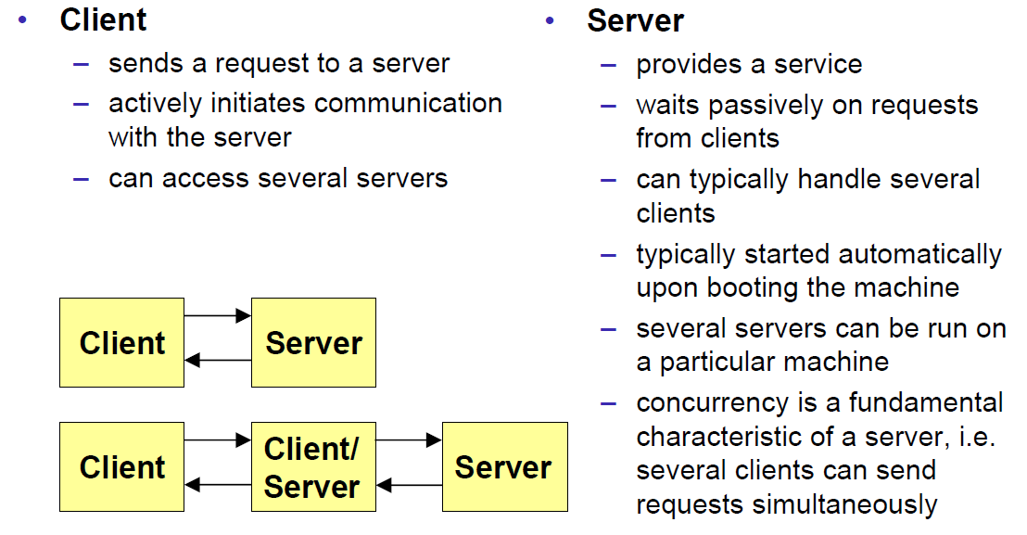

### Communication Models

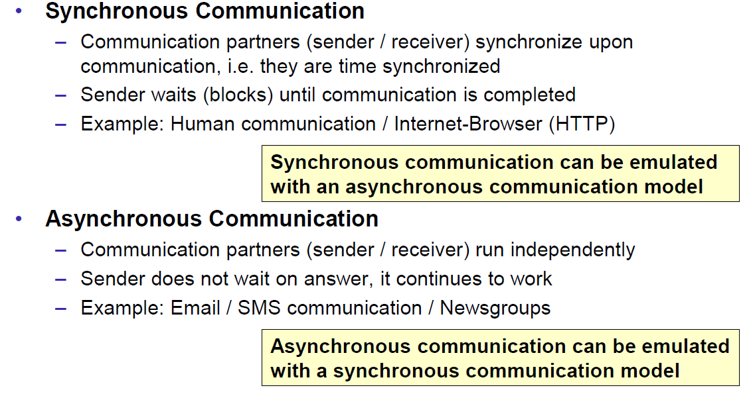

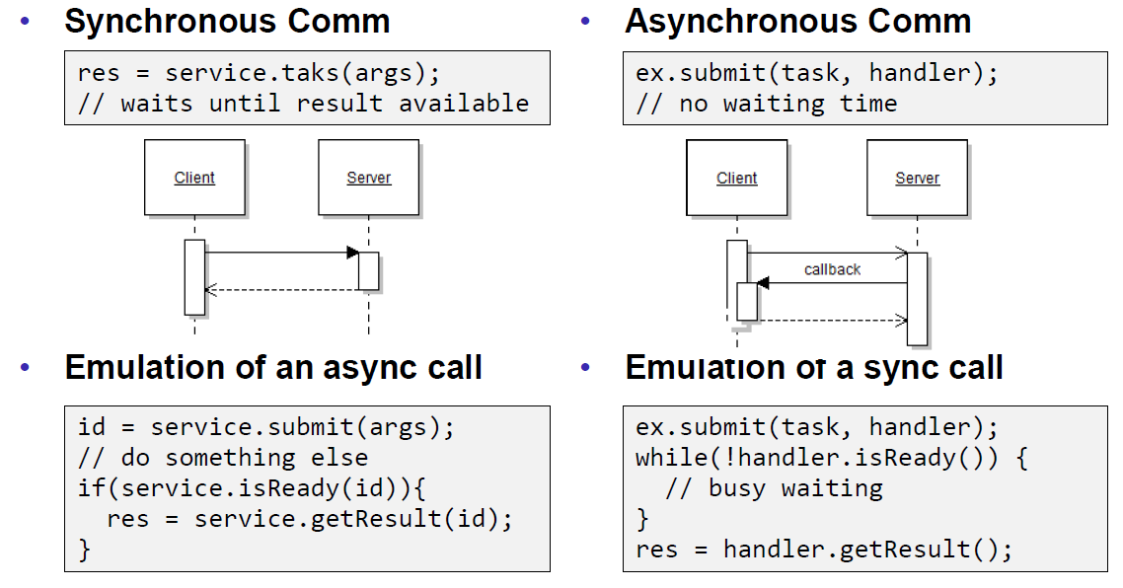

### Communication Styles

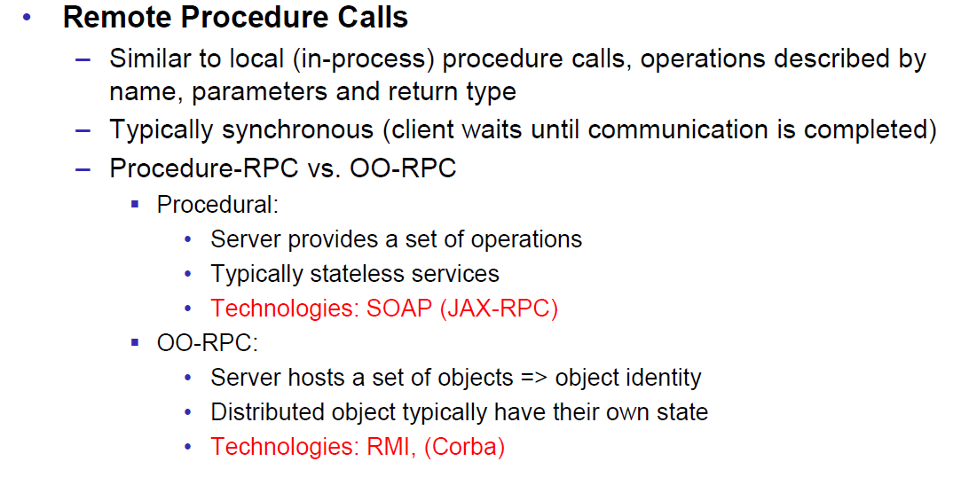

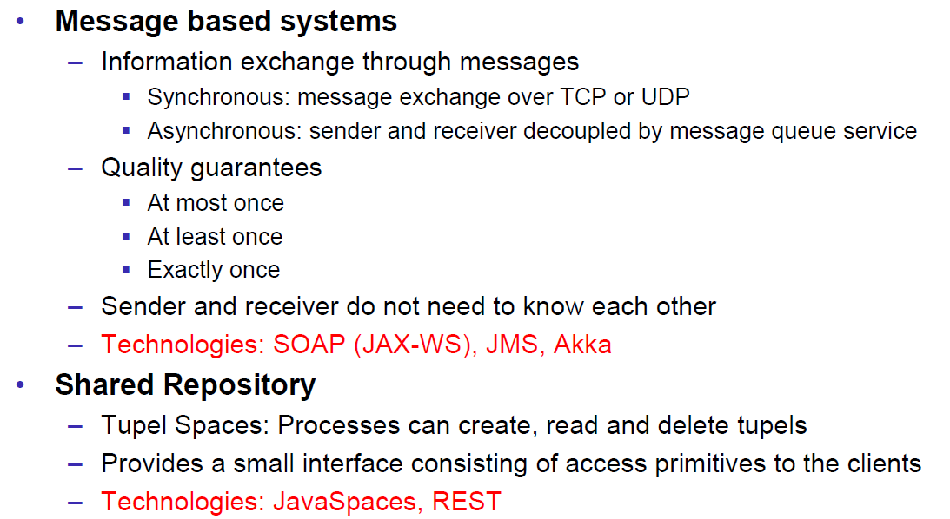

## Challenges of Distributed Systems

### Heterogeneity

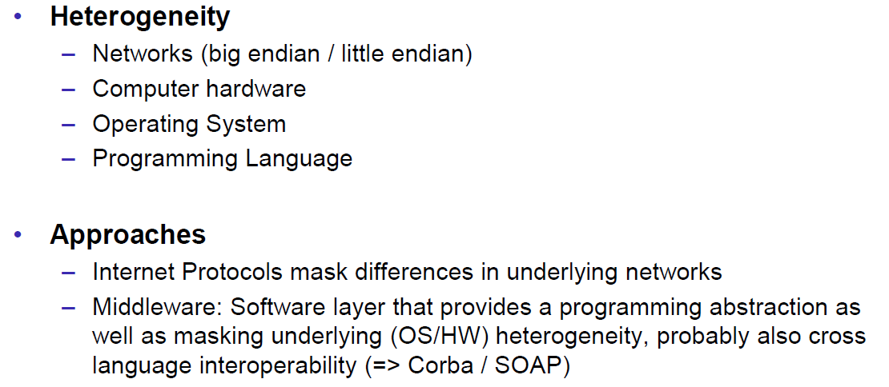

### Latency

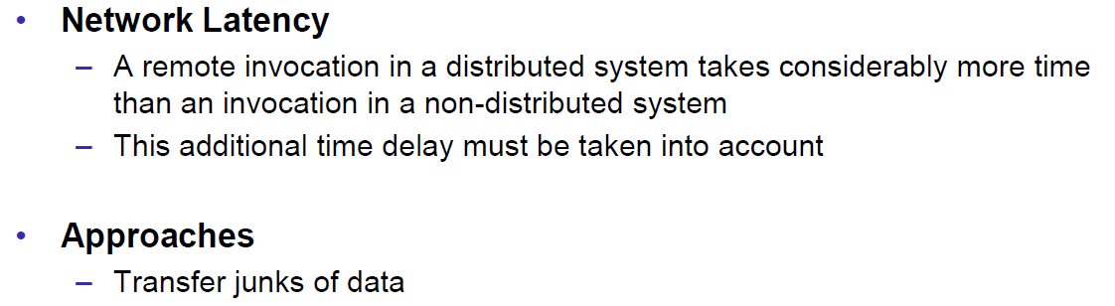

### Security

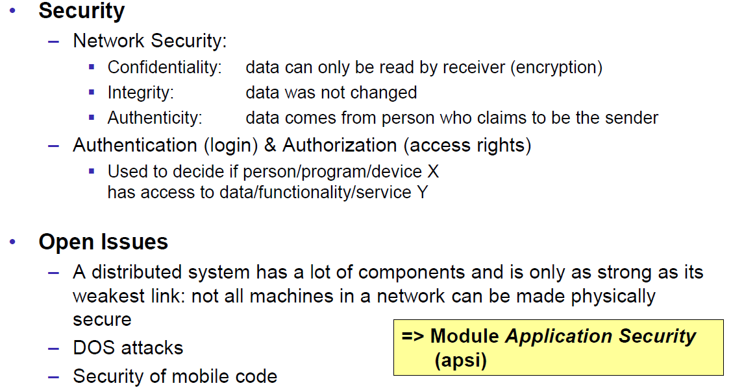

### Scalability

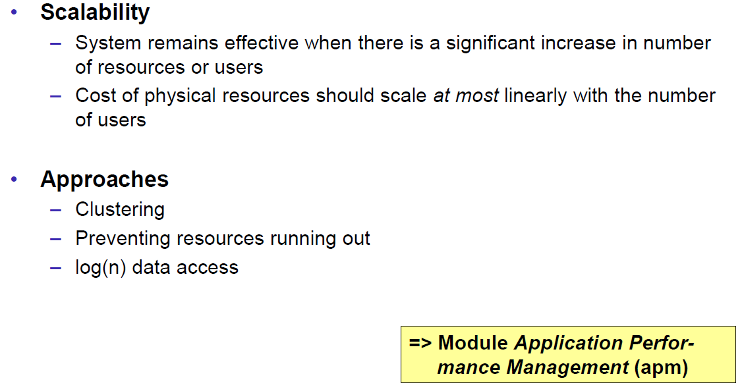

### Failures

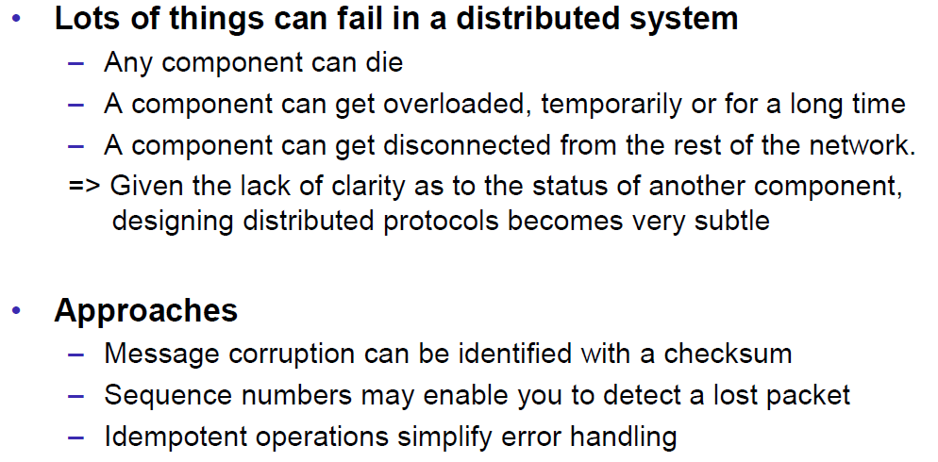

### Concurrency

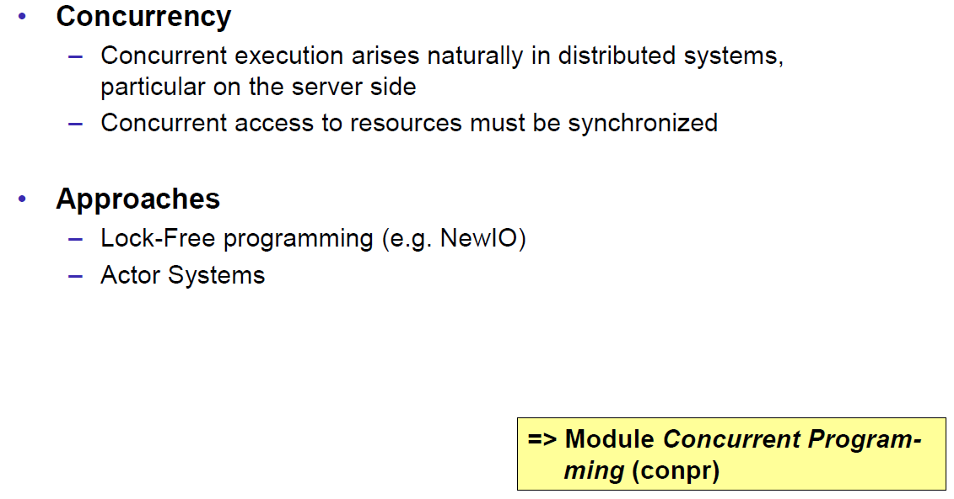

### Consistency

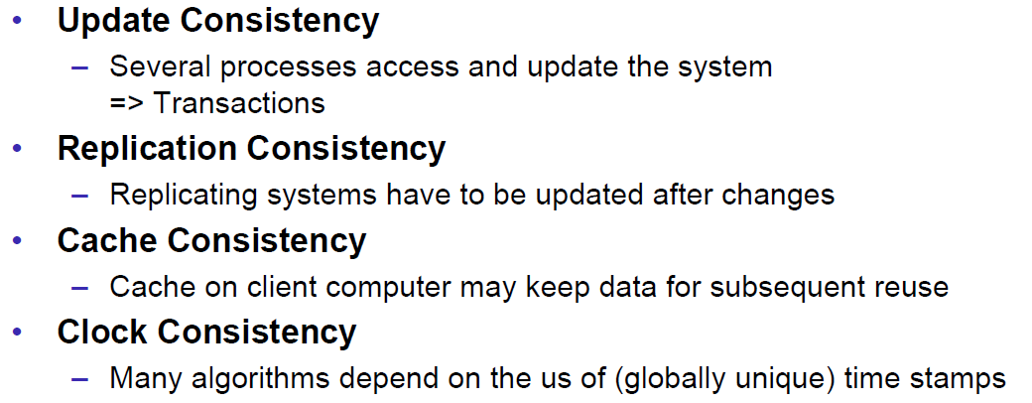

## Networking

### Protocol & Network Levels

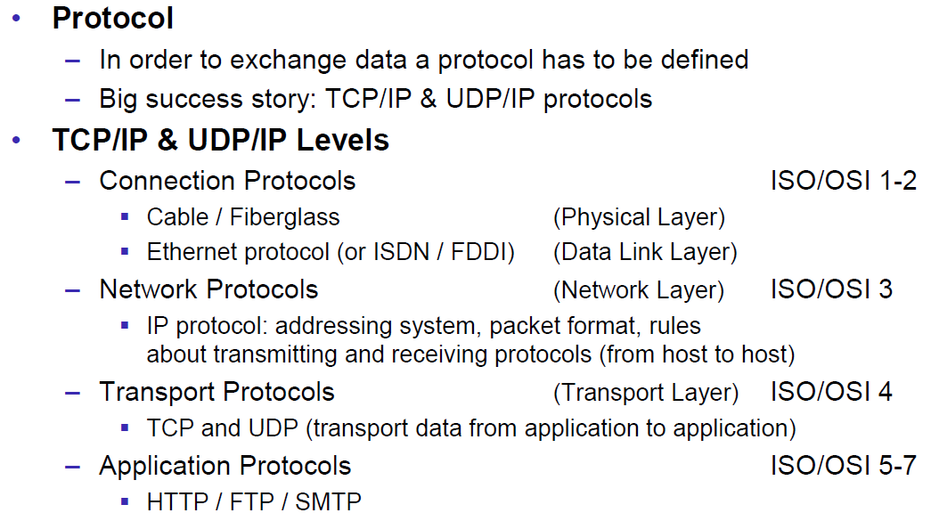

### IP Socket Connections

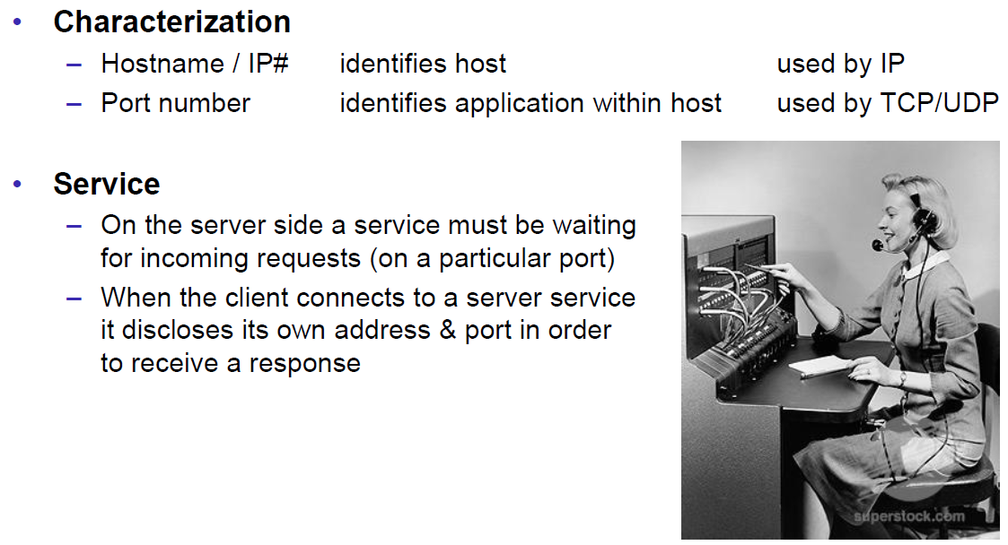

### IP Addressing

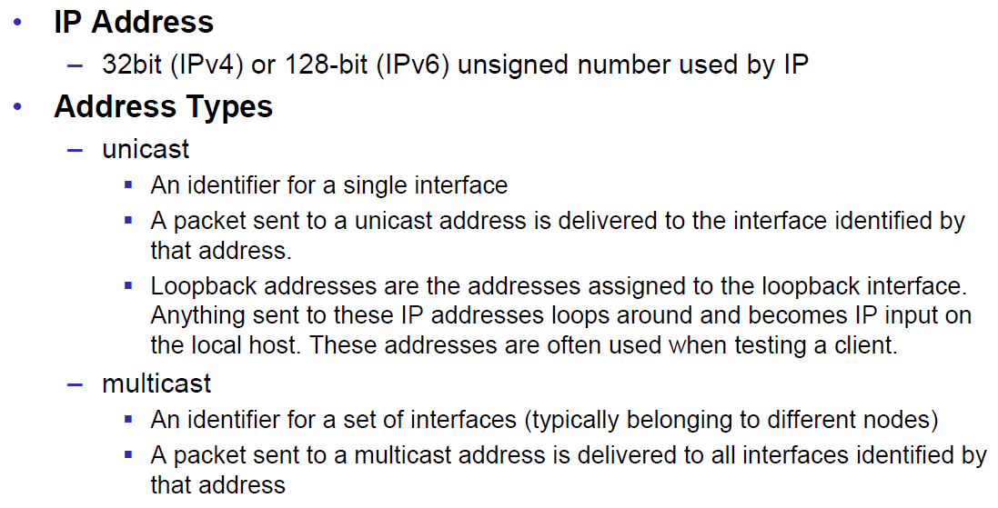

### TCP/UDP Common Port Numbers

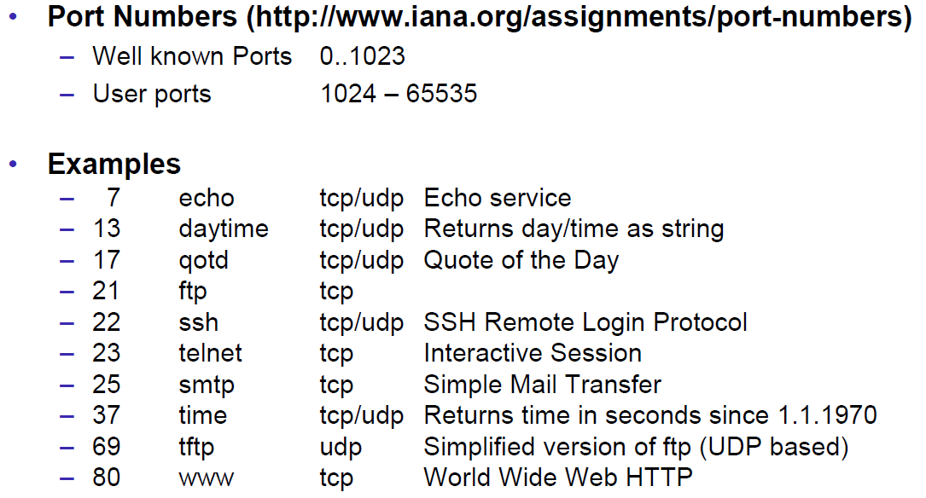

### InetAddress

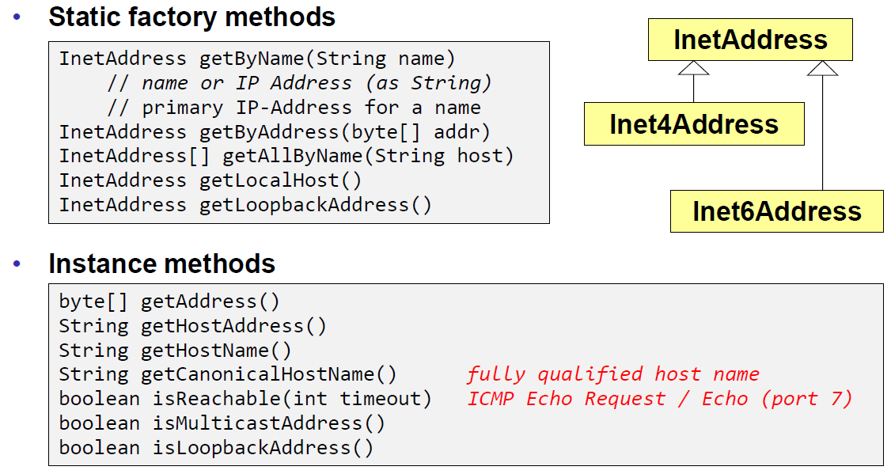

### Network Interfaces

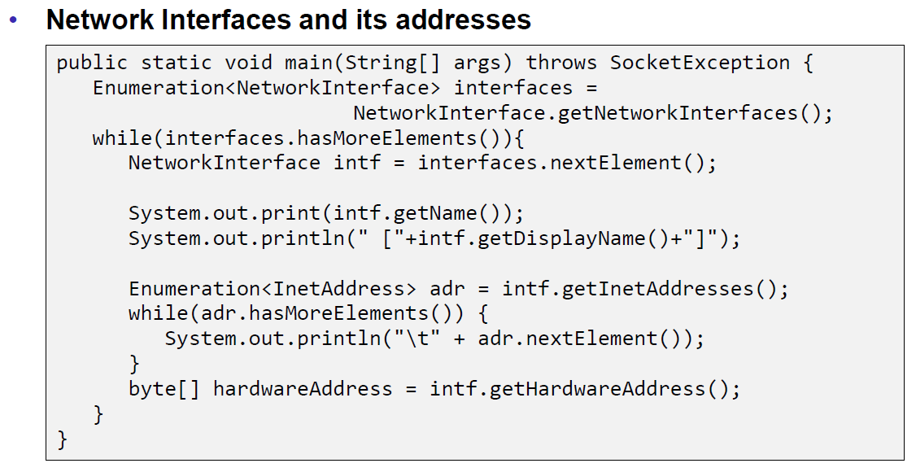

## Sockets

### Sockets

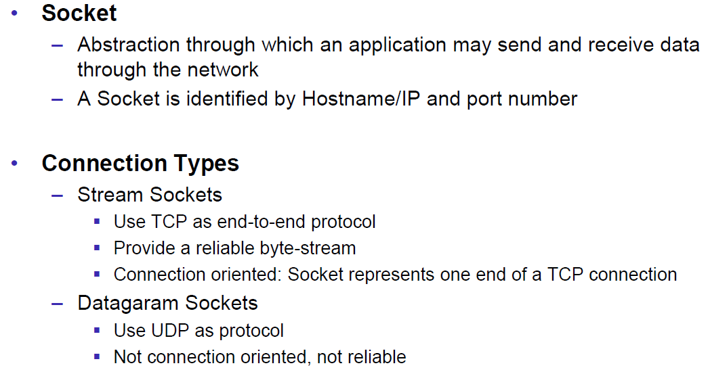

### TCP Sockets

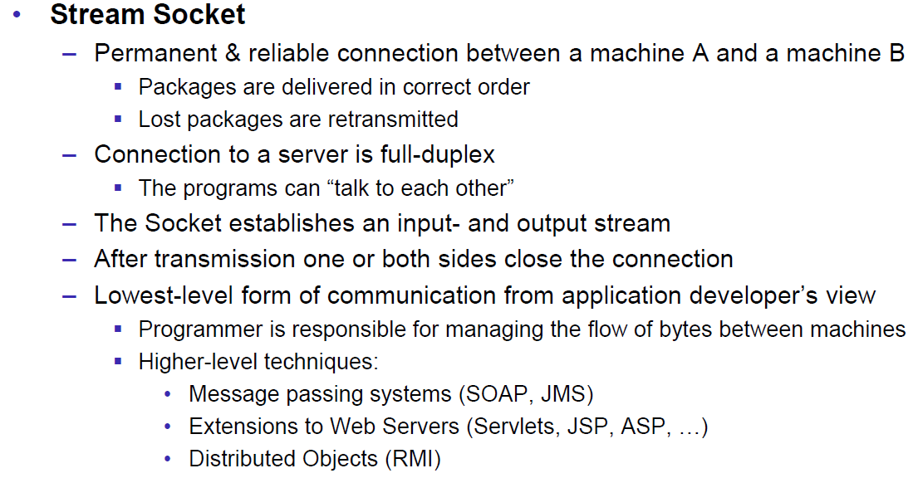

### Java Socket

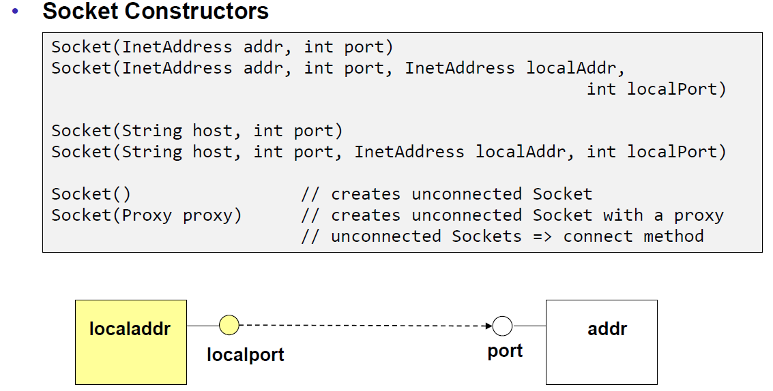

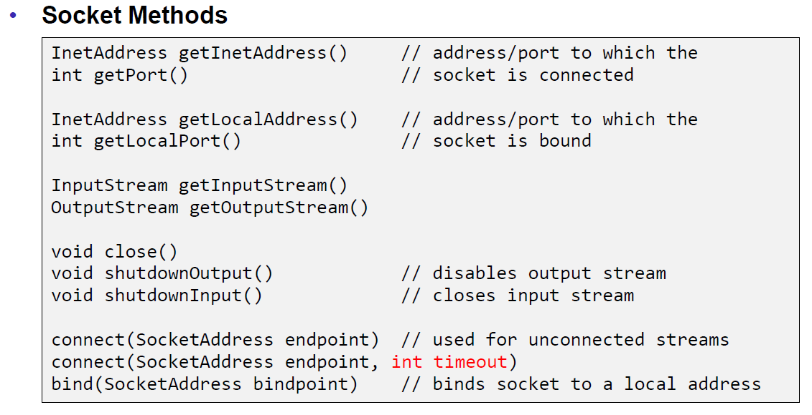

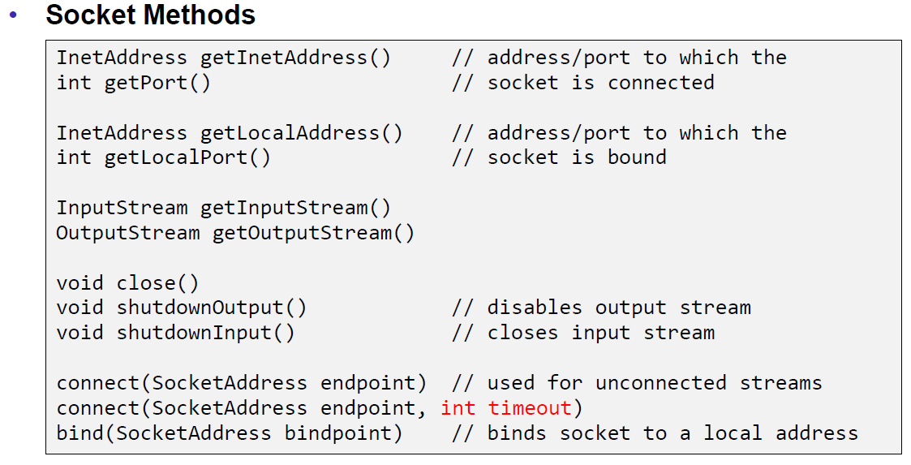

### Sample Client (Echo)

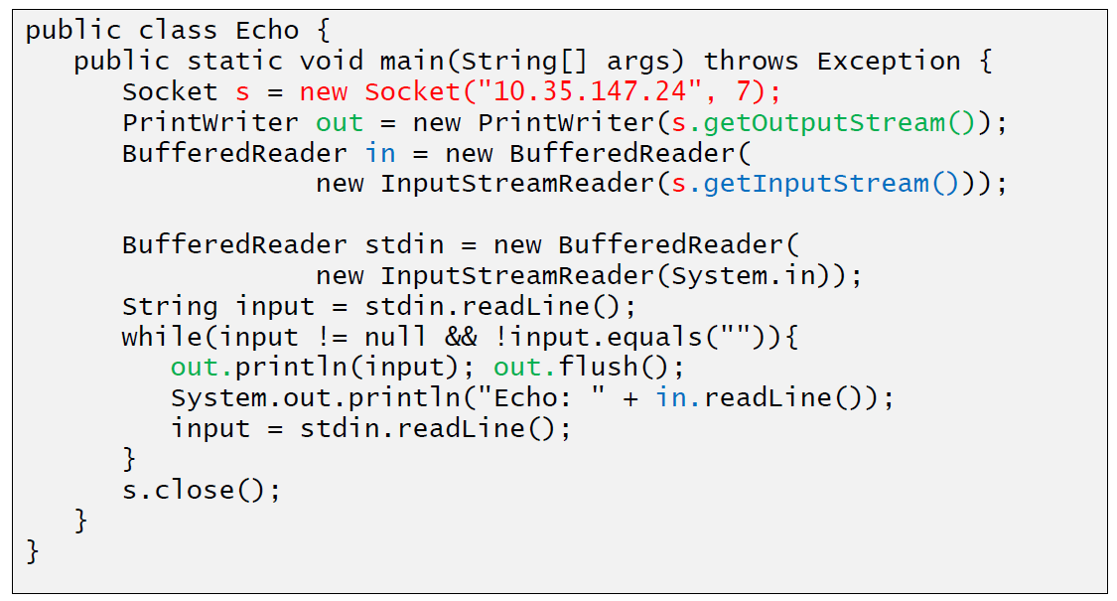

### Sample Client (Mailer)

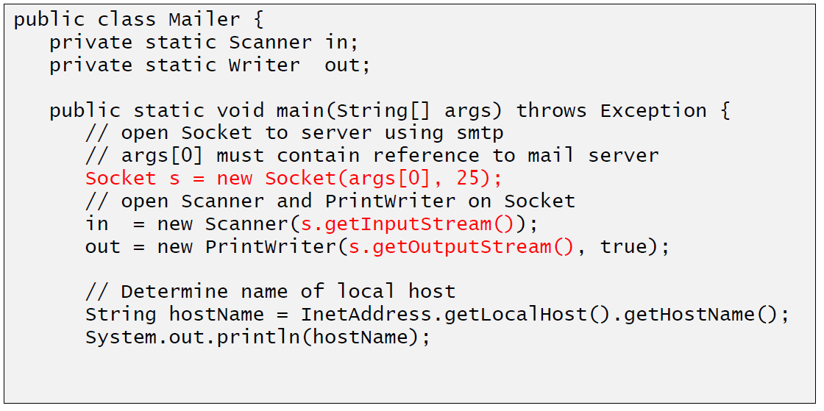

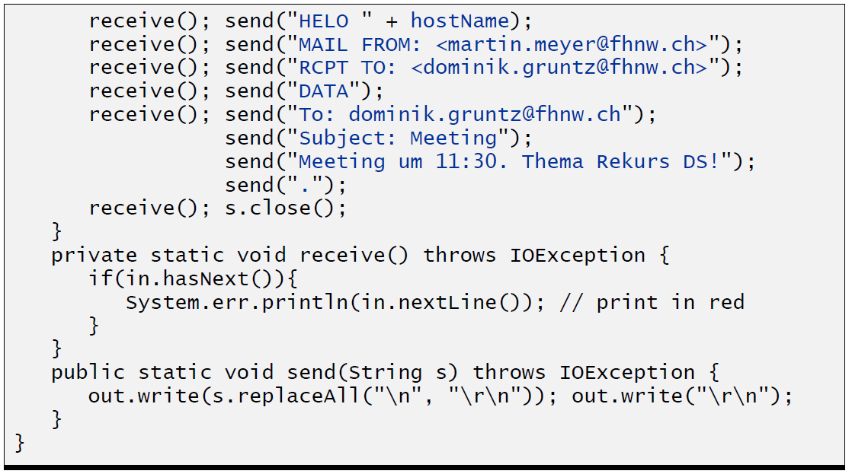

### ServerSocket

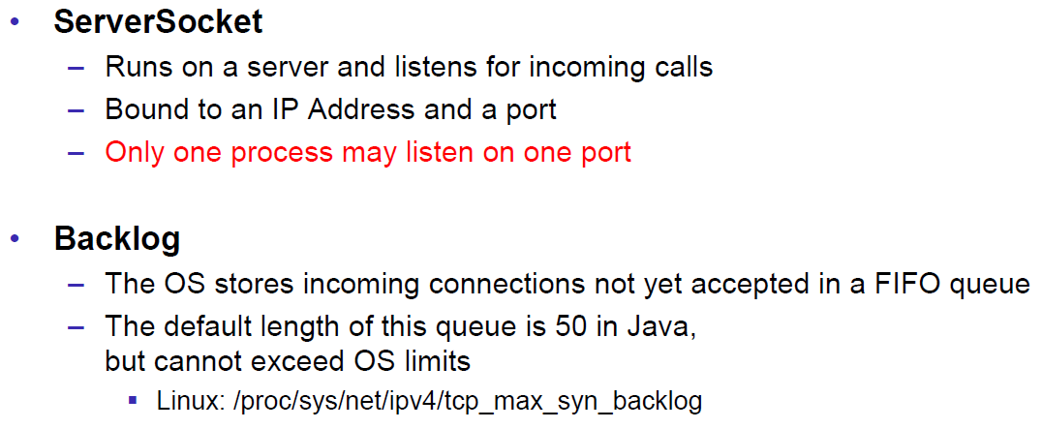

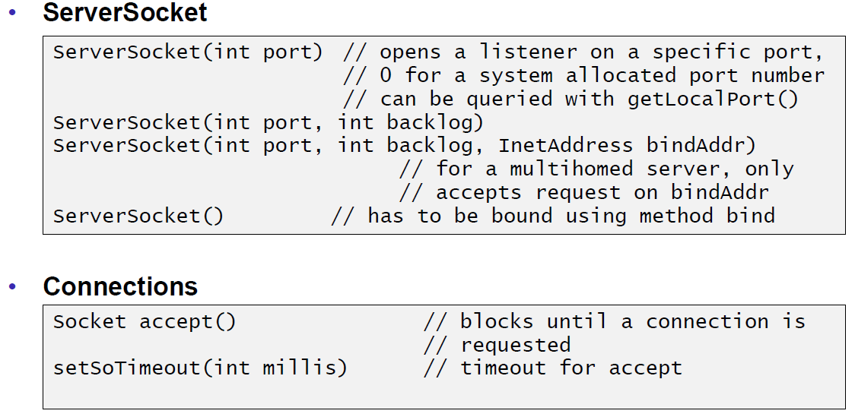

### Echo Server

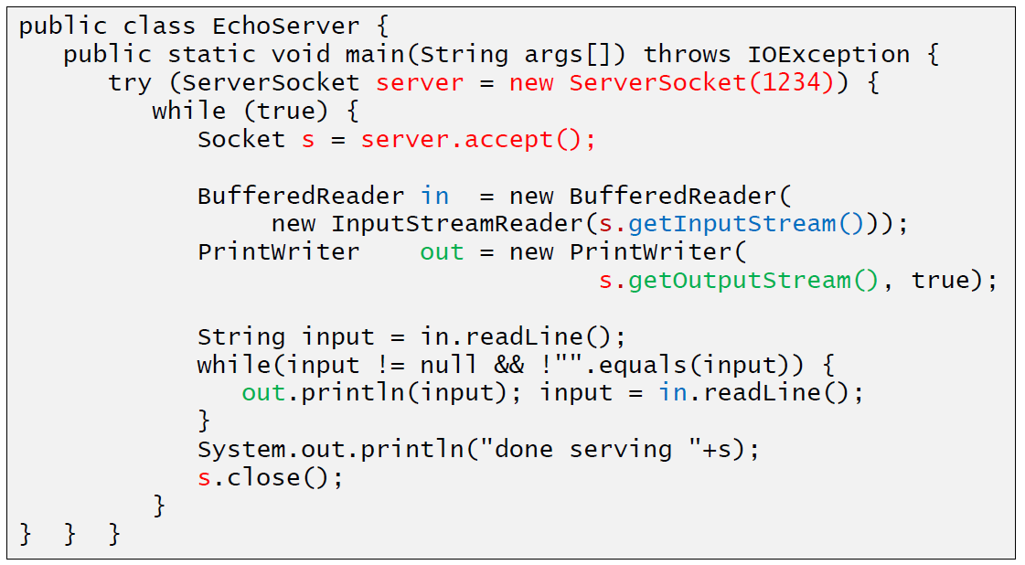

### Concurrent Echo Server

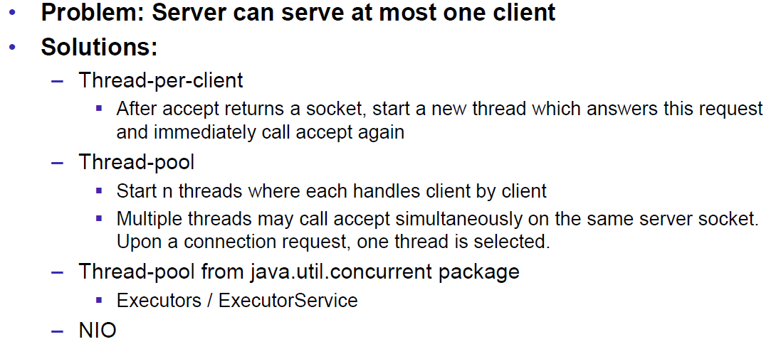

### Concurrent Echo Server (Threaded)

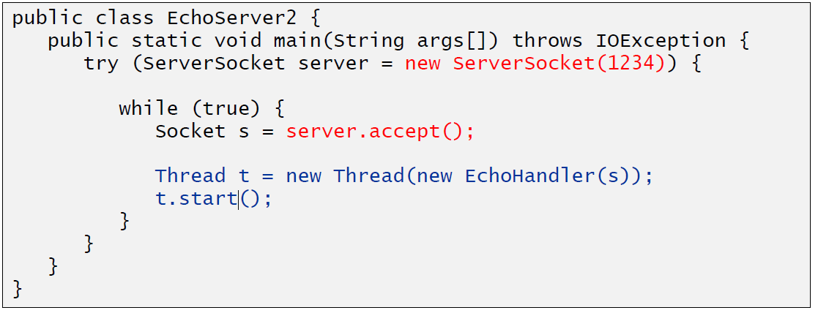

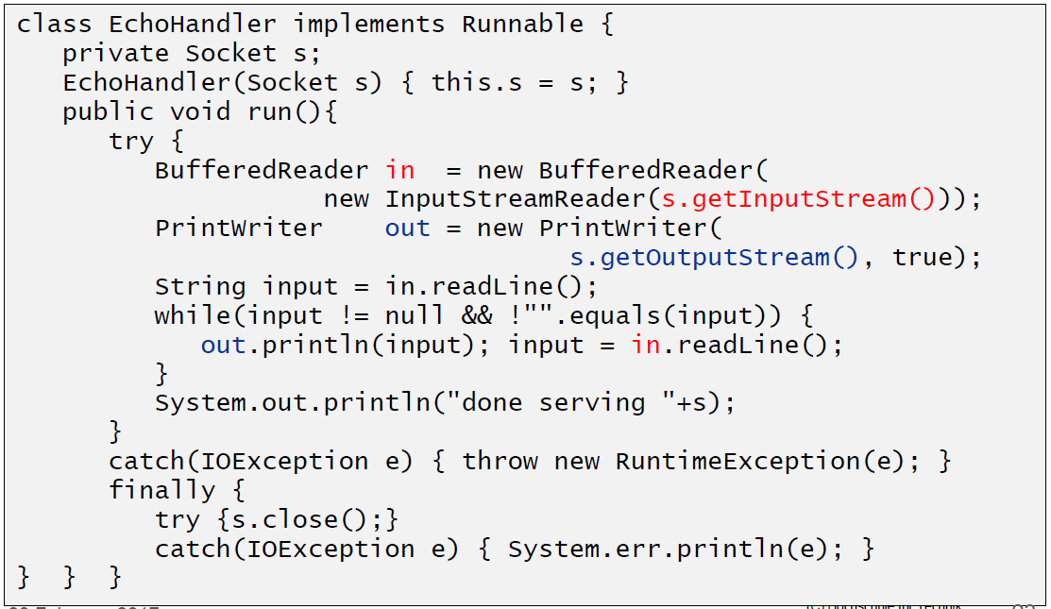

### Concurrent Echo Server (Limitierter Threadpool)

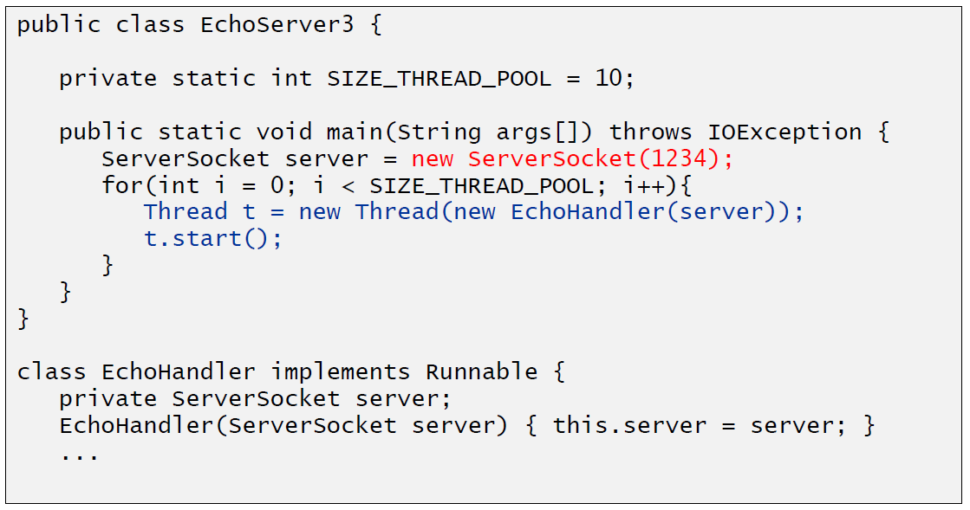

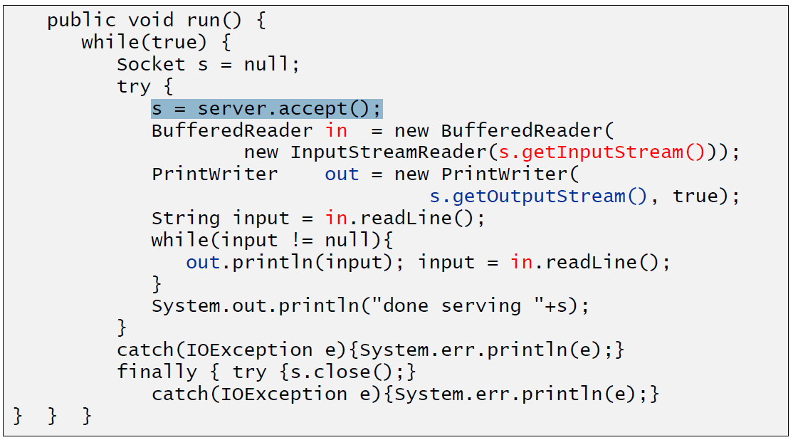

### Concurrent Echo Server (Dynamischer Threadpool)

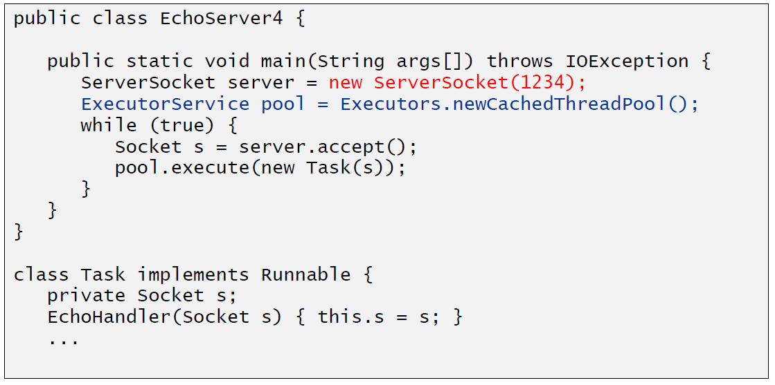

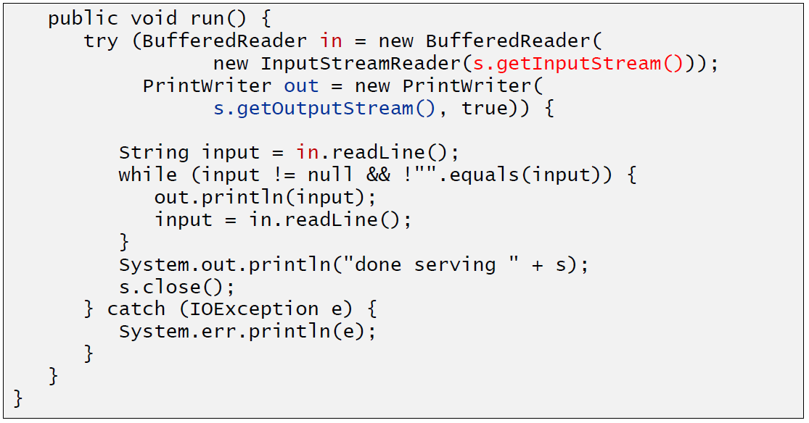

# Woche 2

## Input and Output Streams

### OutputStream

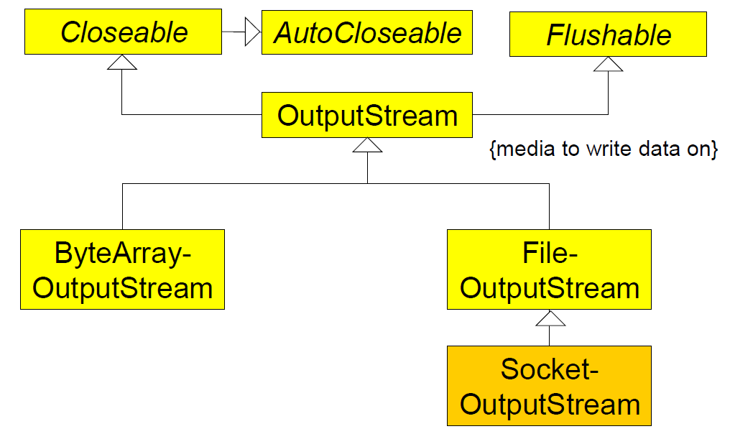

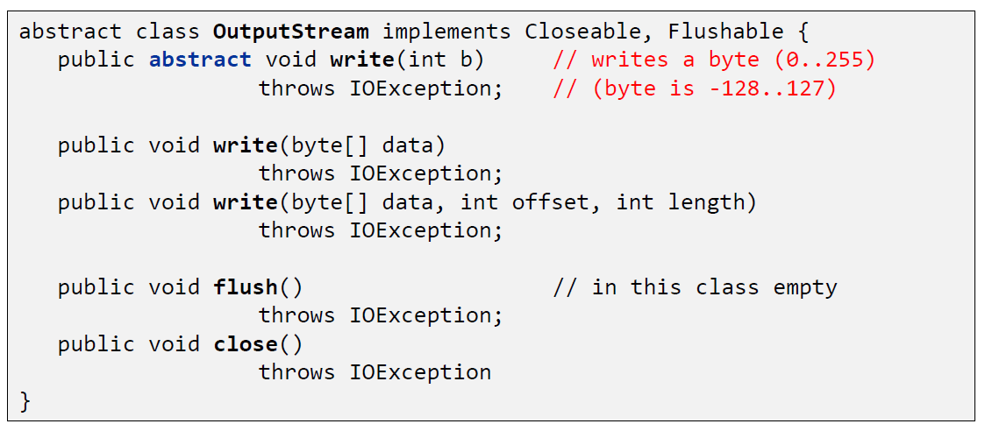

### InputStream

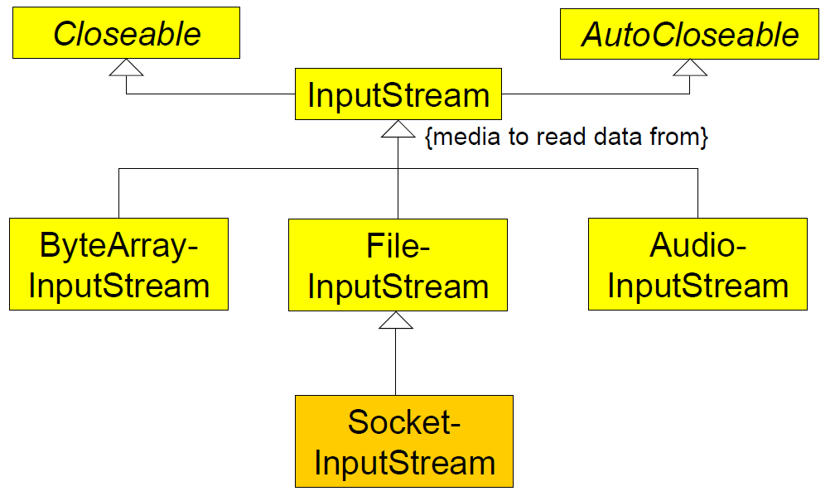

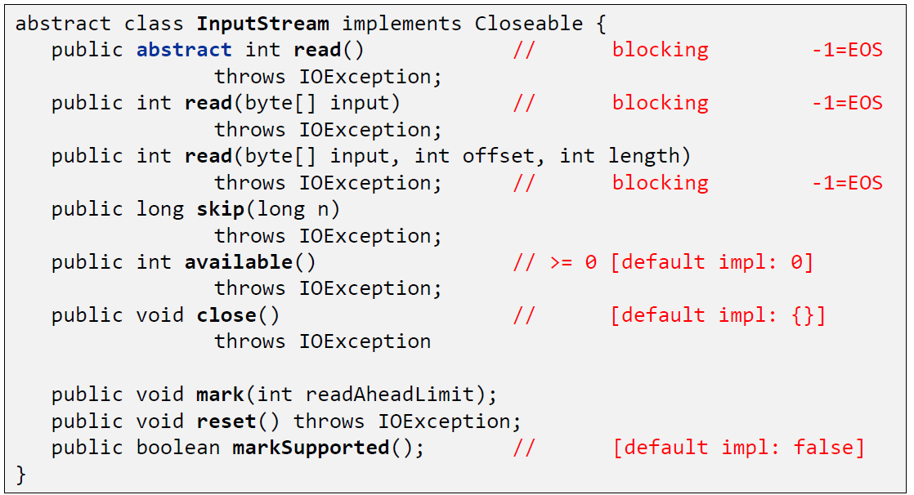

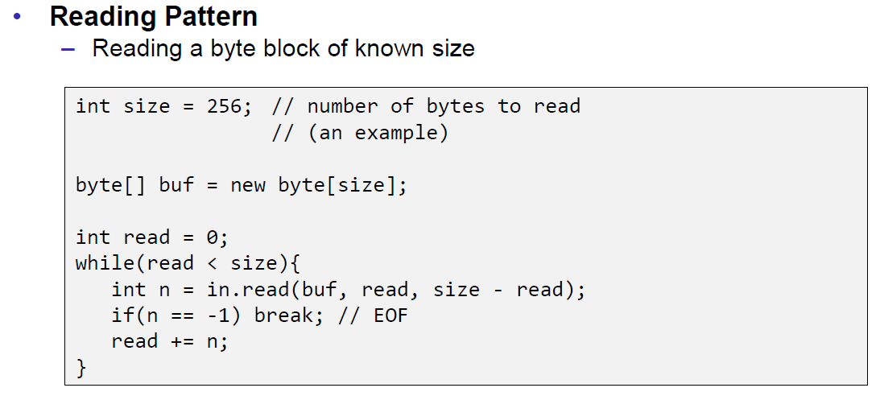

## Filter Streams

### FilterOutputStream

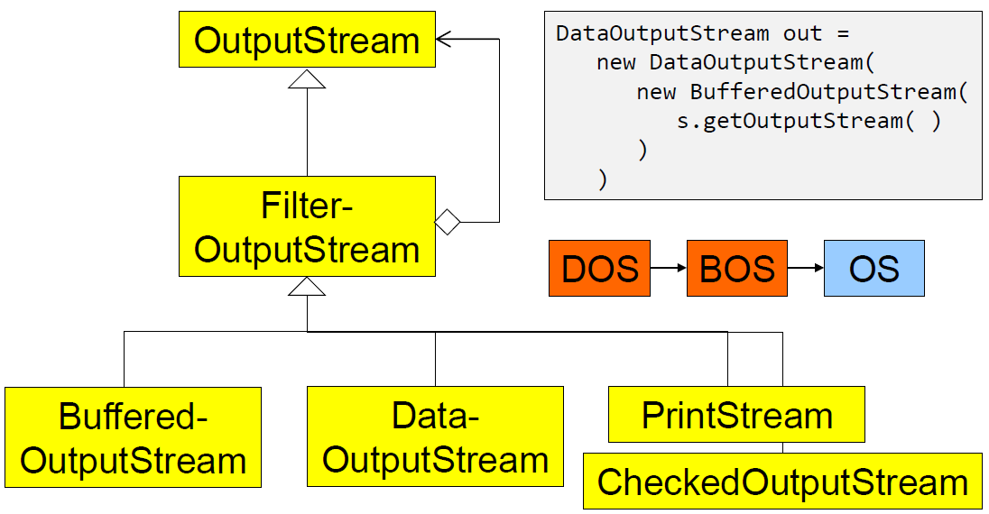

### DataOutputStream

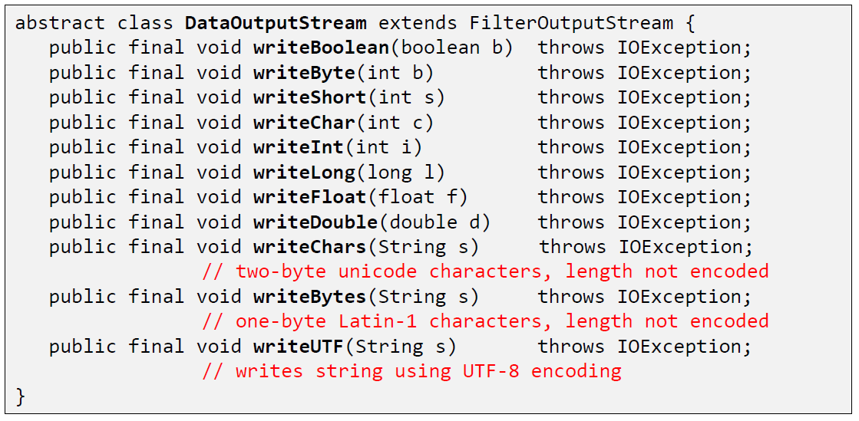

### DataOutputStream with writeInt

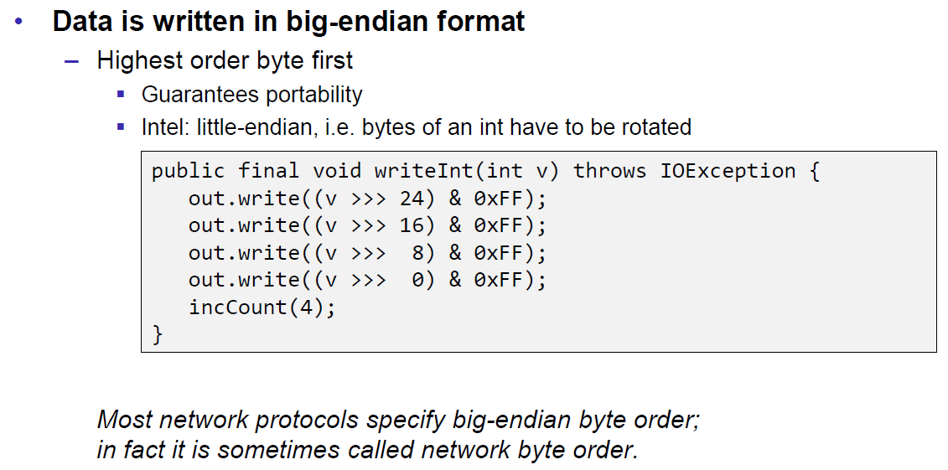

### DataOutputStream with writeUTF

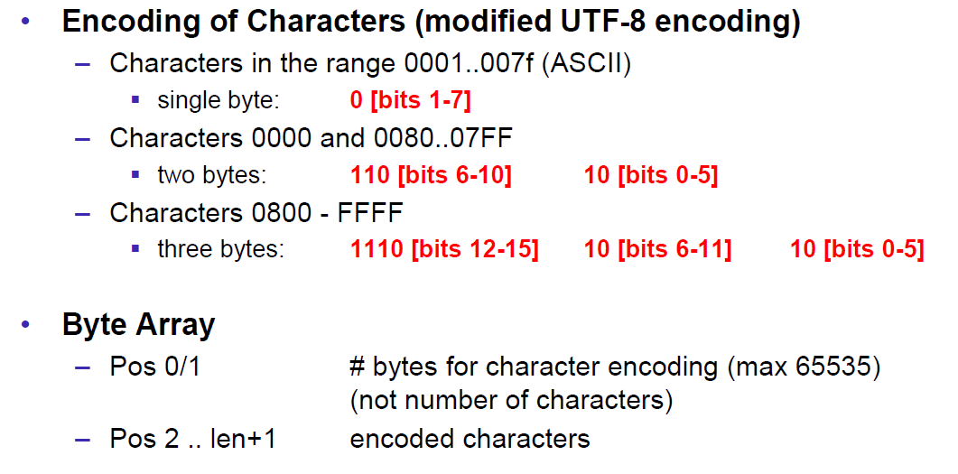

### PrintStream

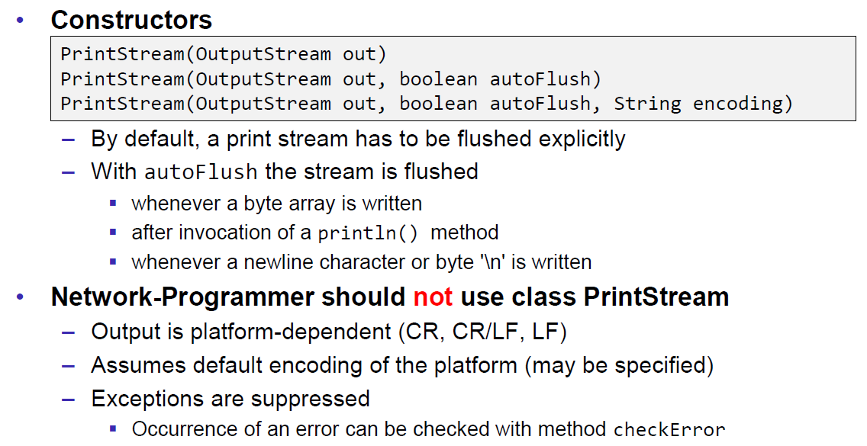

### FilterInputStream

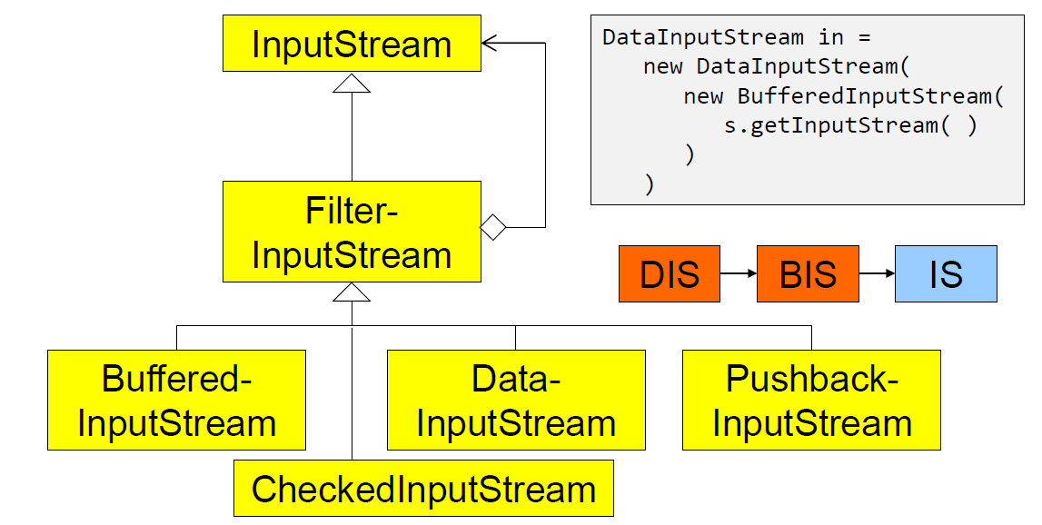

### DataInputStream

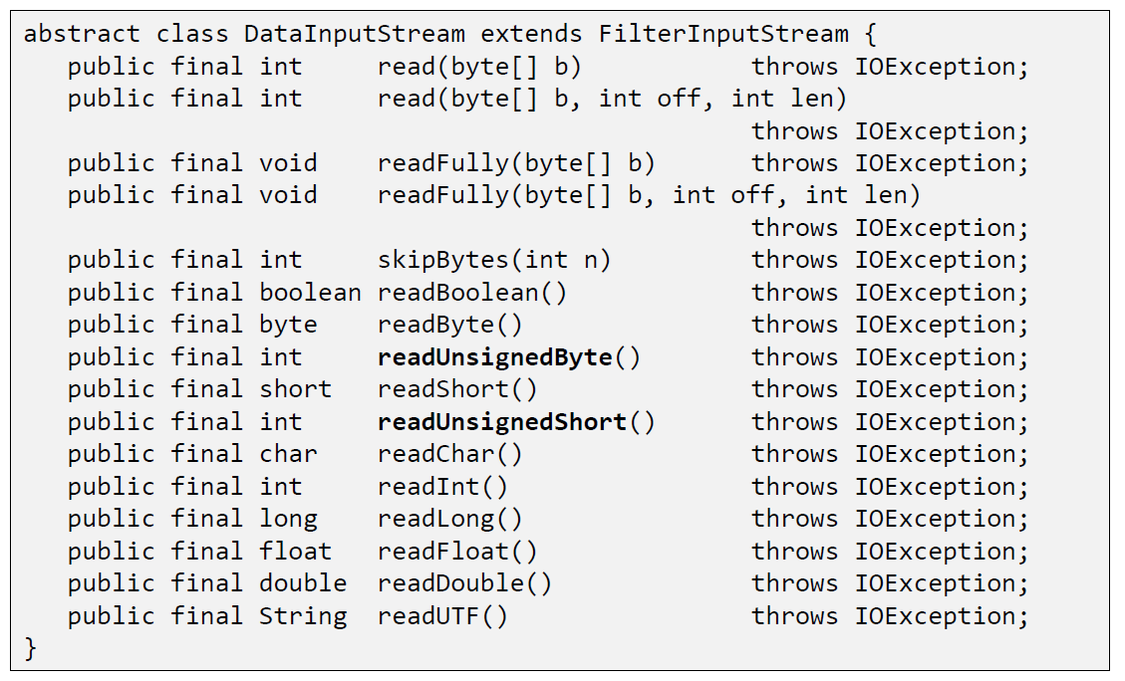

### DataInputStream with readFully

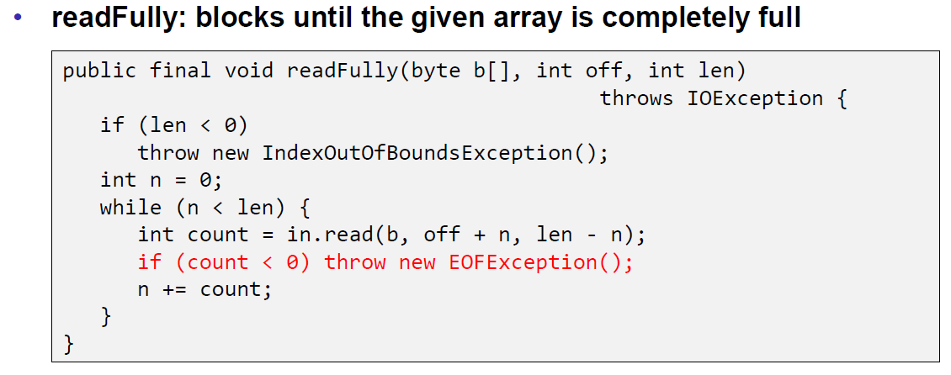

### Filter Streams

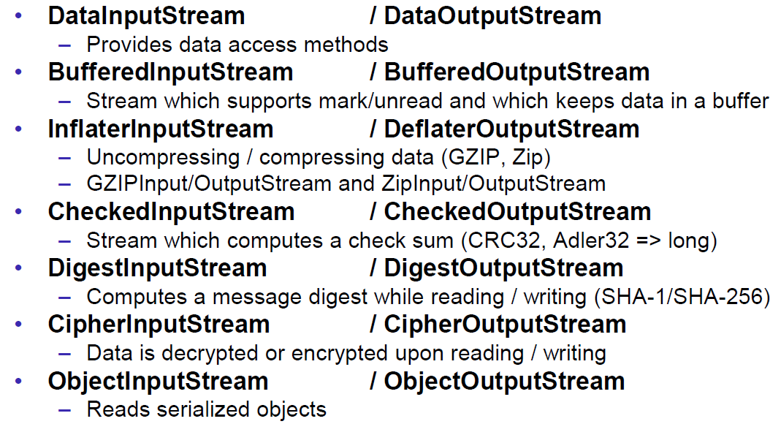

## Object Streams & Serialization

### ObjectStream

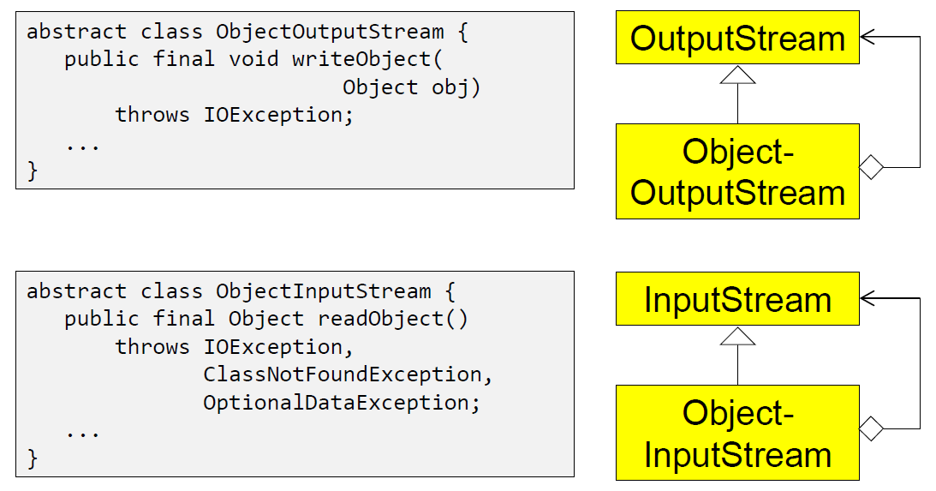

### Serialization with ObjectStream

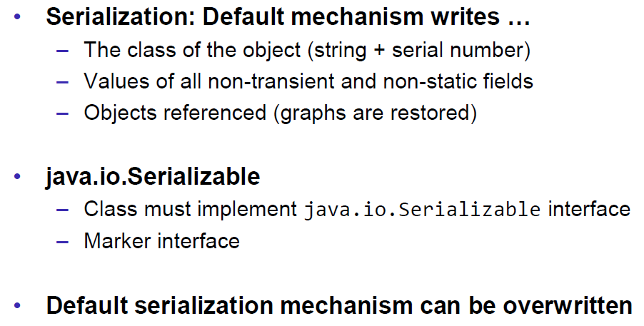

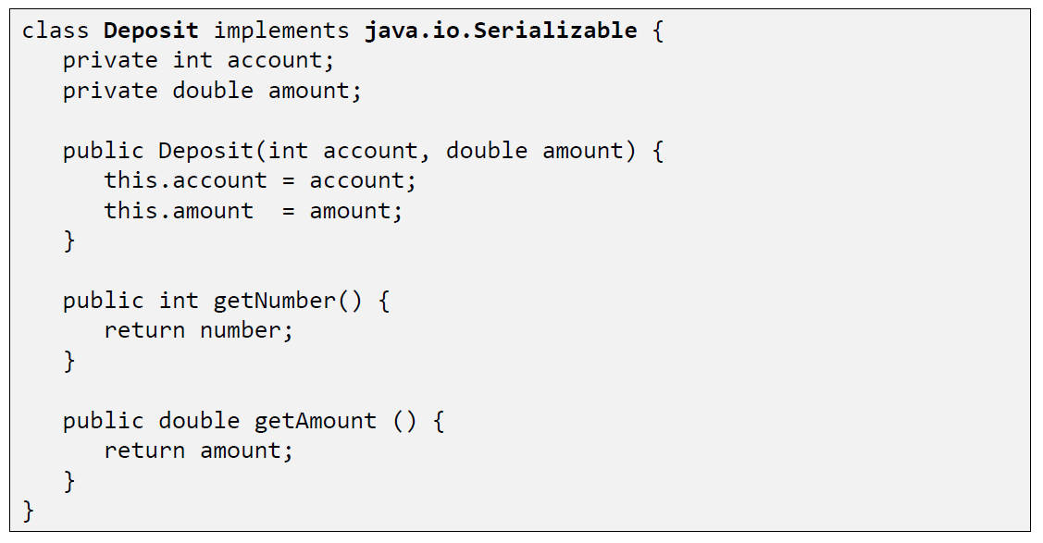

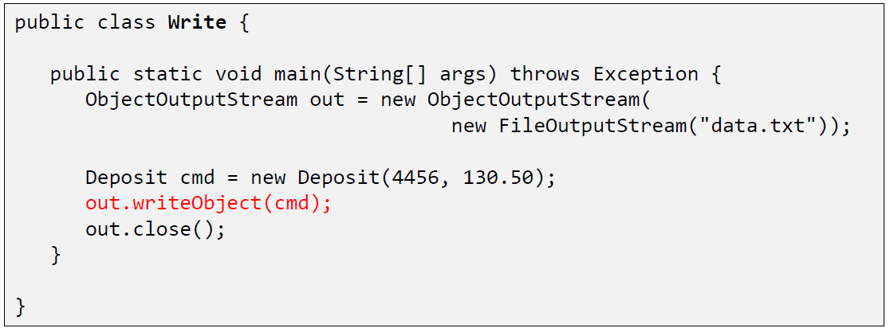

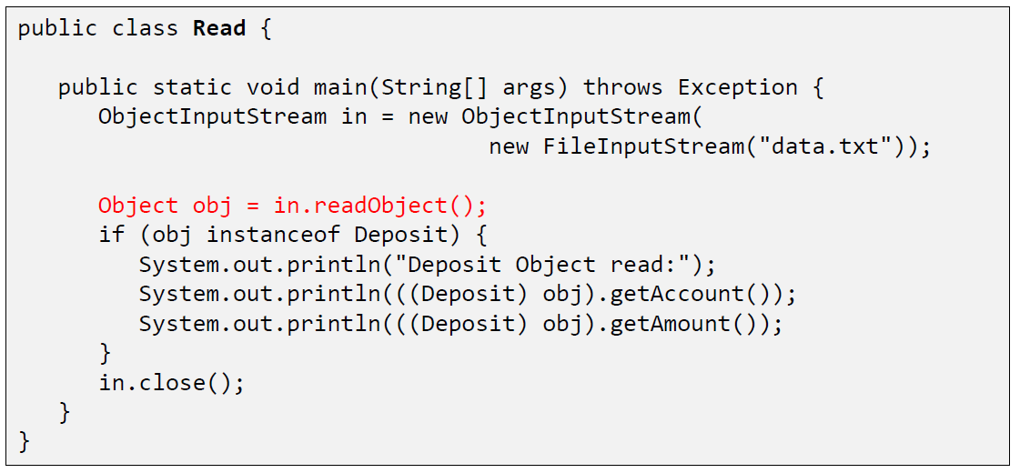

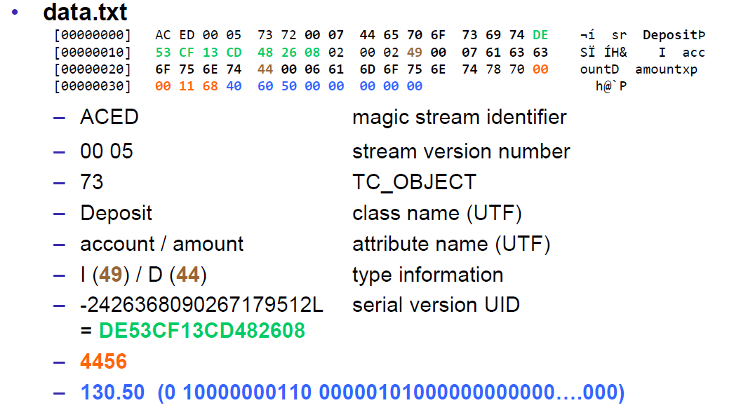

### Serial Version Number

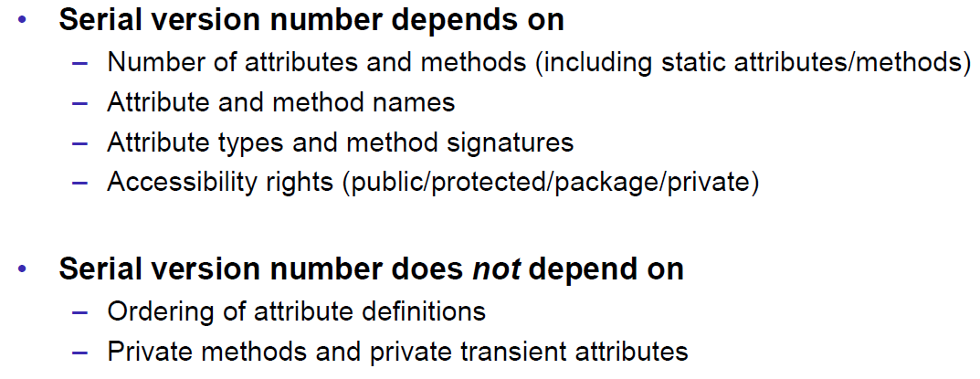

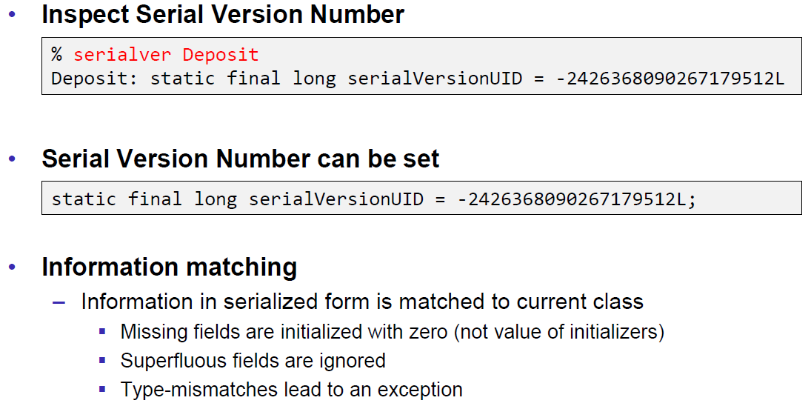

### Serialization Customization

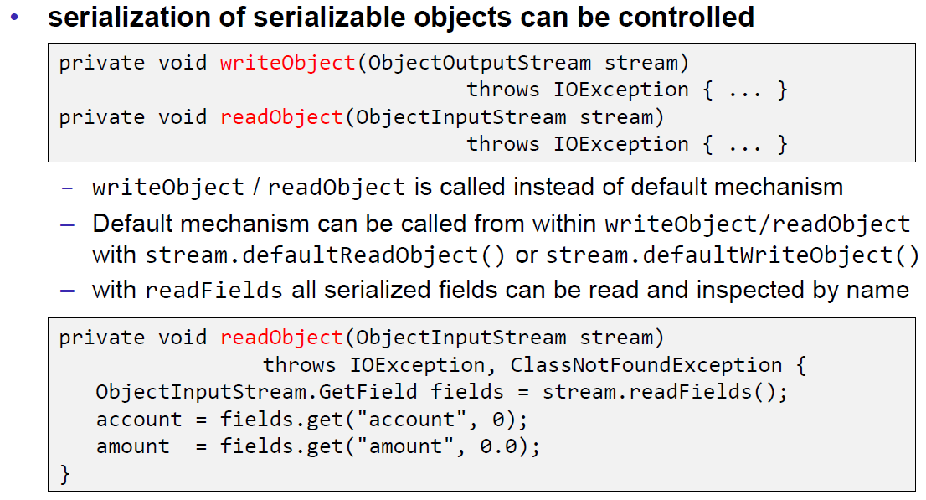

### Serialization Hints

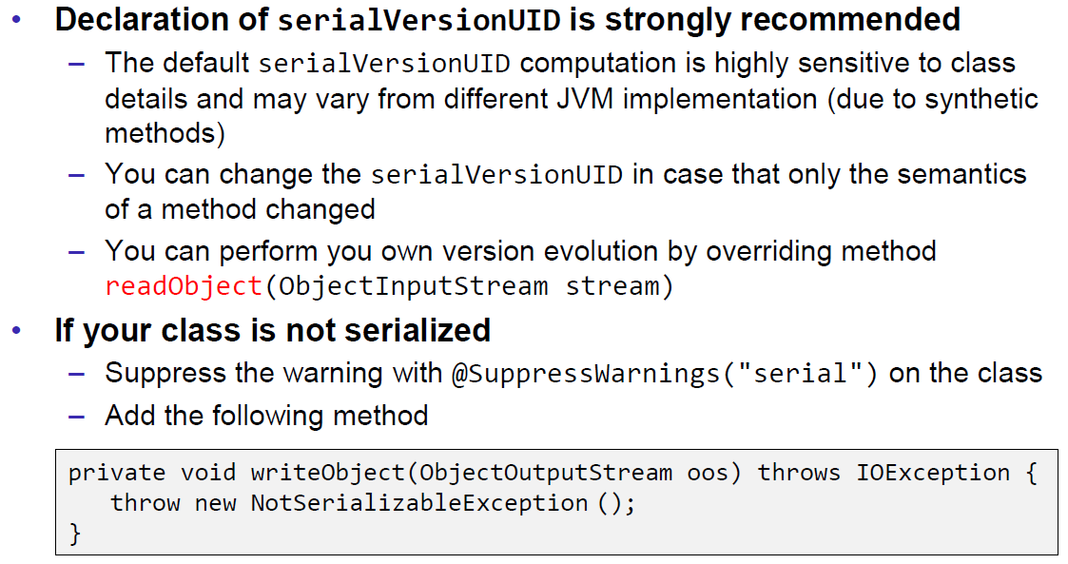

## Sending and Receiving Data

### Framing

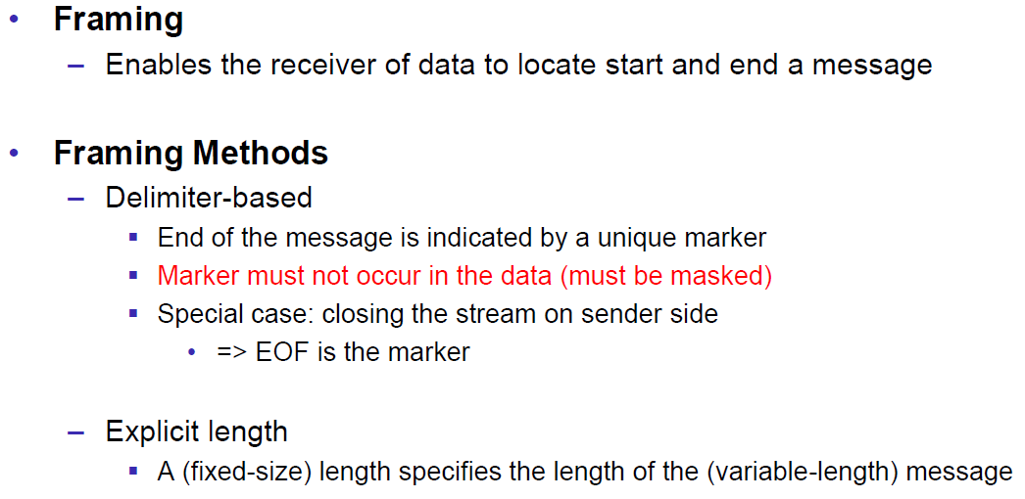

### Example of Framing

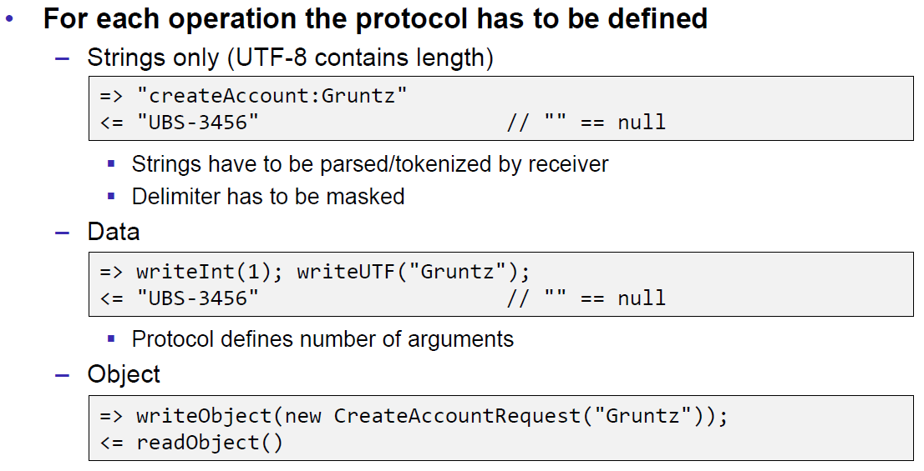

## Summary

### Whole Picture of Input Streams

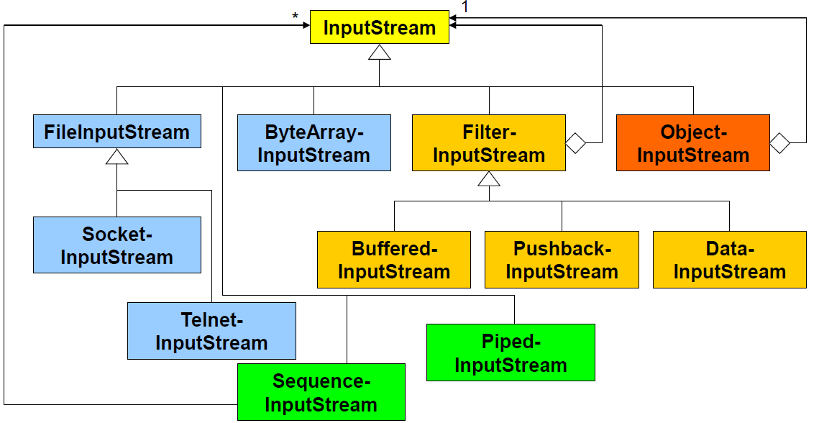

### Whole Picture of Output Streams

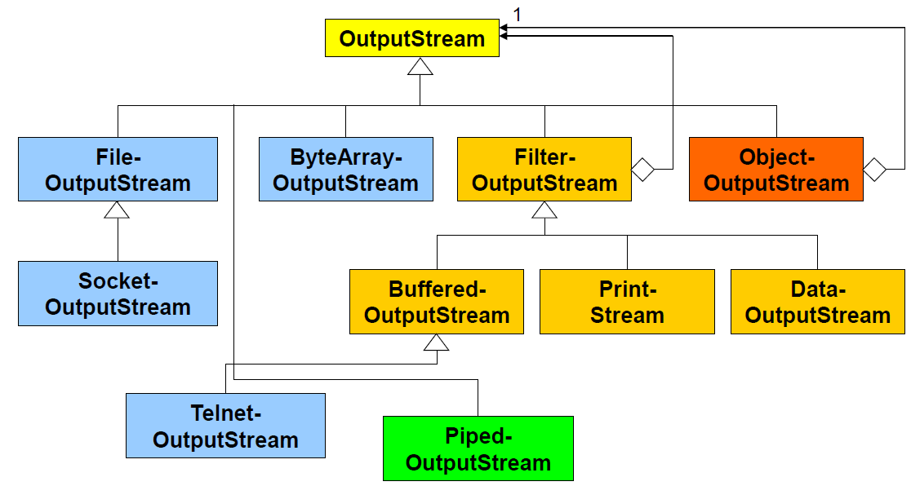

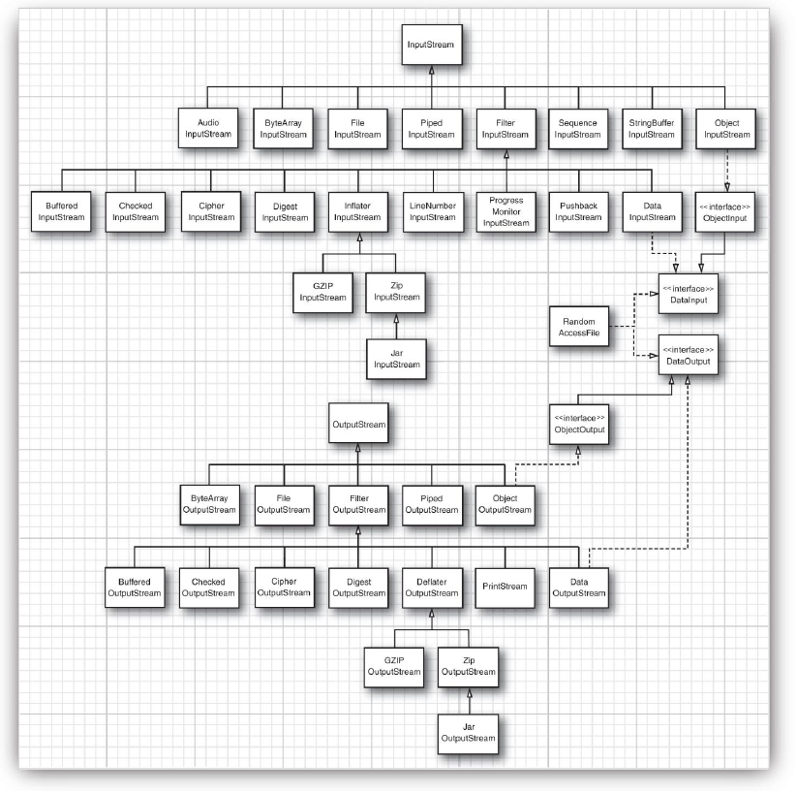

### Reading and Writing Text (Unicode Strings)

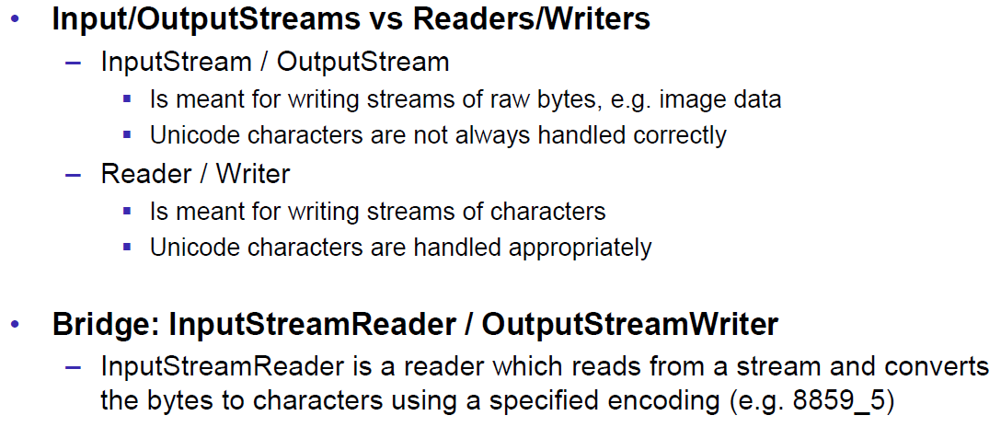

### Whole Picture of Reader

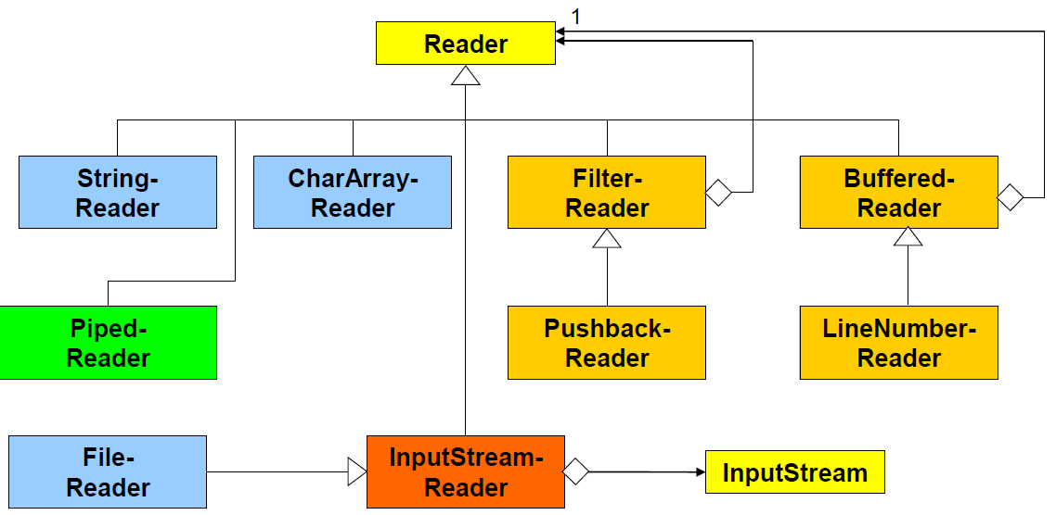

### Whole Picture of Writer

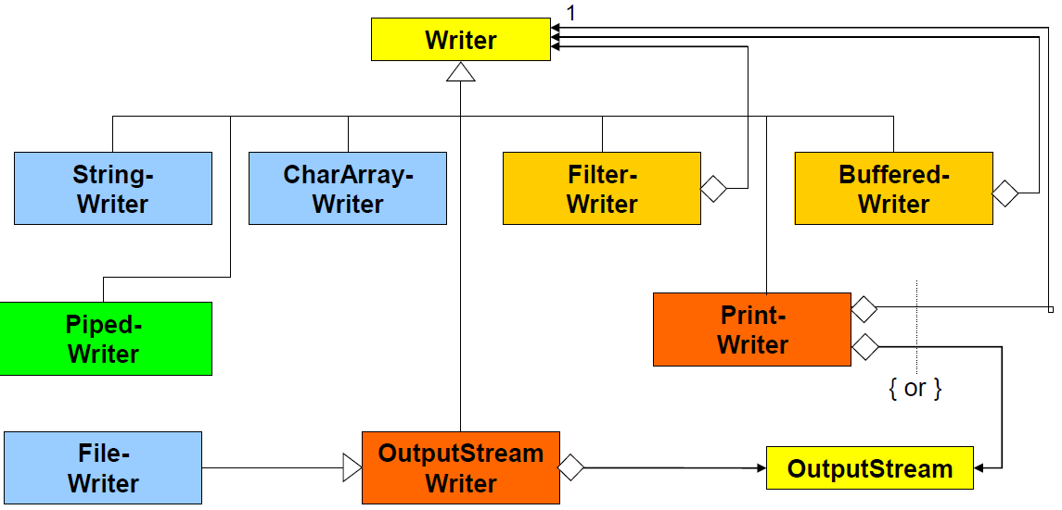

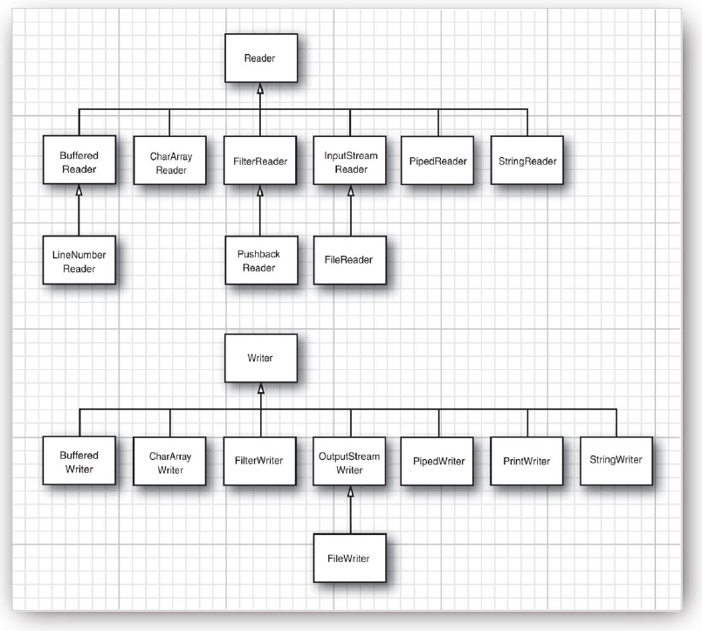

## Controlling Socket Behaviors

### Blocking and Timeouts

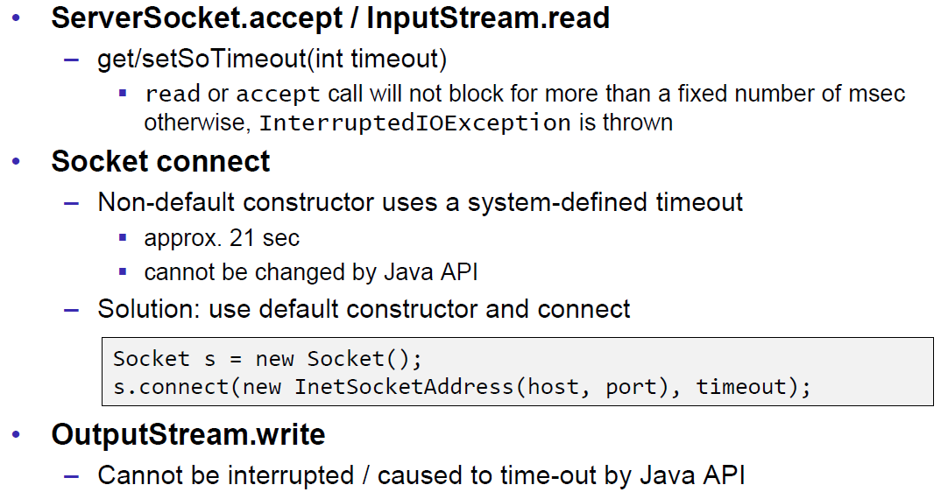

### Send and Receive Buffer Size

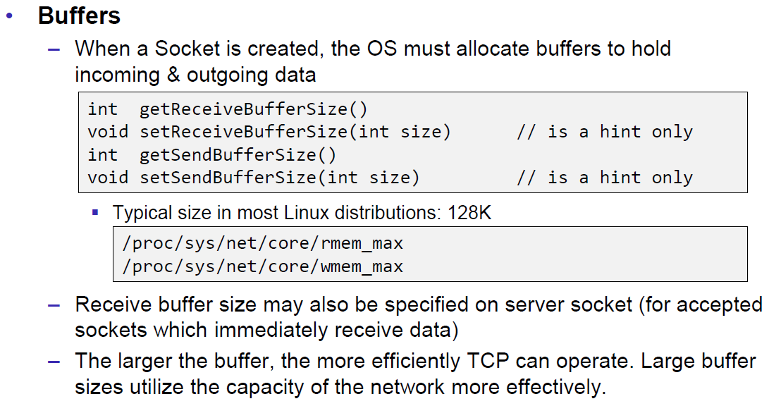

### Package Delay

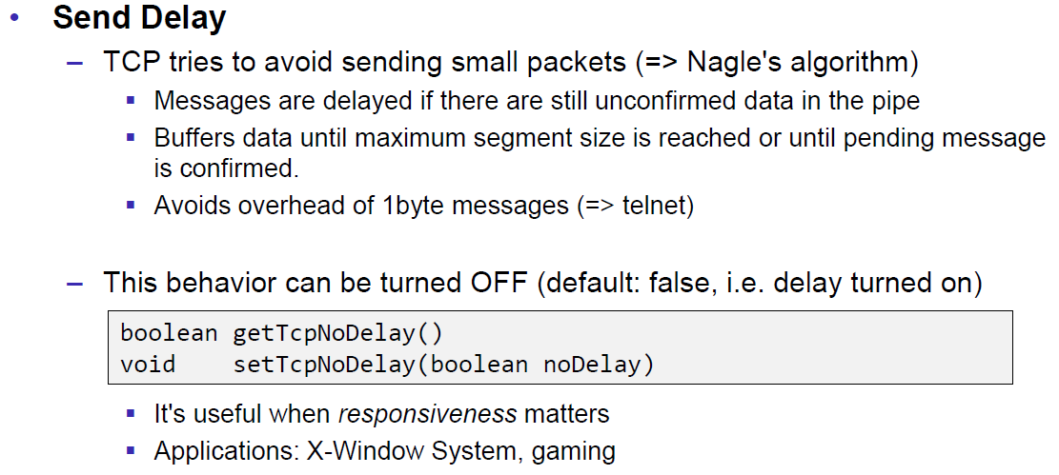

## Closing Connections

### Closing Connections

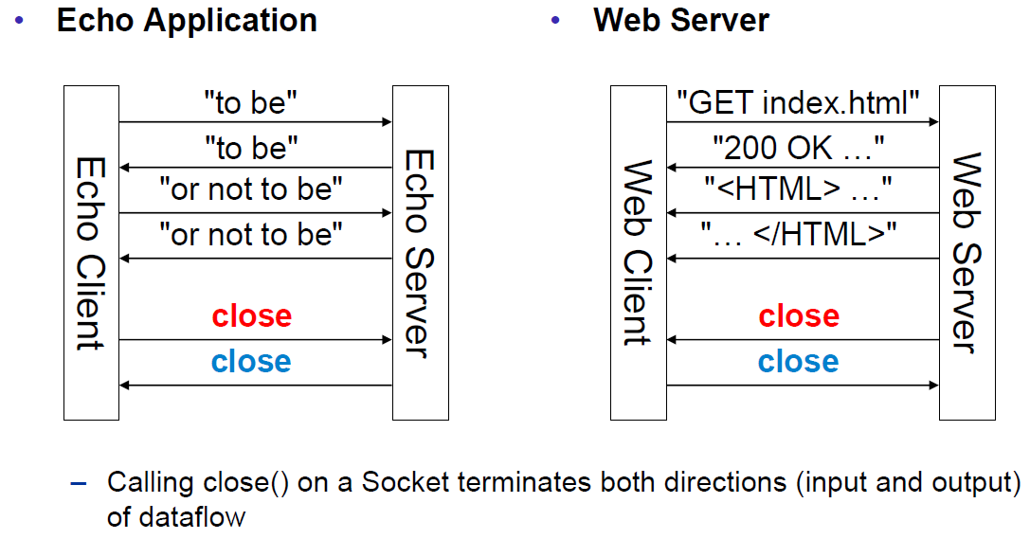

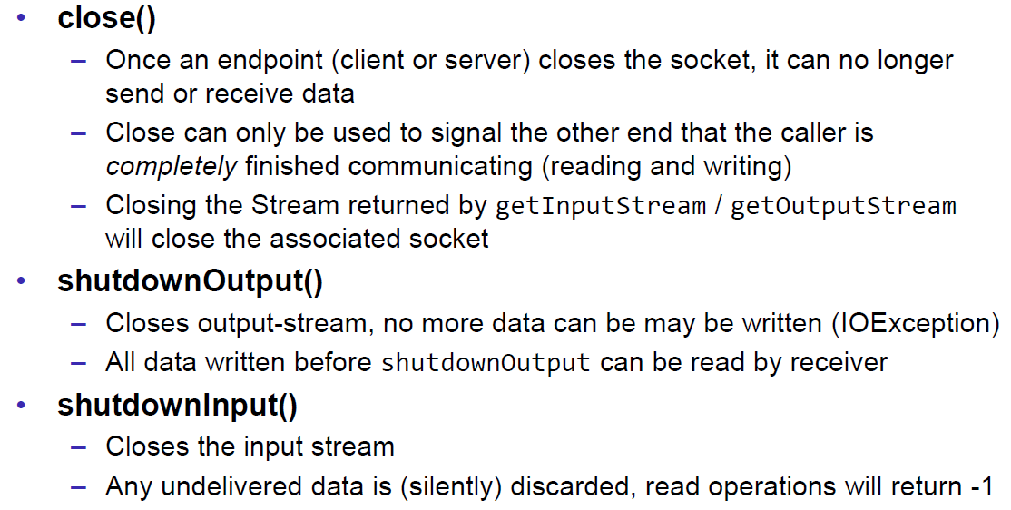

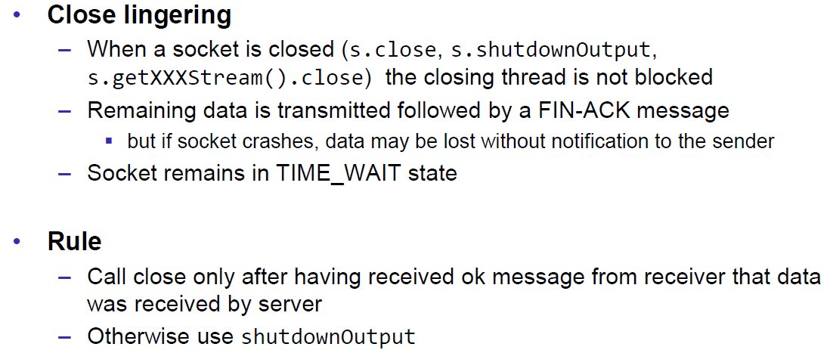

### Example of a Close Test

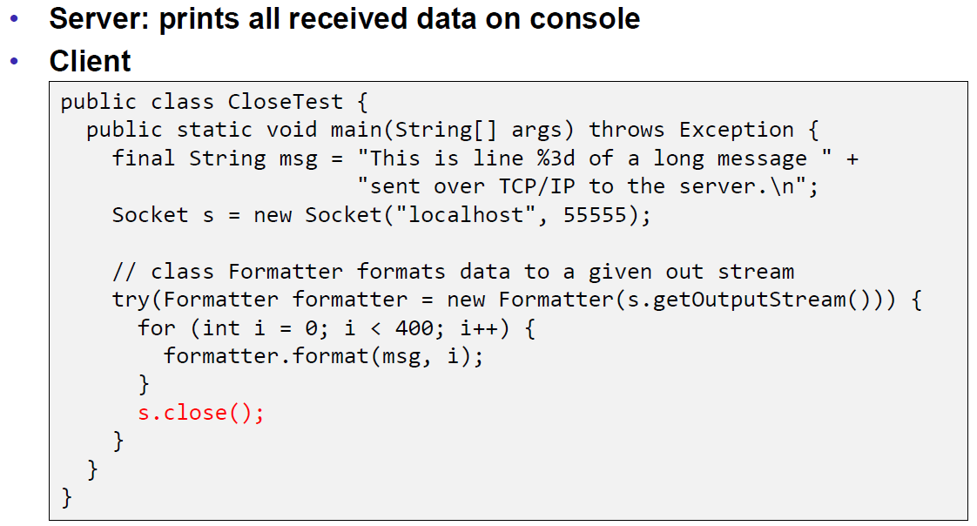

Problem: Some content of the formatter is not received by the server.

Solution: Flush the formatter before you close the socket, otherwise the buffer of the formatter won’t be sent.

### Example of a Compression Server

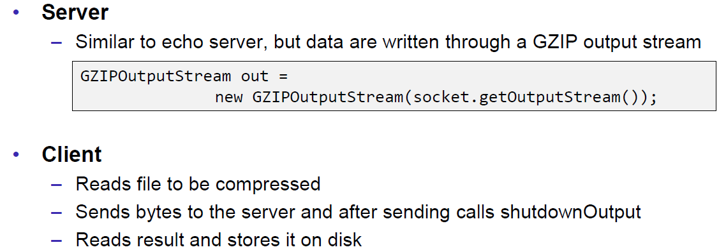

Problem: At some point, the server hangs up and doesn’t reply anymore.

Solution: Don’t send all content before you start reading. Otherwise you will fill up the outgoing (sending) cache of the server (because no one is reading it) and the write process of the server becomes blocking (this prevents a data loss because the outgoing buffer is full). A solution to this problem is to write and read block by block or to start the send process in a separate thread (Both happens in the client), so the client is able to immediately read the result and prevents a full sender buffer of the server.

## UDP Sockets

### UDP (User Datagram Protocol)

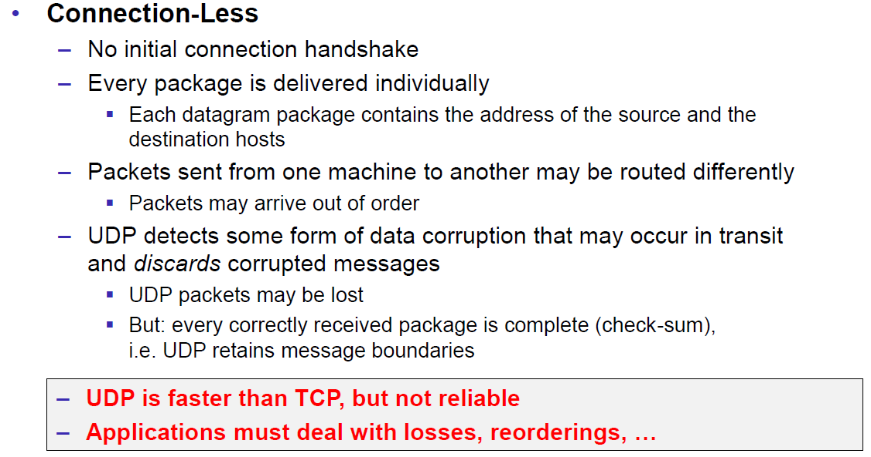

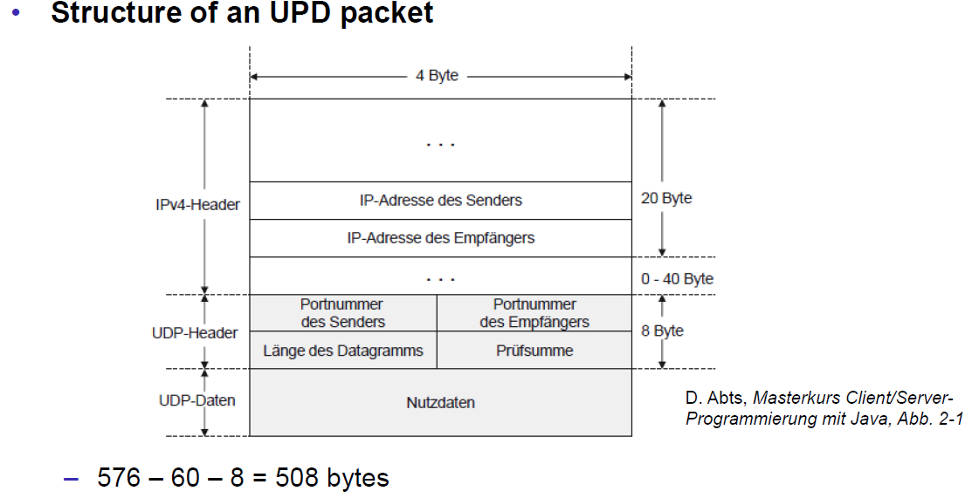

### Java Classes for Datagram

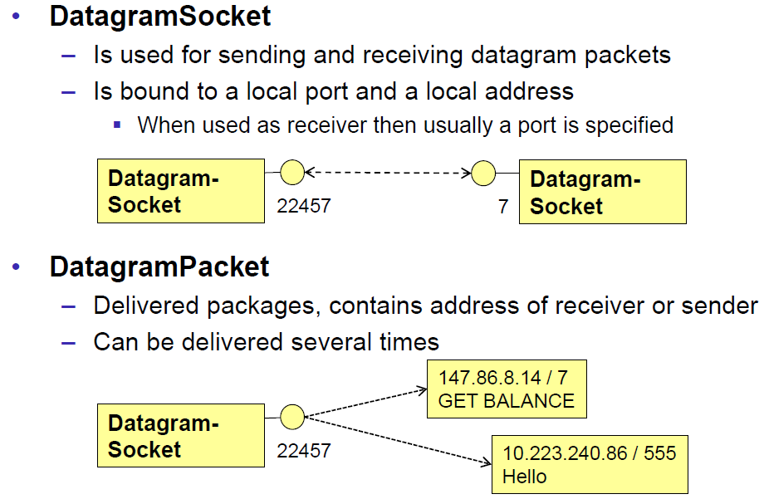

### DatagramSocket

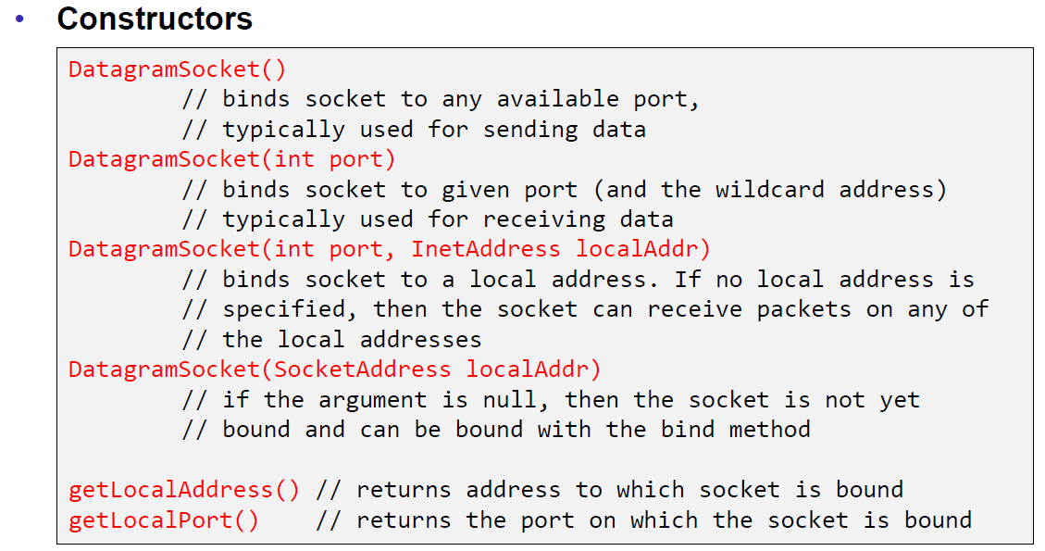

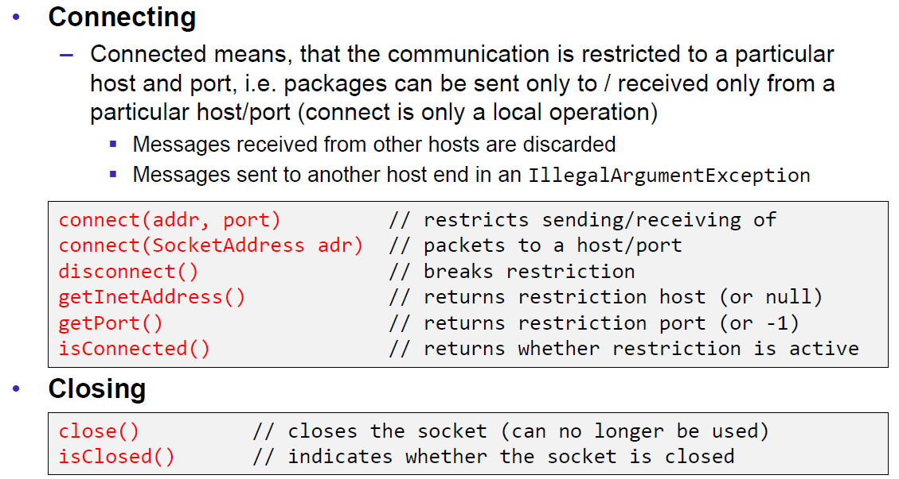

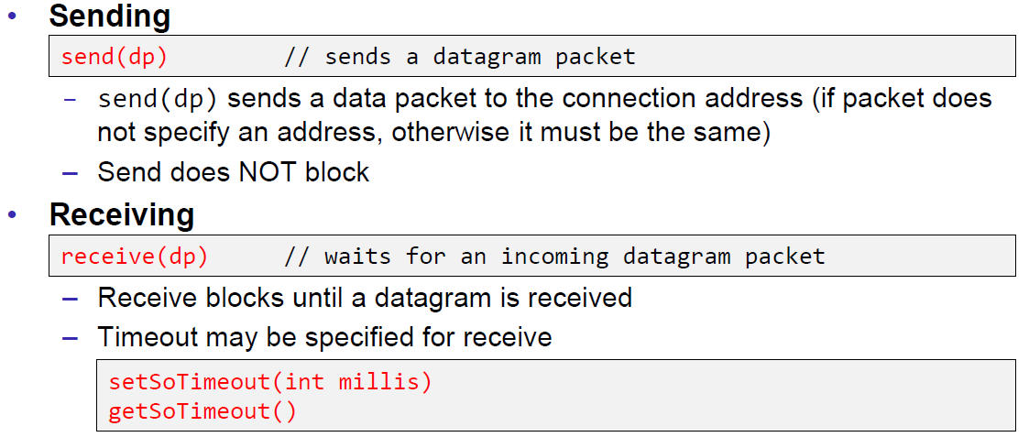

### DatagramPacket

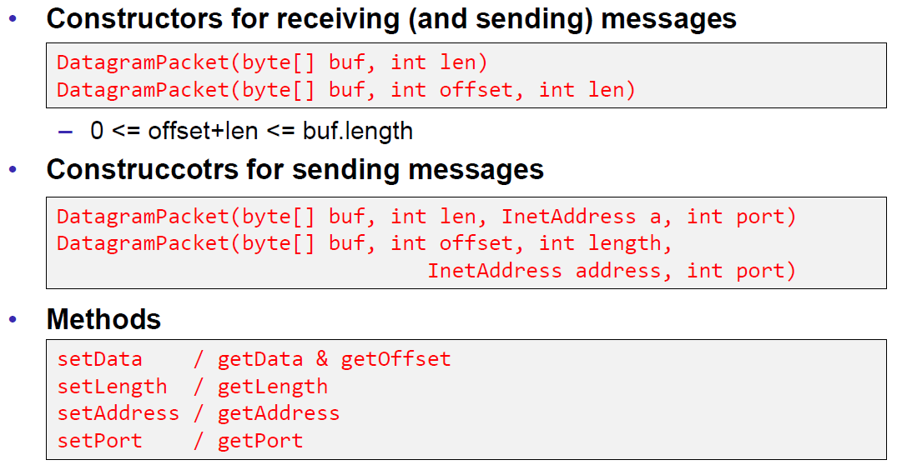

### Example of a UDP Server and Client

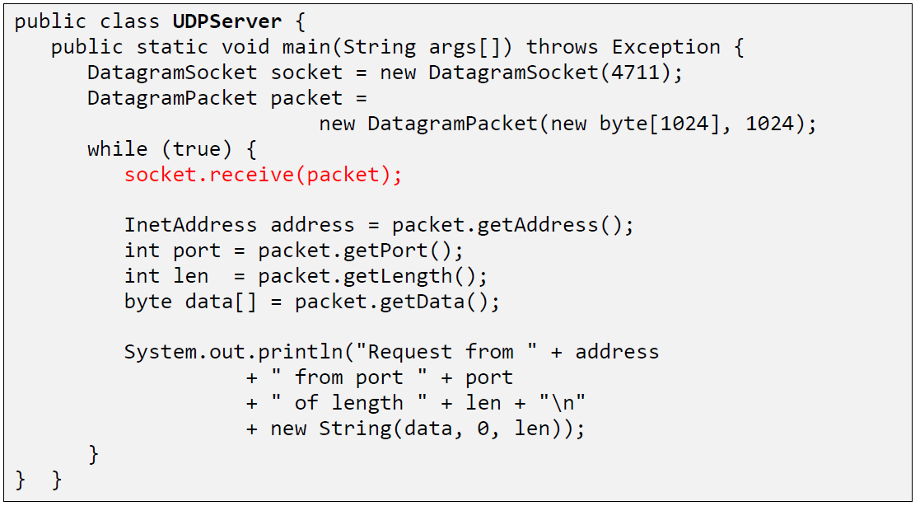

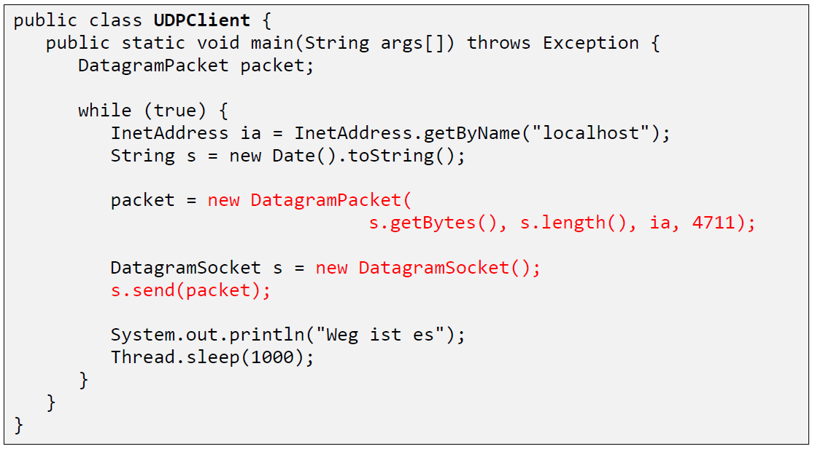

### UDP Implementation

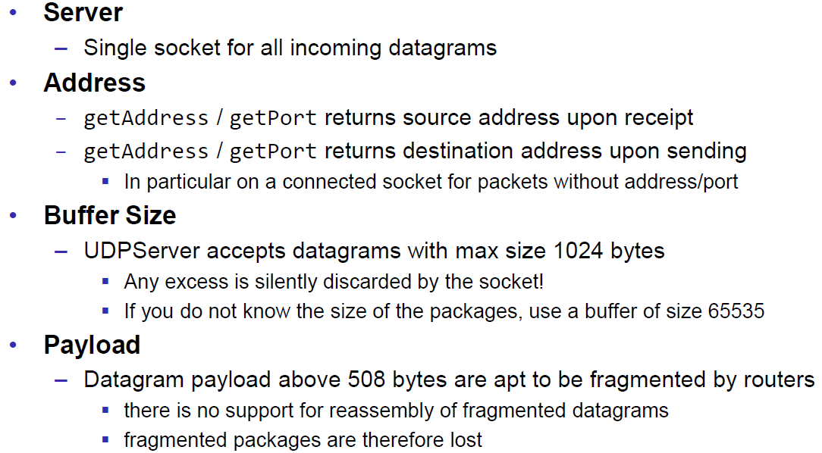

### Reliable UDP

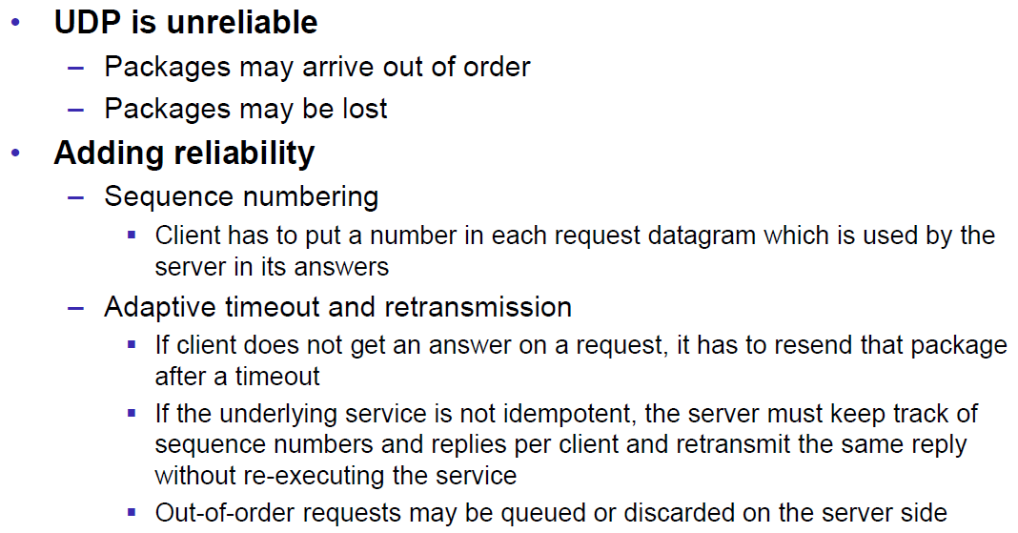

# Woche 3

## HTTP Protocol

### IETF RFC

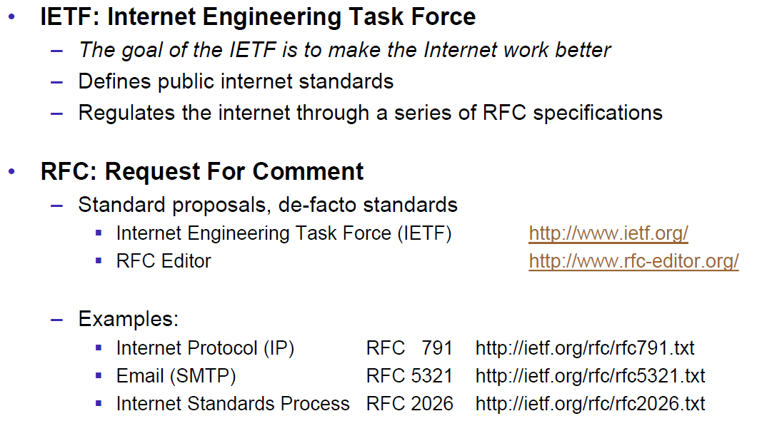

### HTTP Protocol

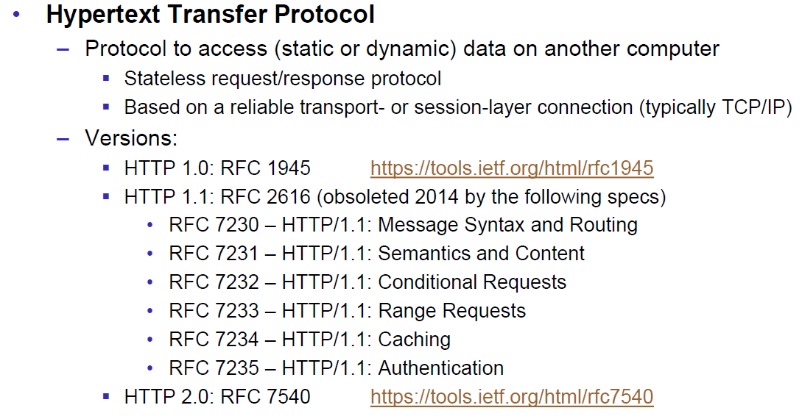

### HTTP Request

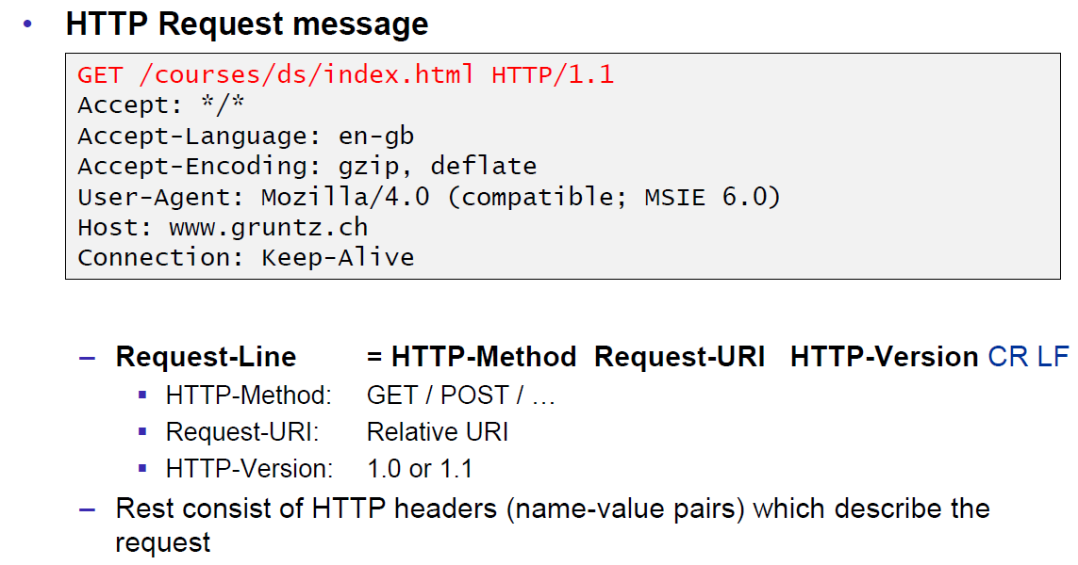

### HTTP Response

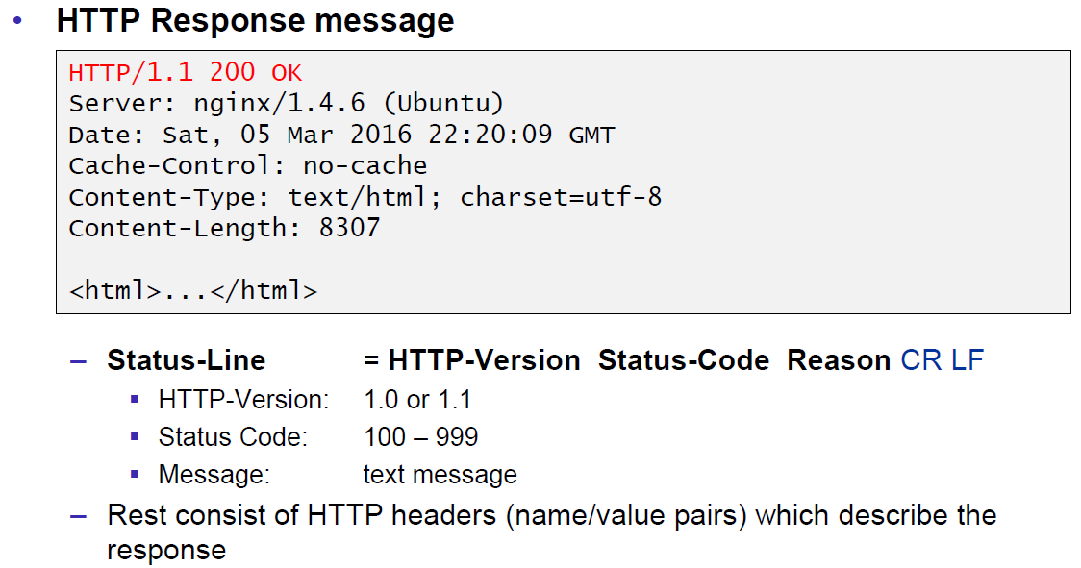

### HTTP Protocol

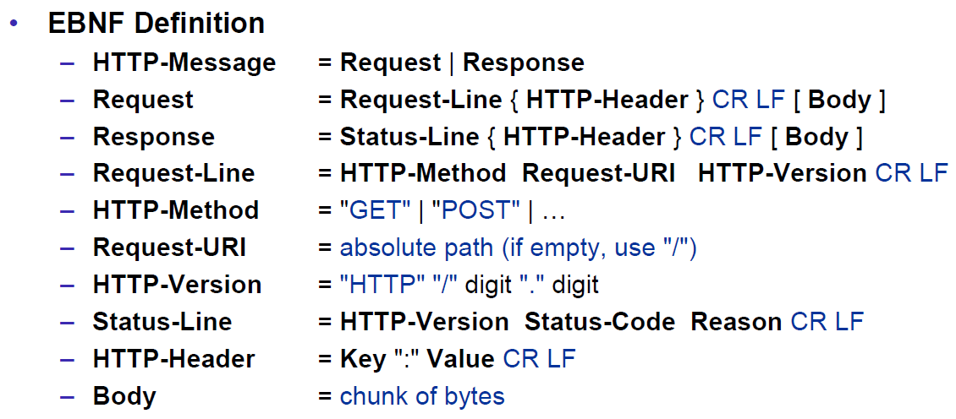

### HTTP Sample

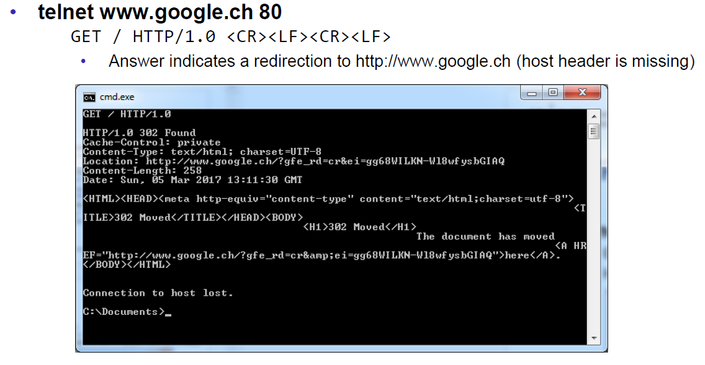

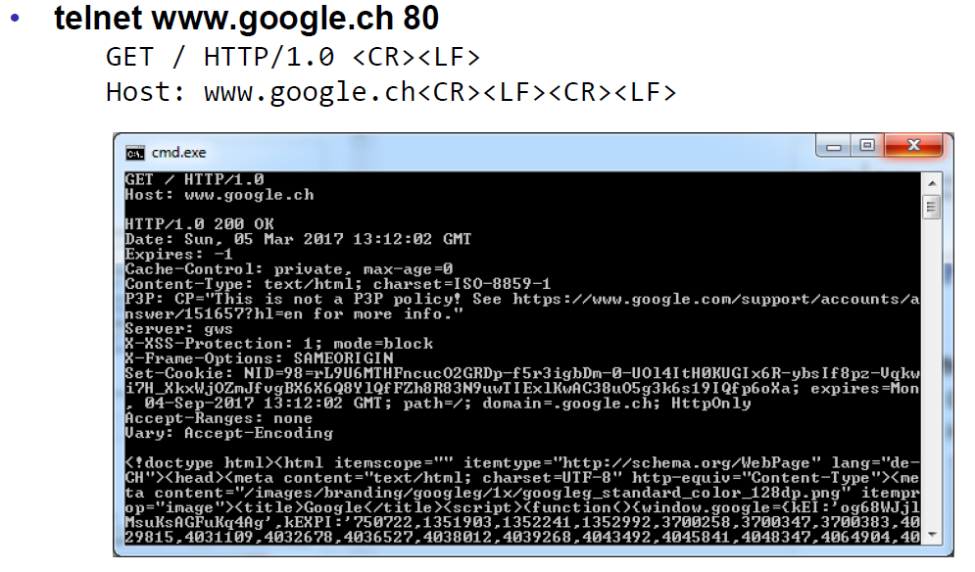

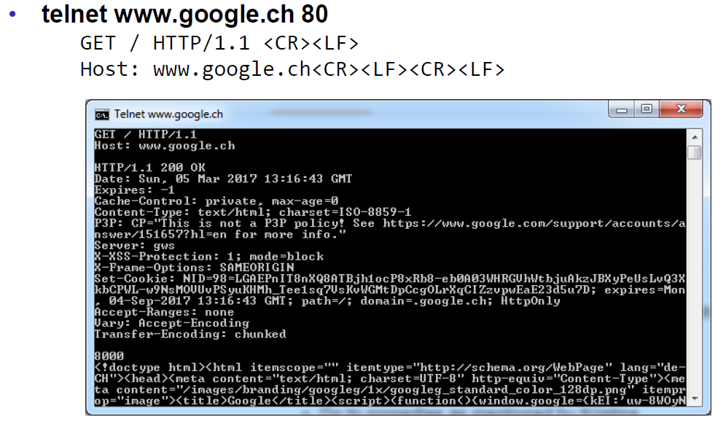

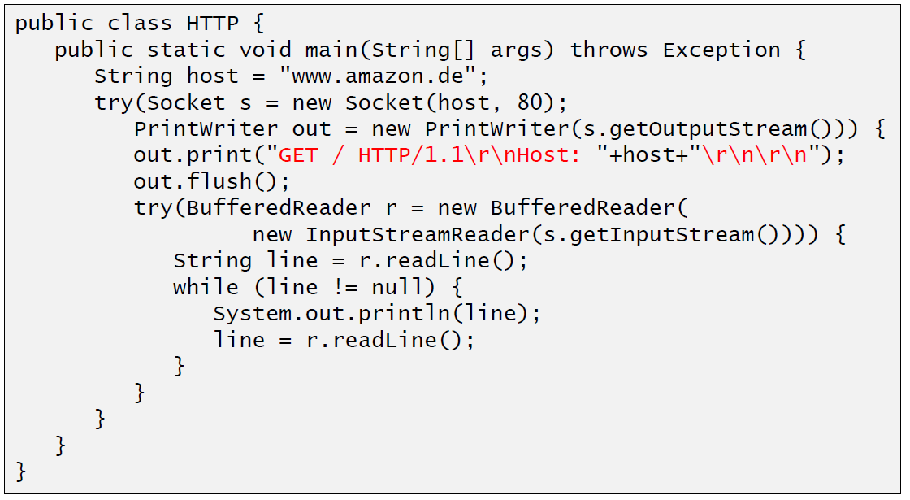

### HTTP 1.0 Request Methods

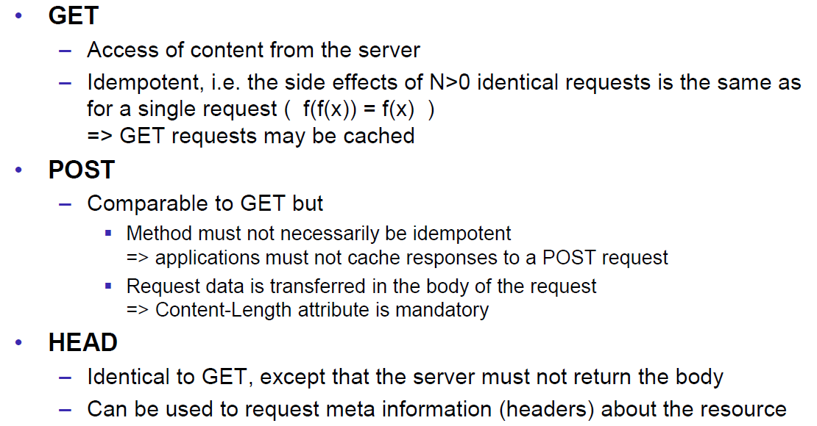

### HTTP Response Codes

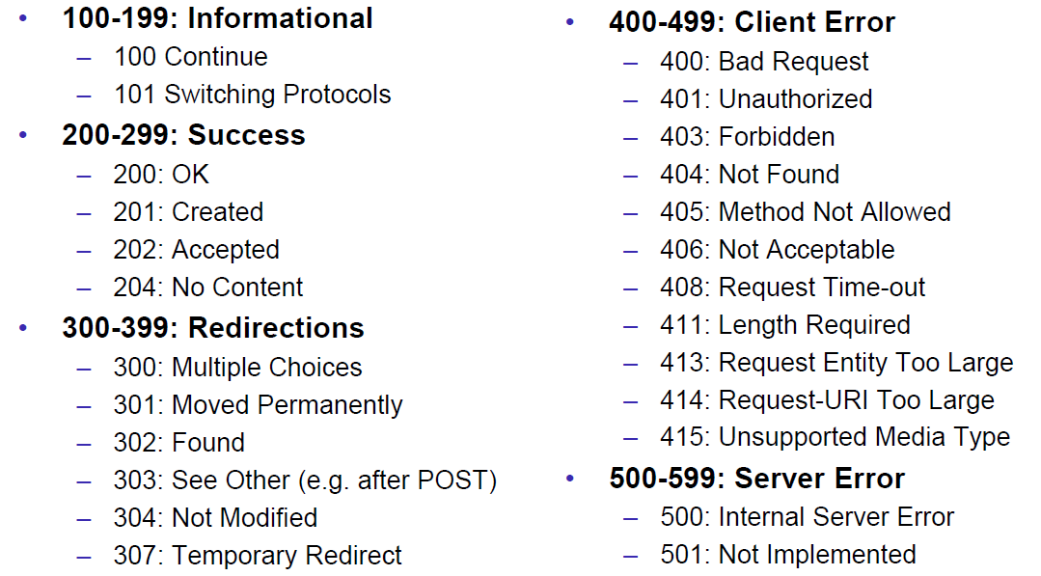

### HTTP Request Headers

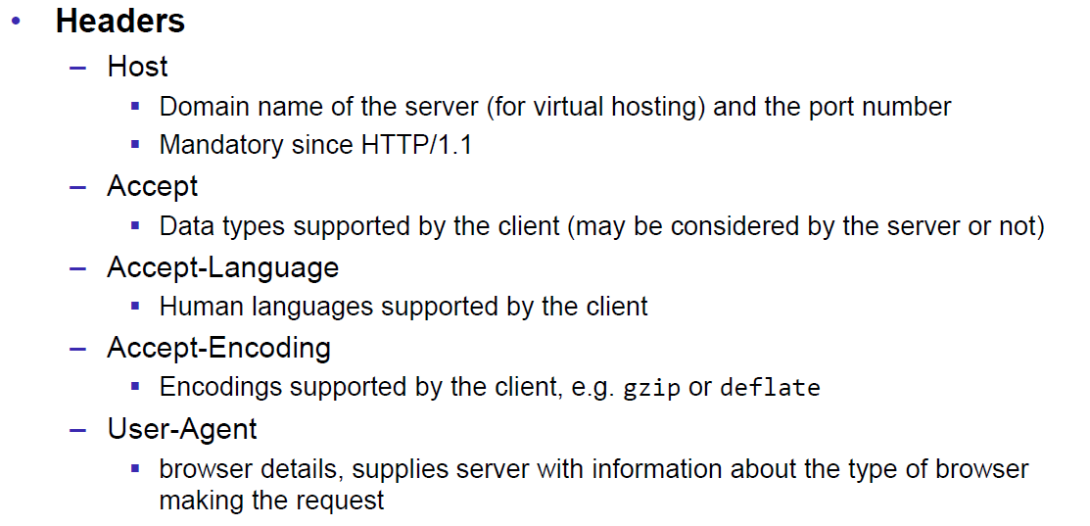

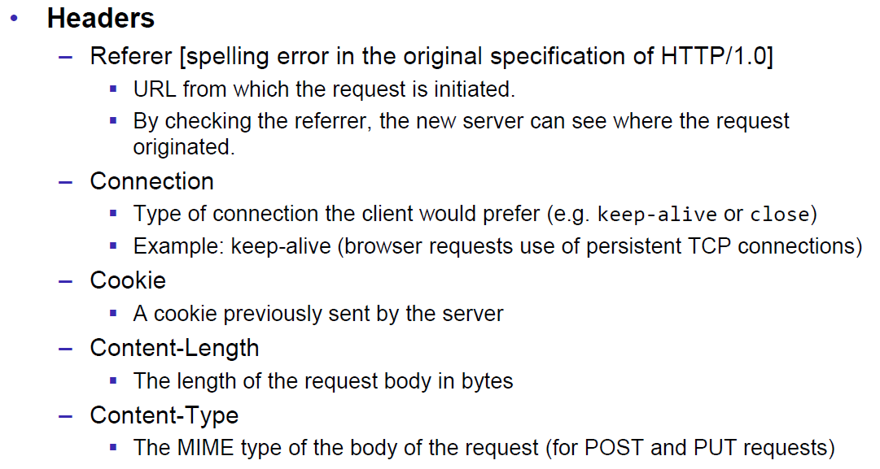

### HTTP Response Headers

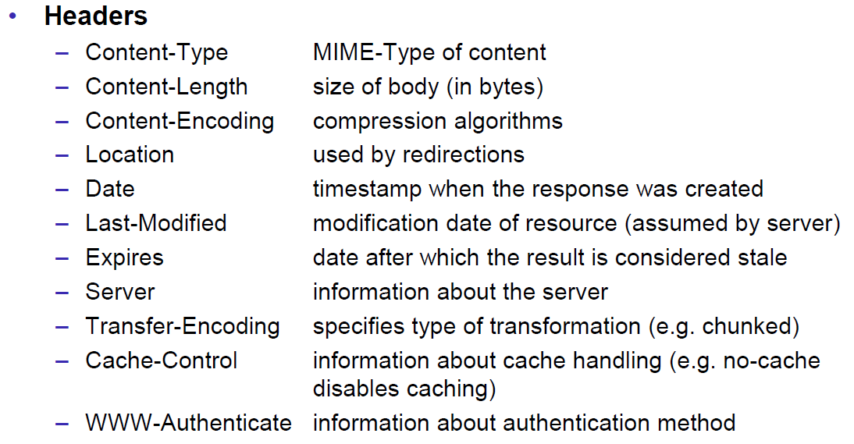

### MIME Types

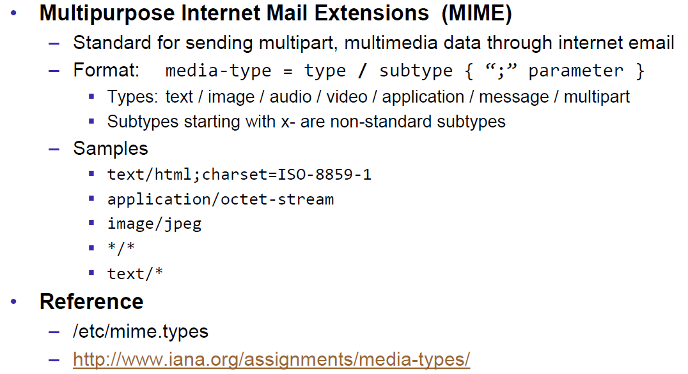

### HTTP Request/Response Sample

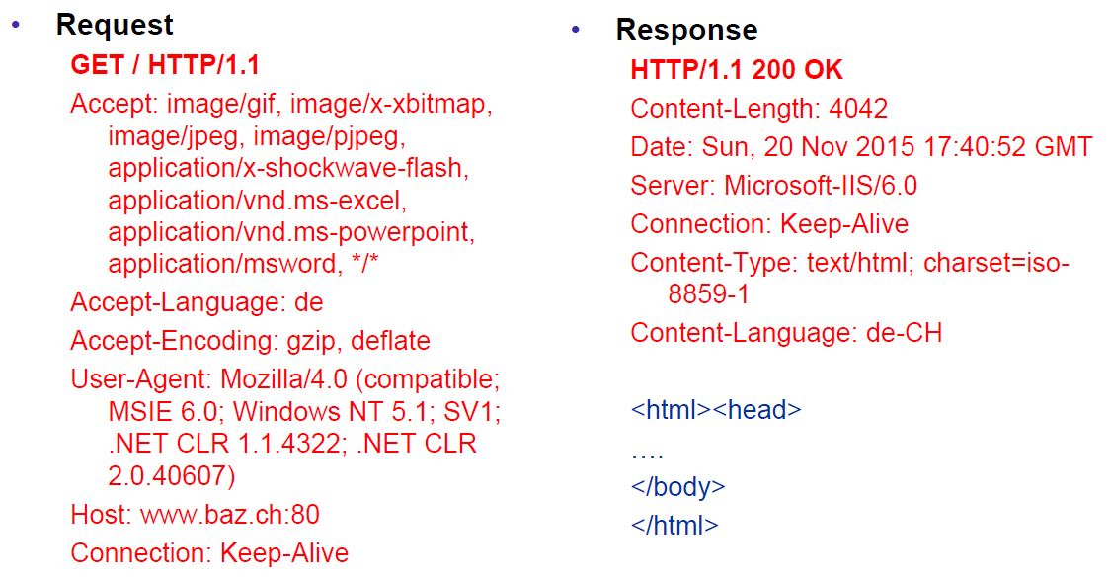

### HTTP 1.1 Enhancements

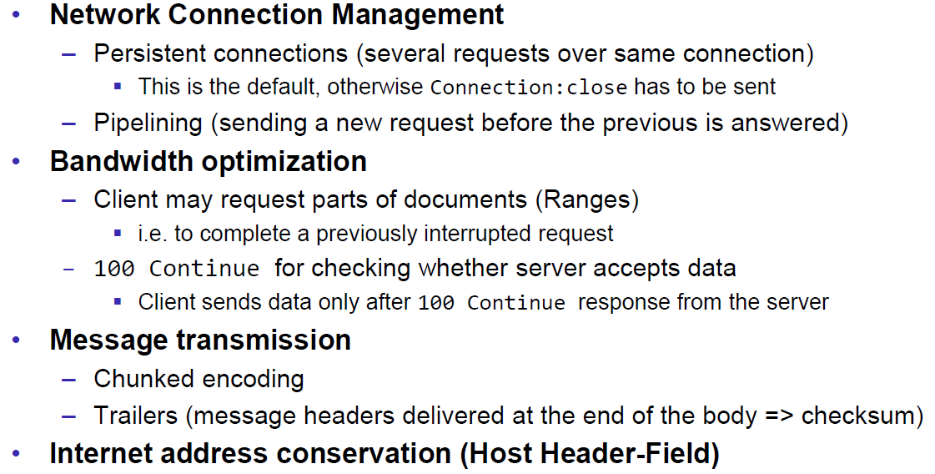

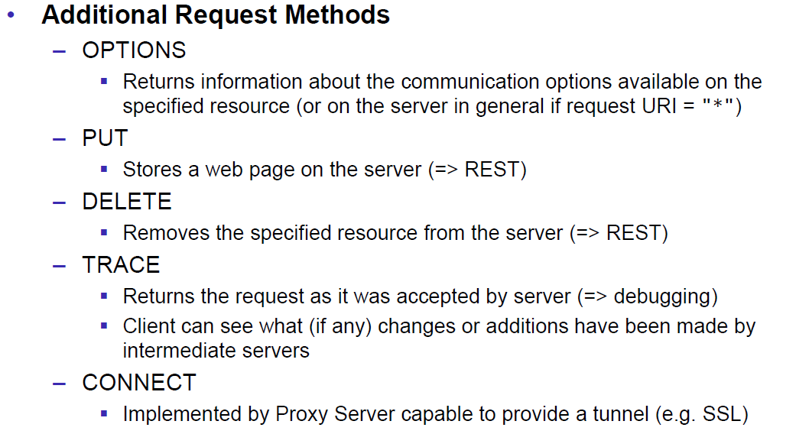

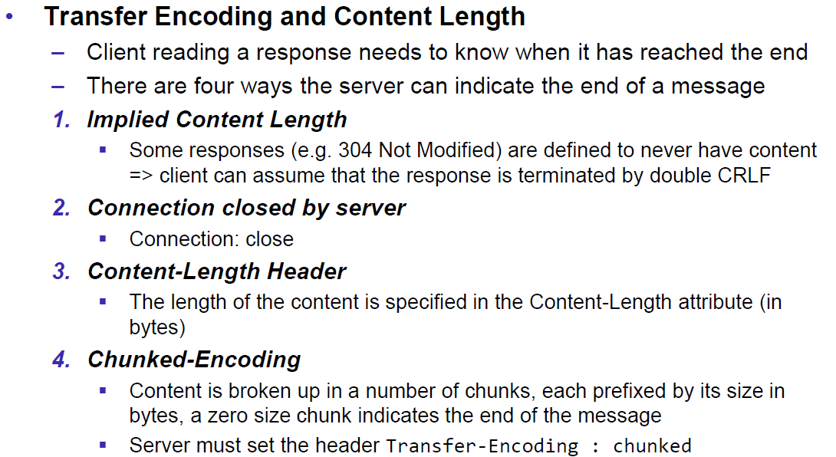

## HTTP Web Server

### A simple Web Server

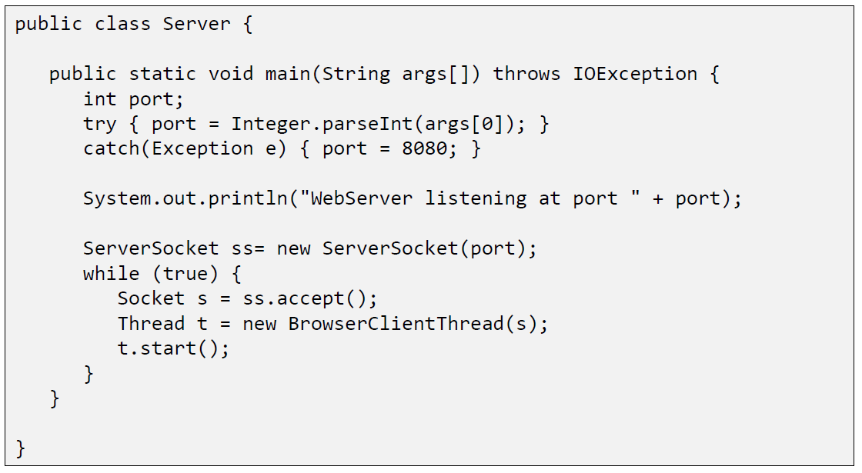

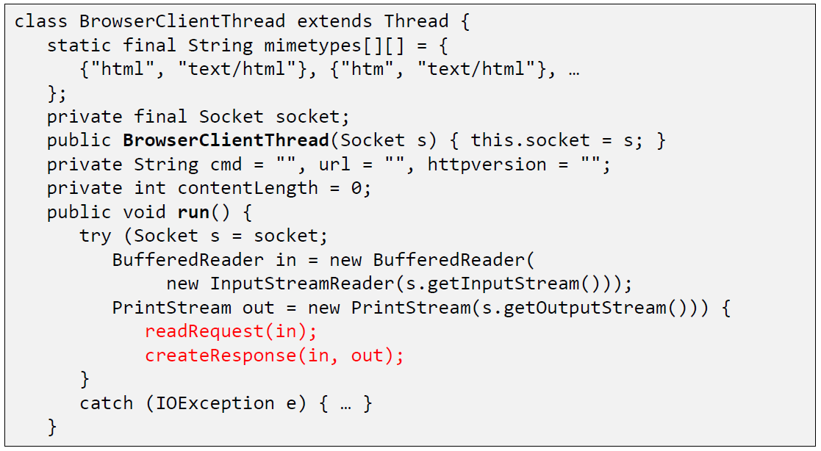

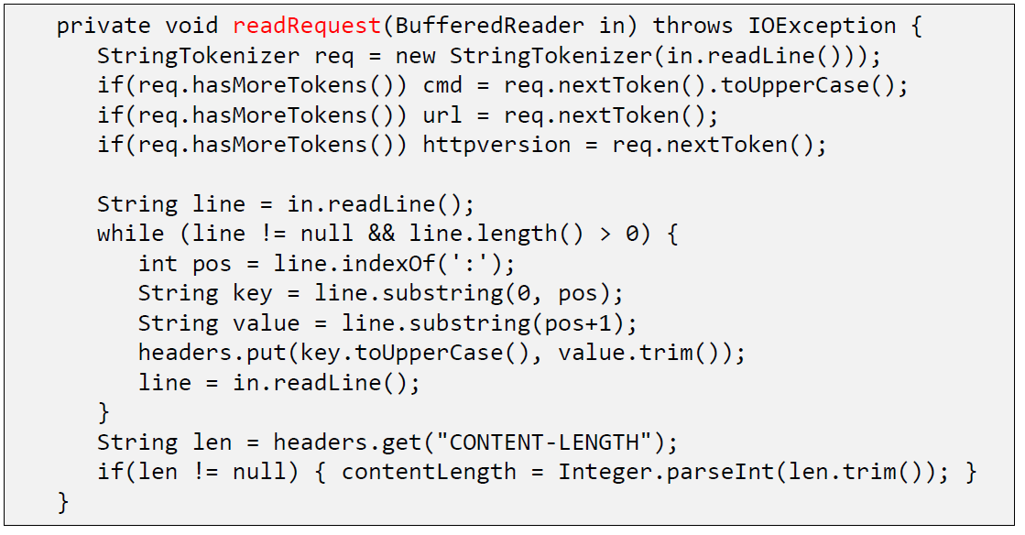

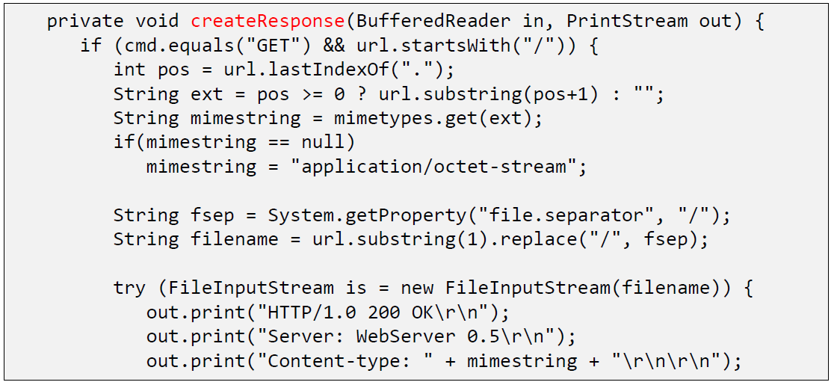

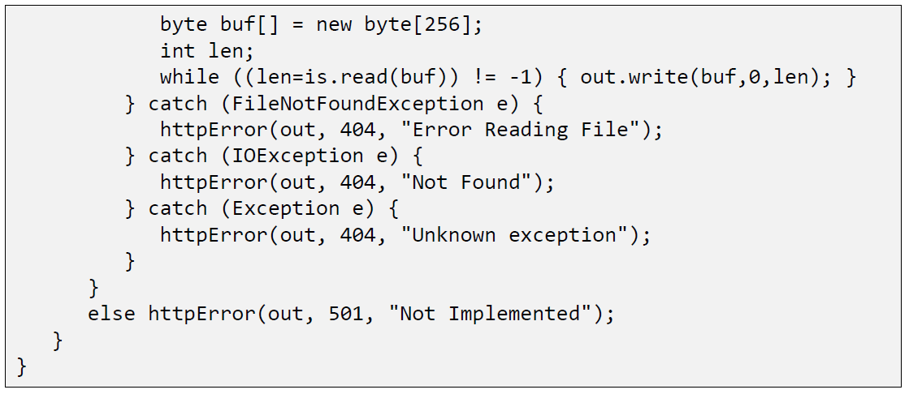

### Java internal Web Server

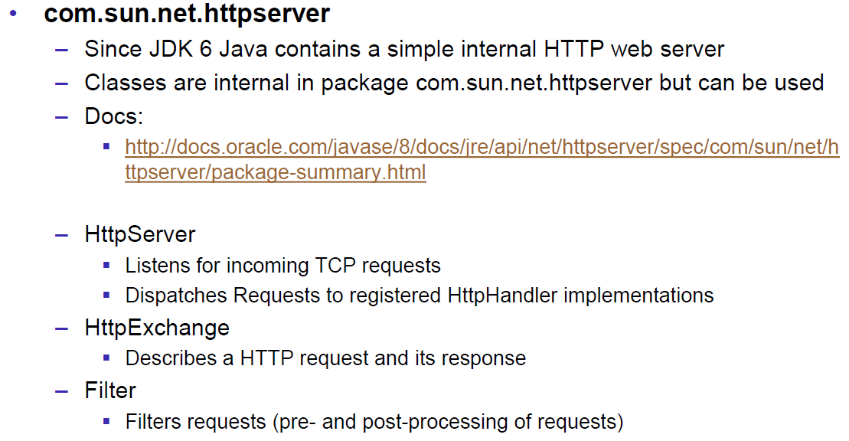

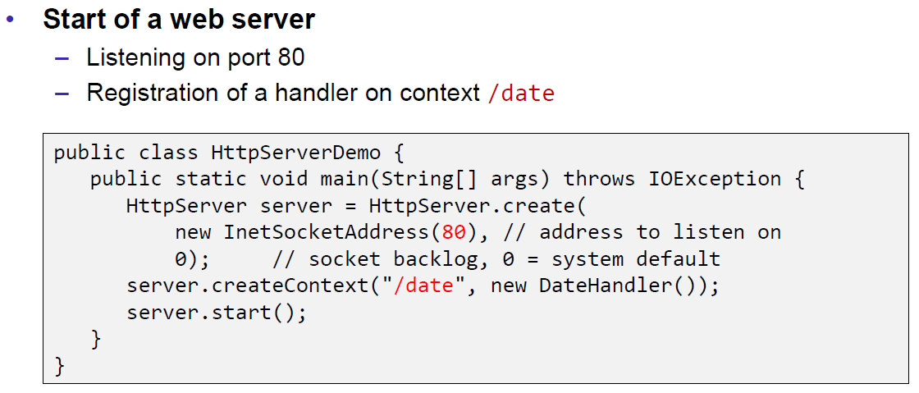

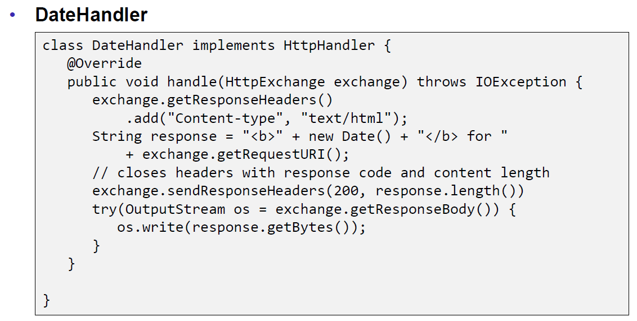

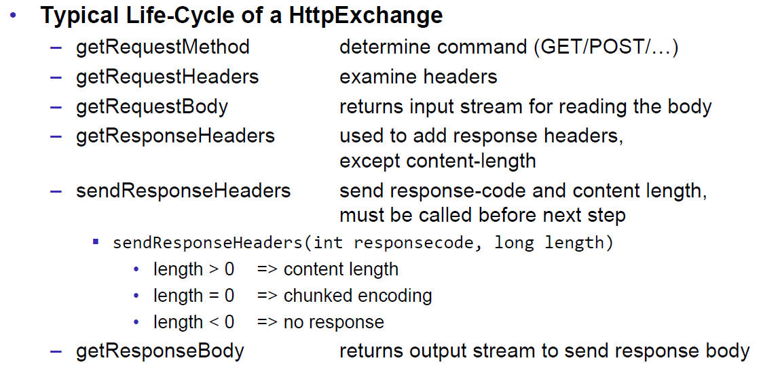

## HTML Forms & URL Encoding

### HTML GET Form

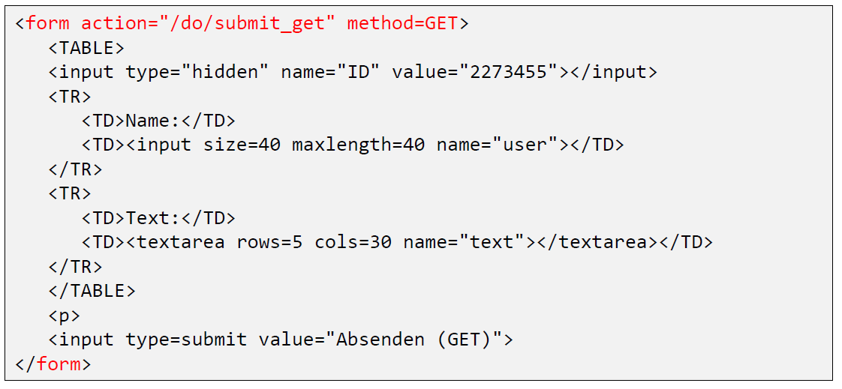

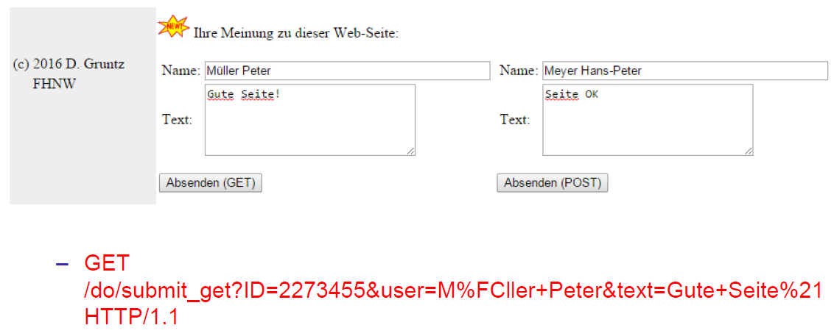

### URL Encoding

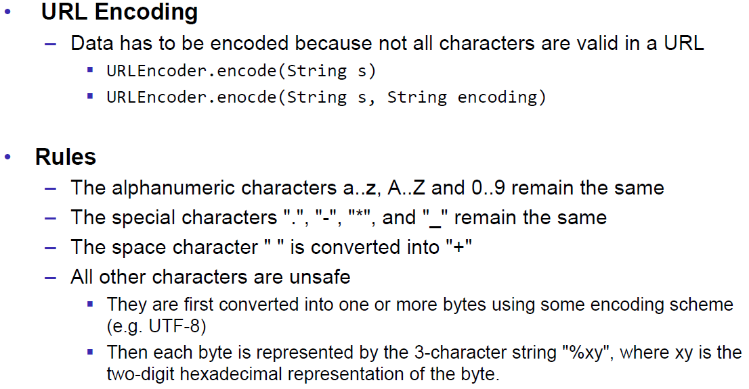

### HTML POST Form

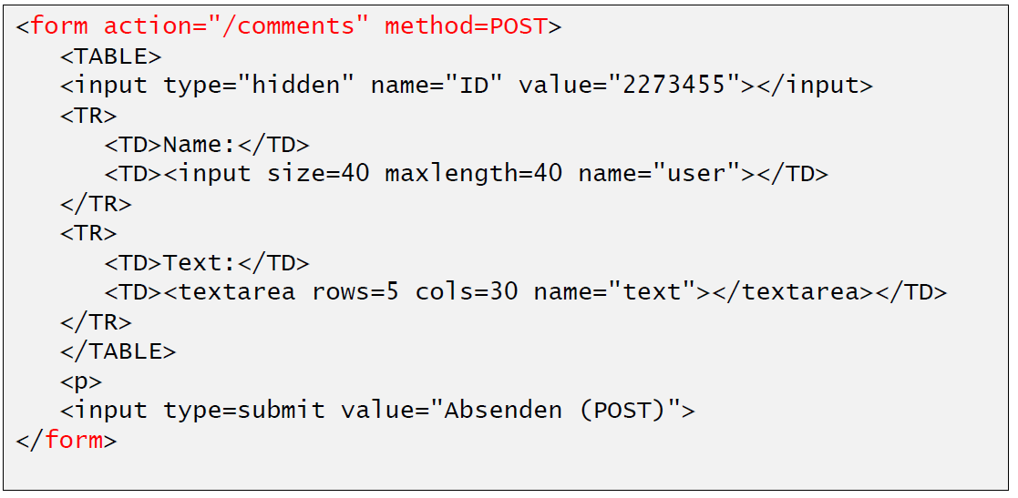

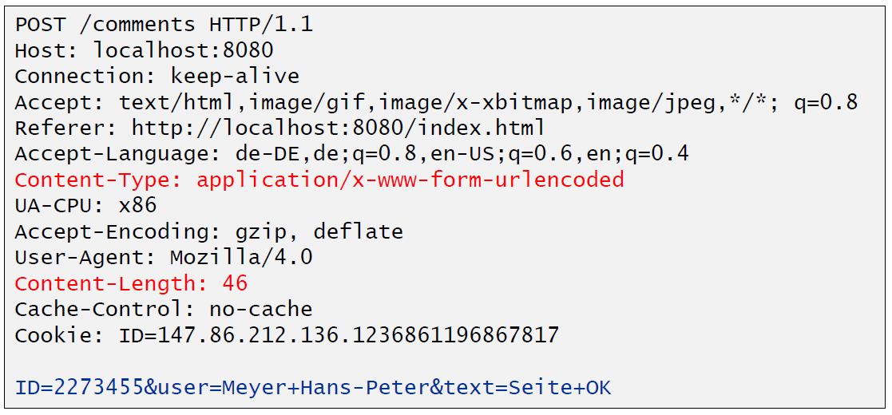

## HTTP Requests from Java

### URL

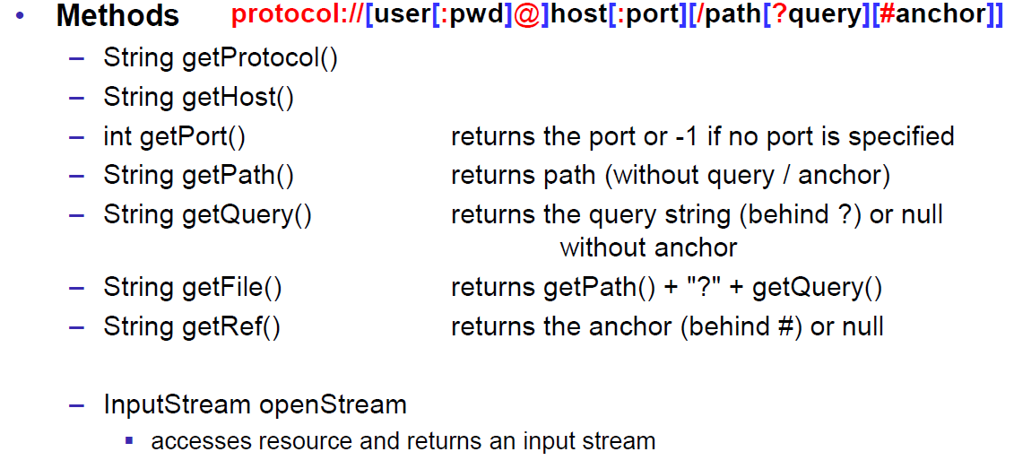

### Sending GET Requests from within Java

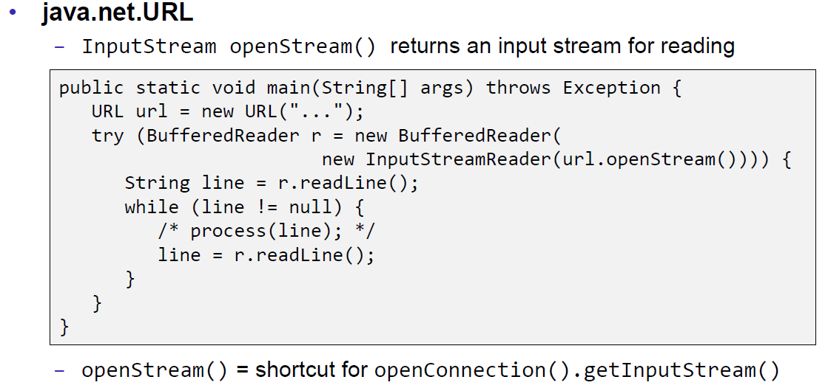

### URLConnection

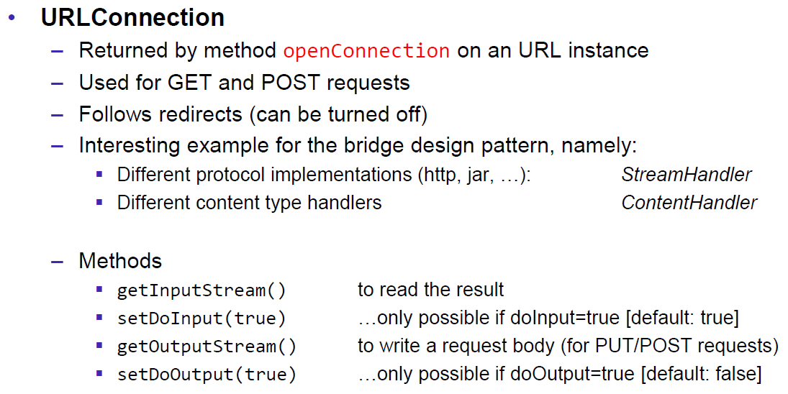

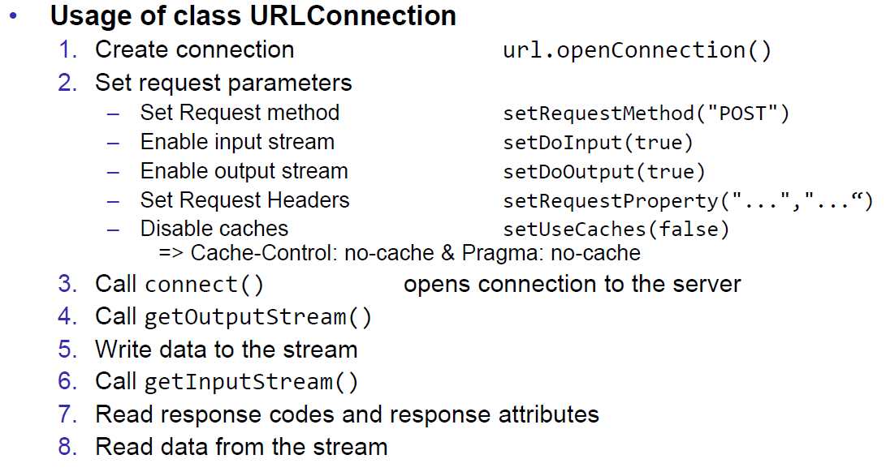

### URLConnection Tips & Tricks

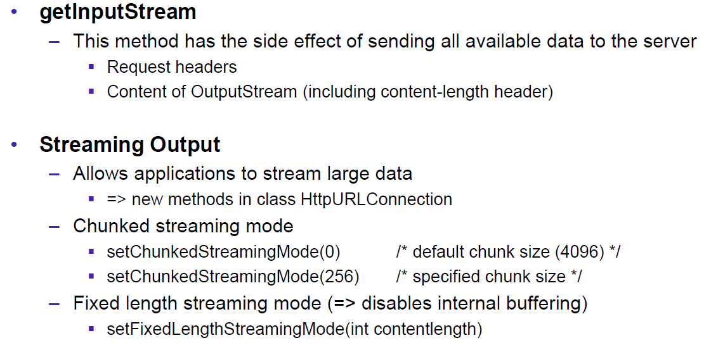

### Sample 1: URLConnection GET

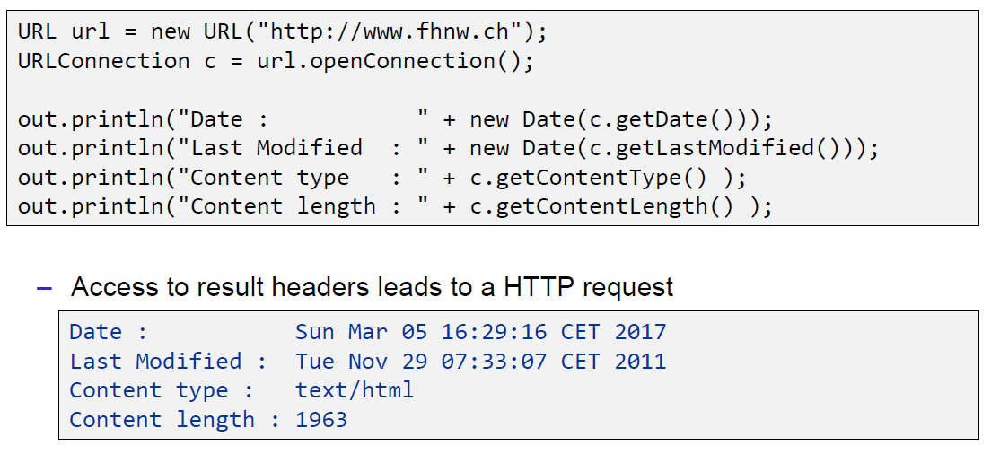

### Sample 2: URLConnection POST

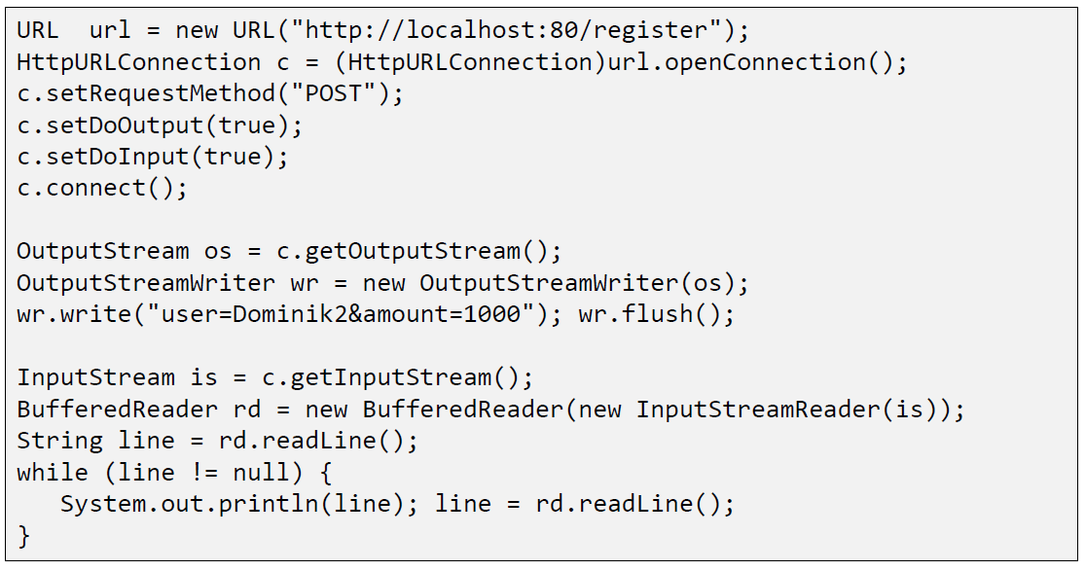

### Sample 3: Currency Converter

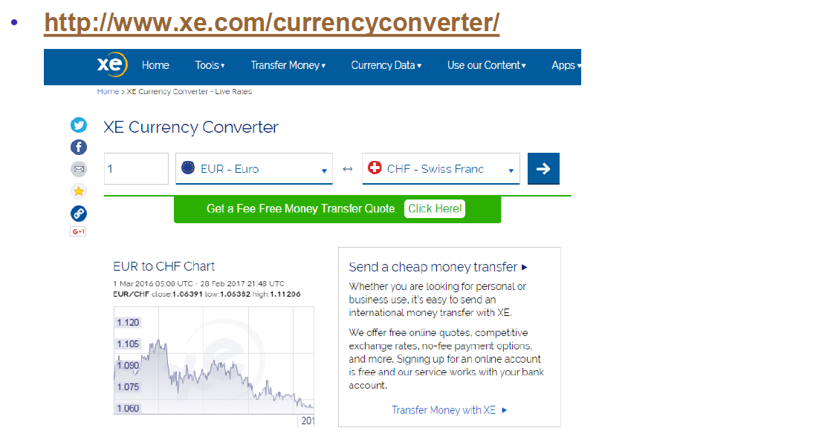

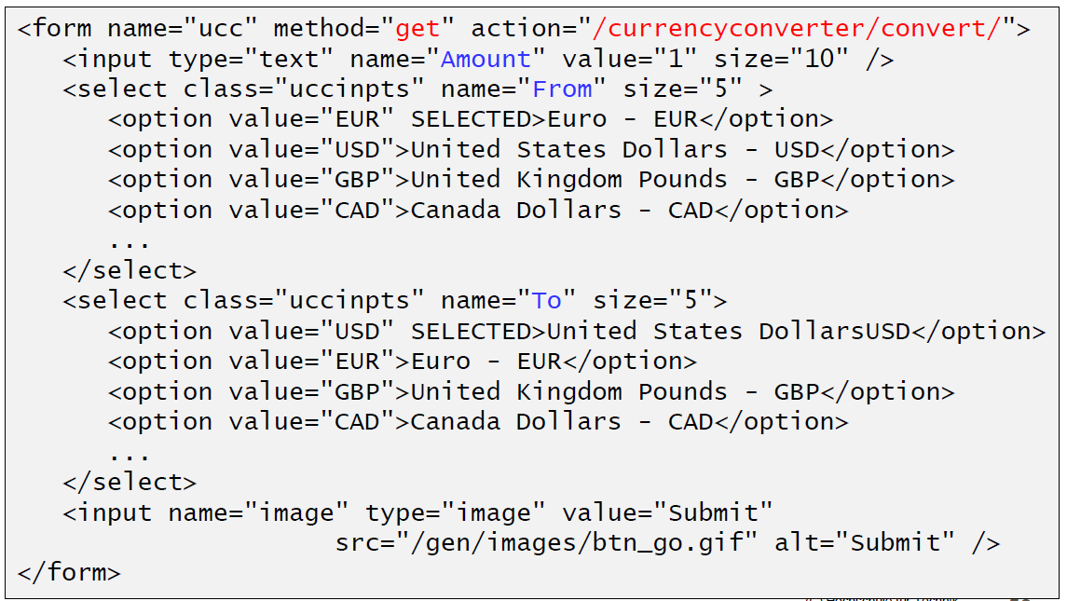

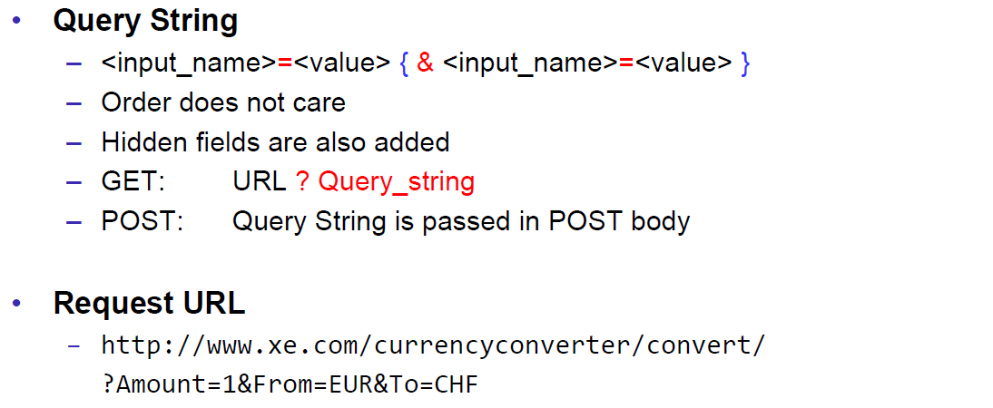

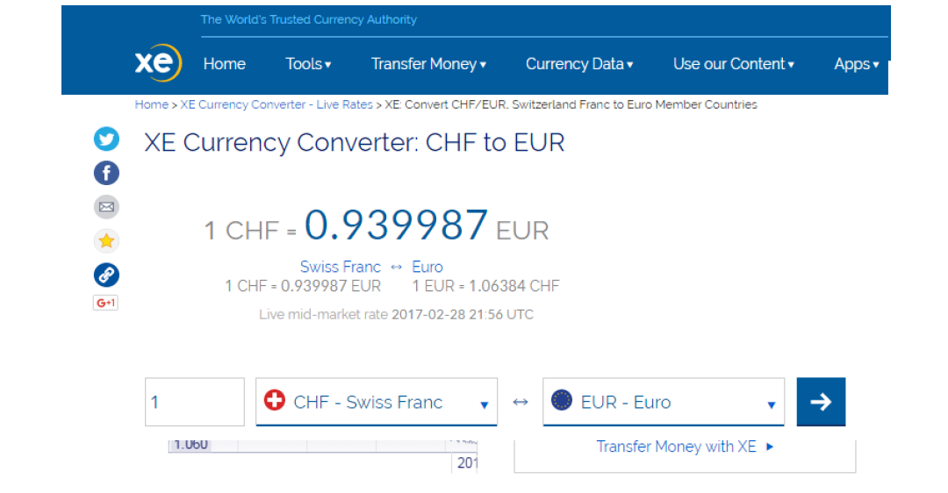

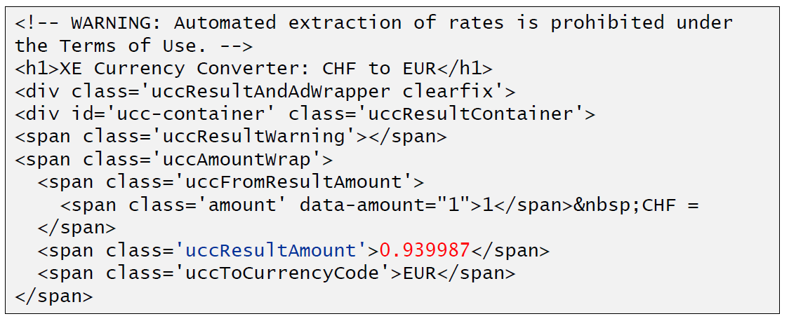

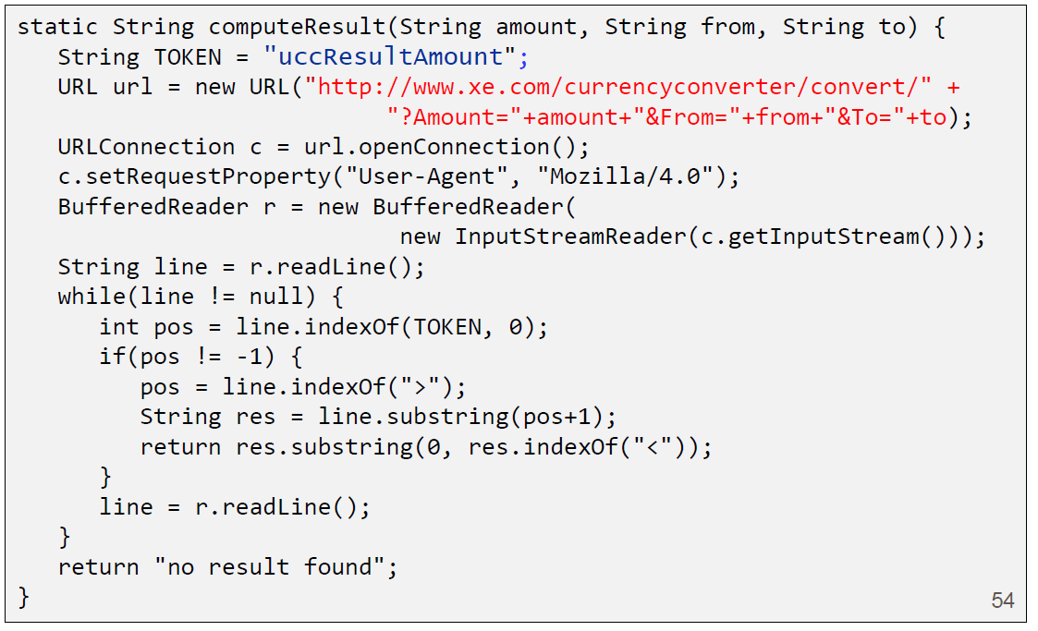

### Other Libraries

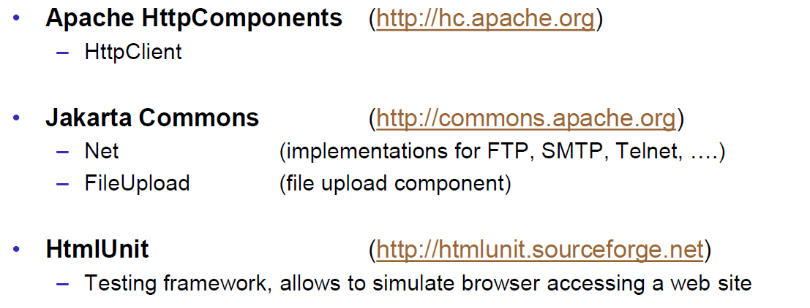

# Woche 4

## Servlets

### Servlet Specification

### Dynamic Content

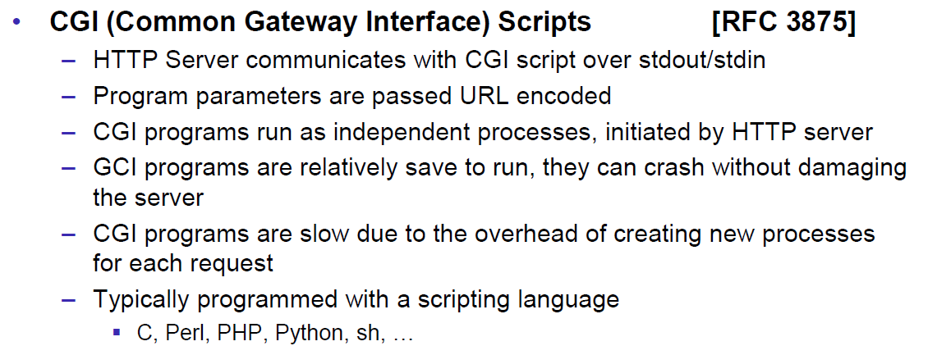

### Servlets

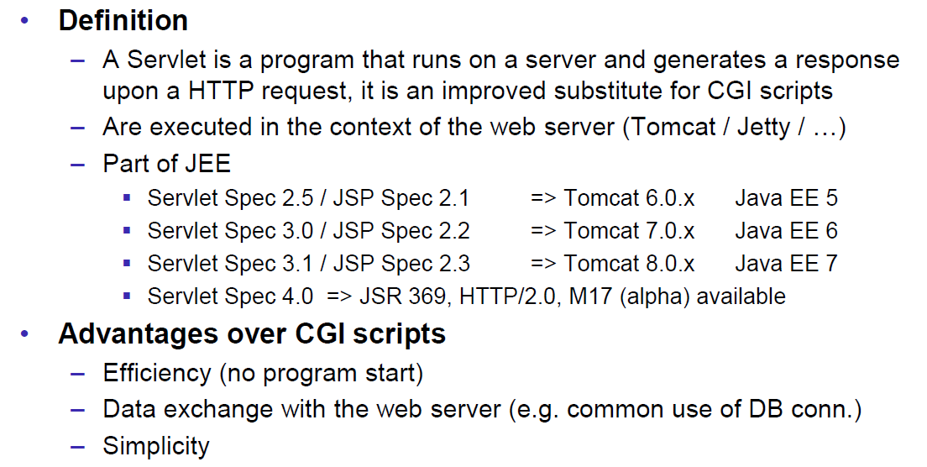

### Servlet Packages

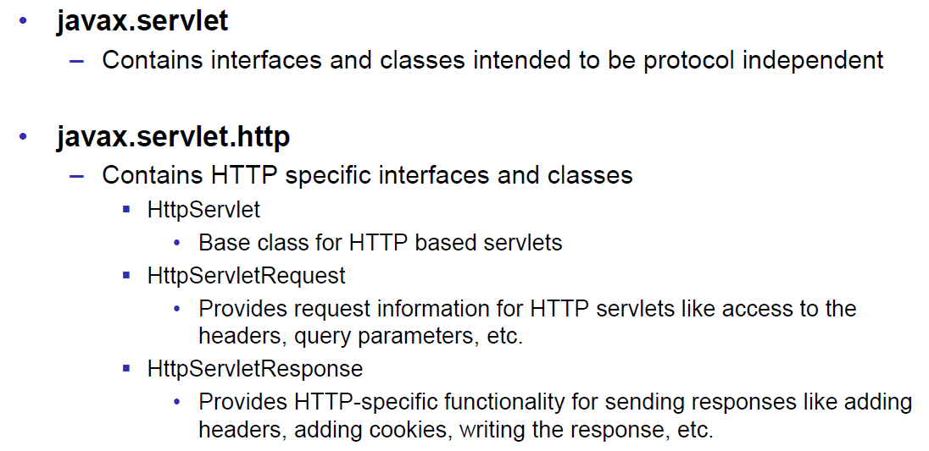

### Servlet Life-Cycle Methods

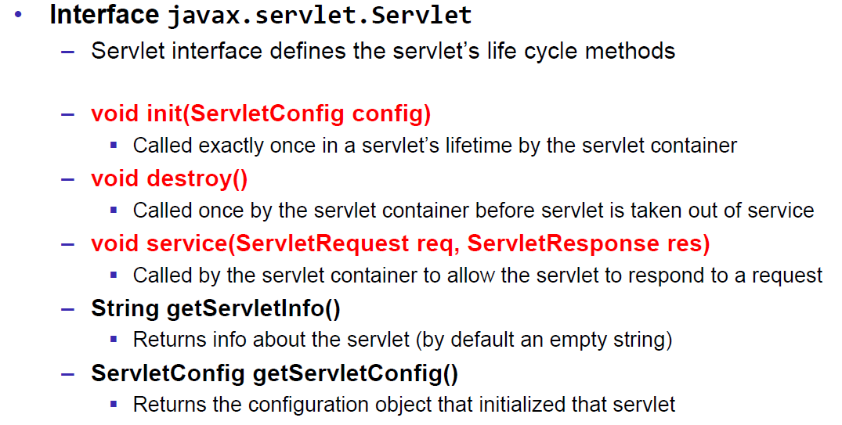

### HttpServlet

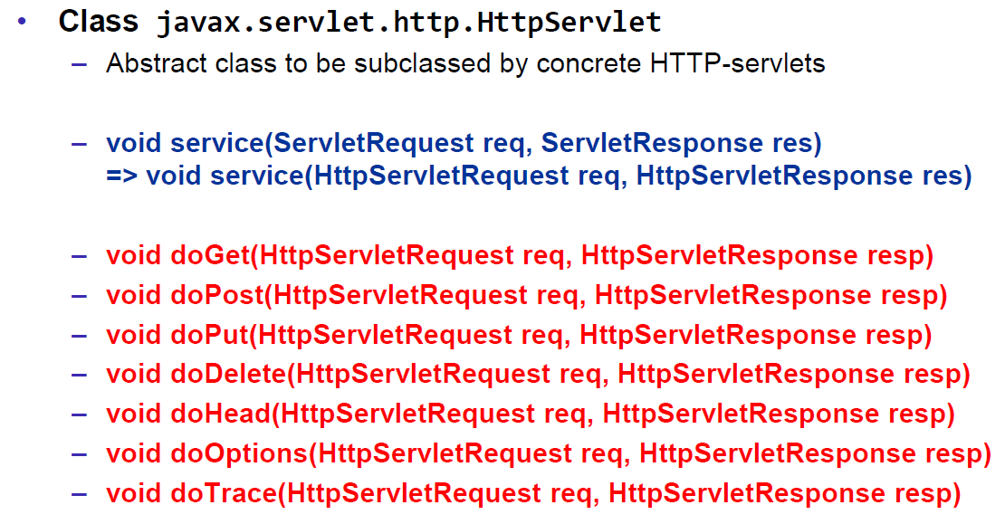

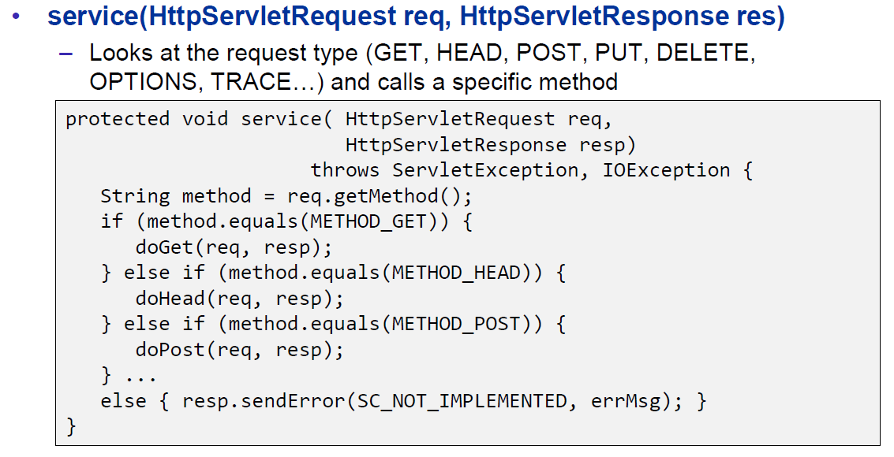

### HttpServletRequest

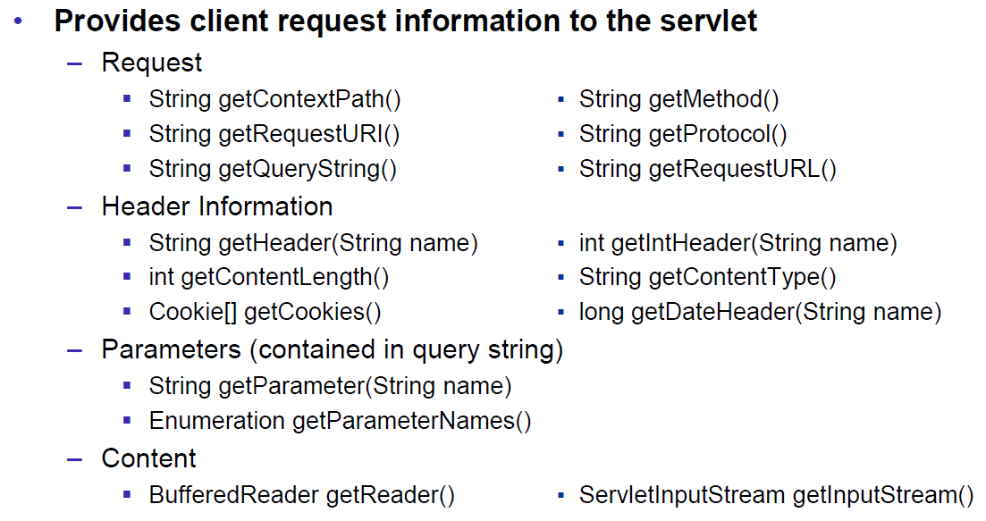

### HttpServletResponse

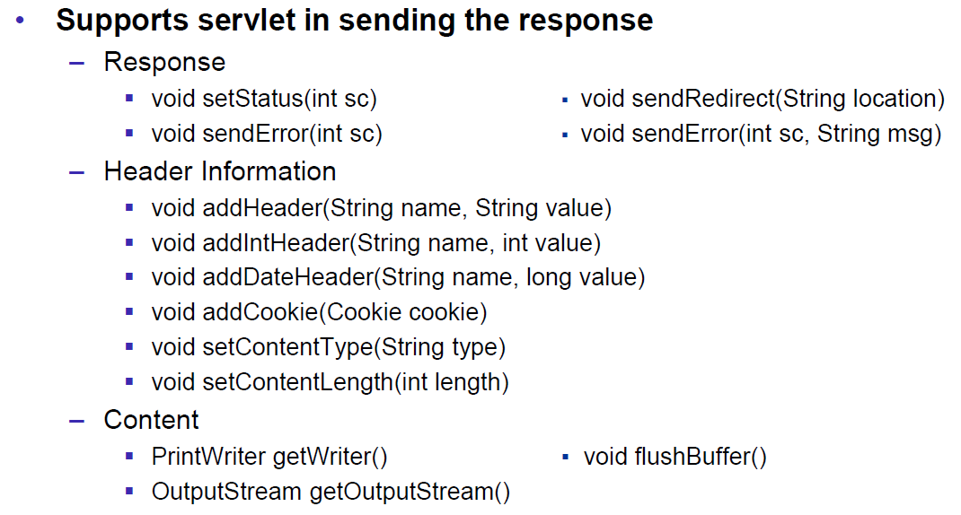

### Servlet Example

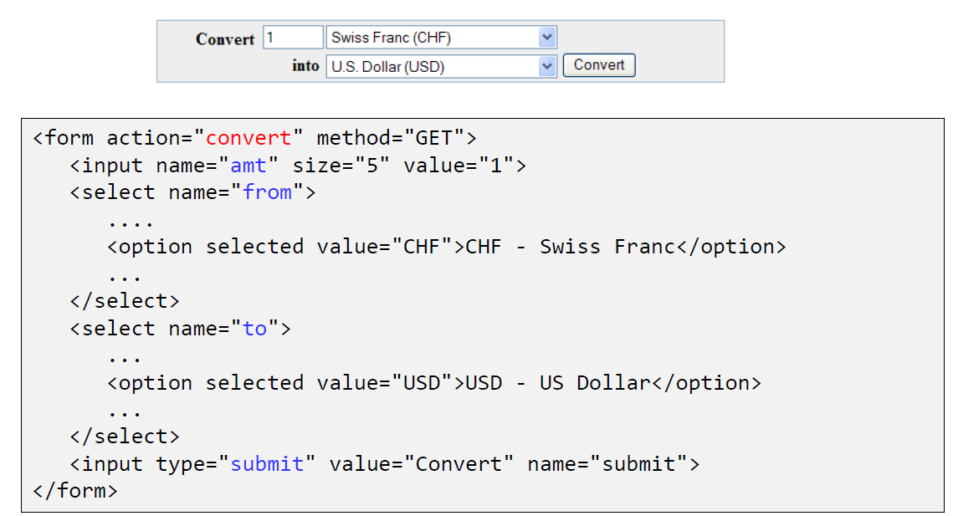

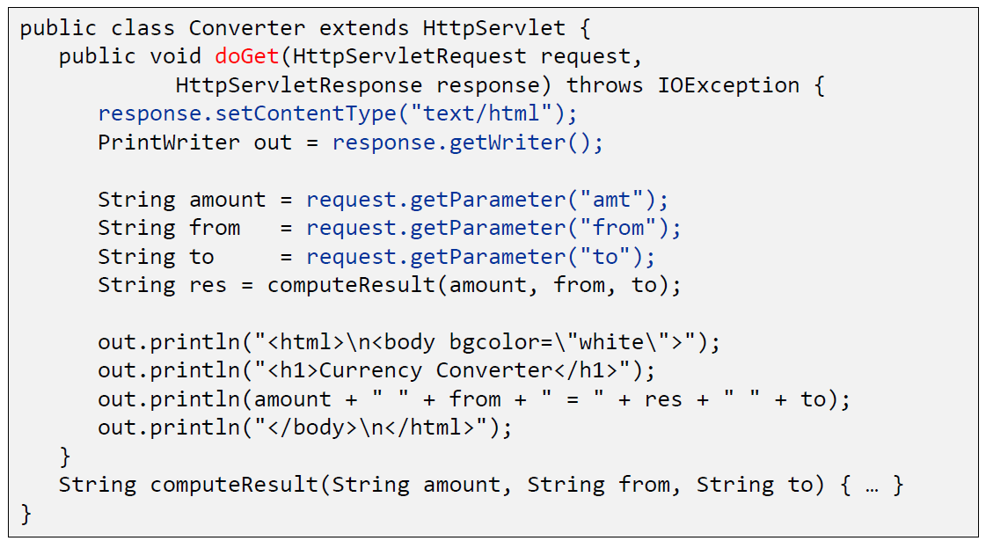

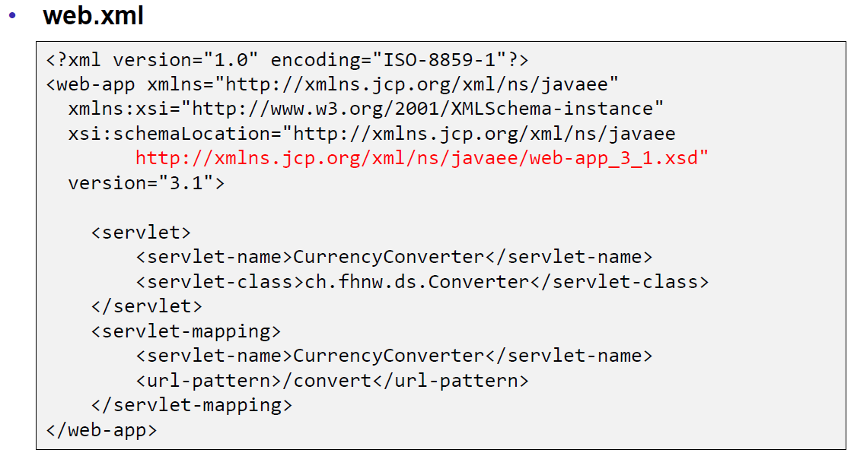

### Webapplication Structure

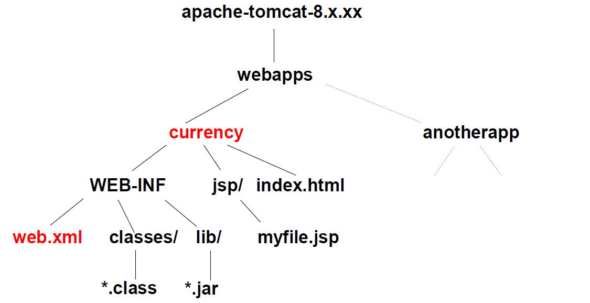

### Annotation WebServlet

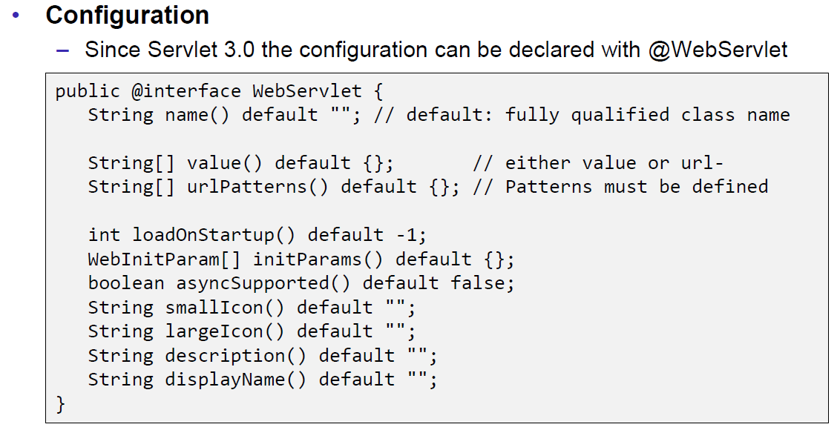

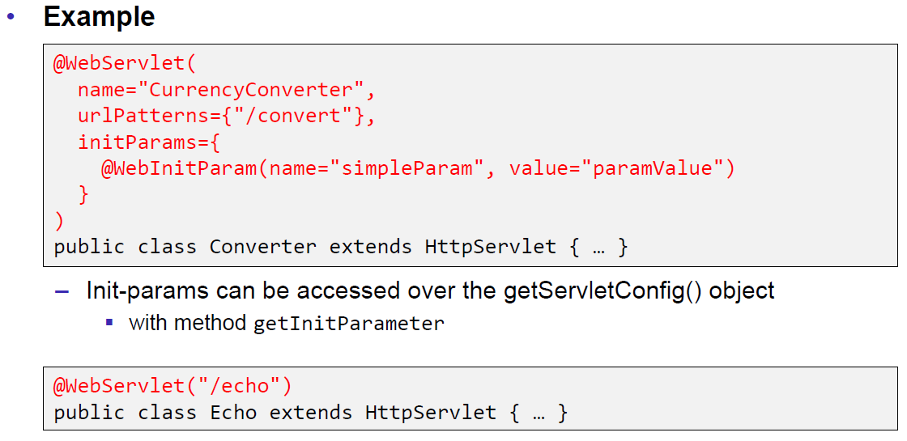

### Webapplication Structure

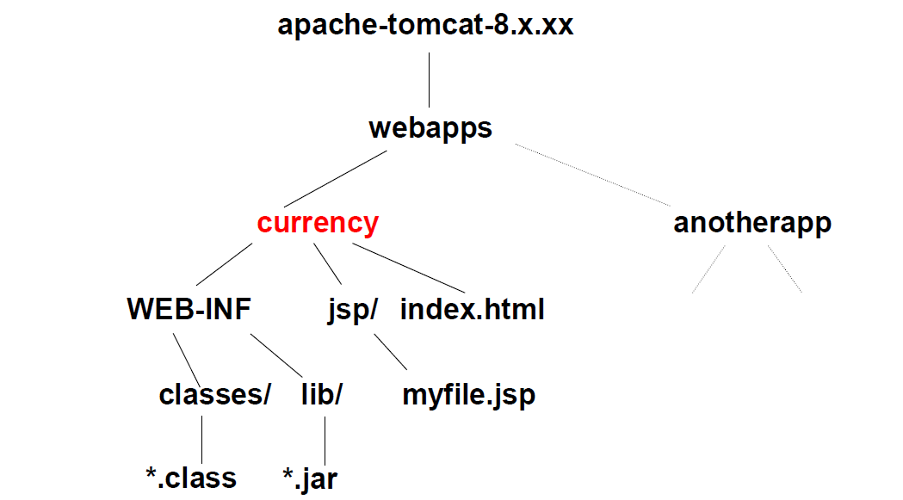

## Tomcat Servlet Server

### Tomcat

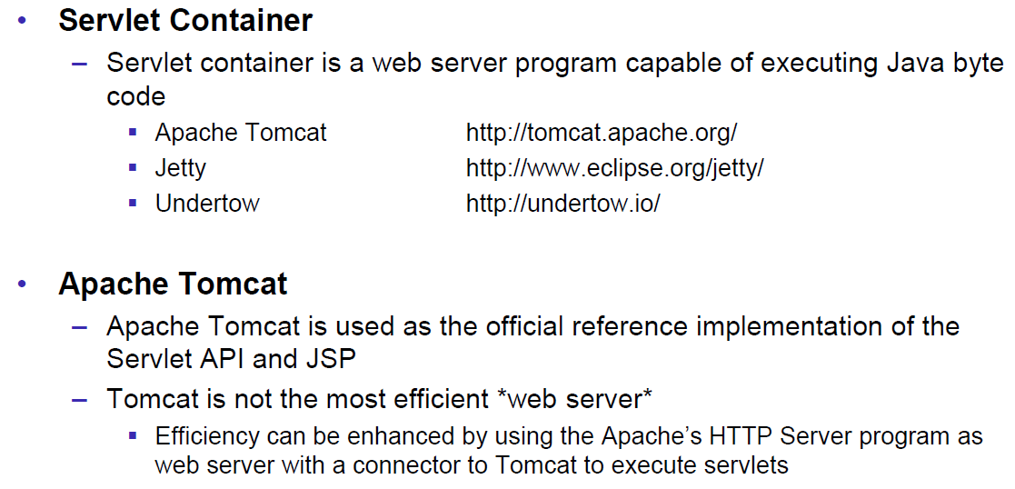

### Tomcat Directory Structure

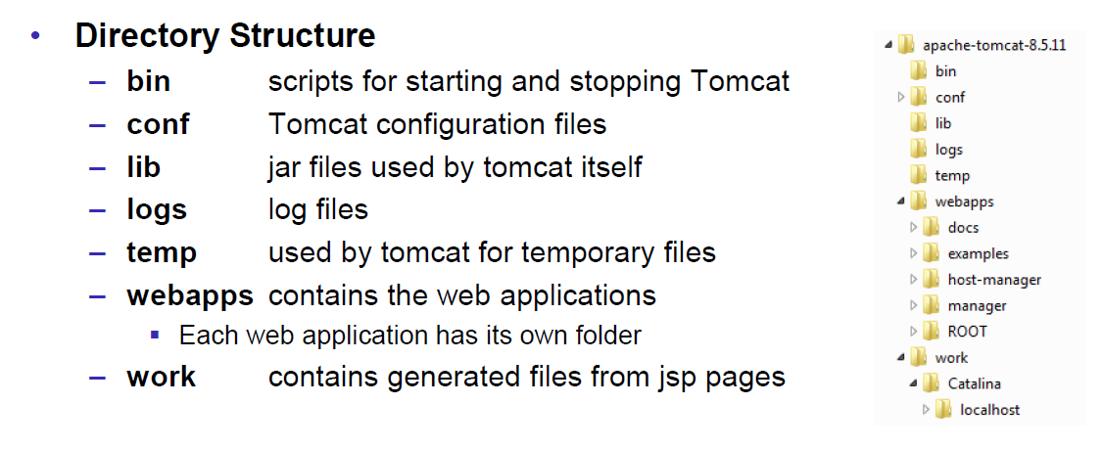

### Tomcat Scripts

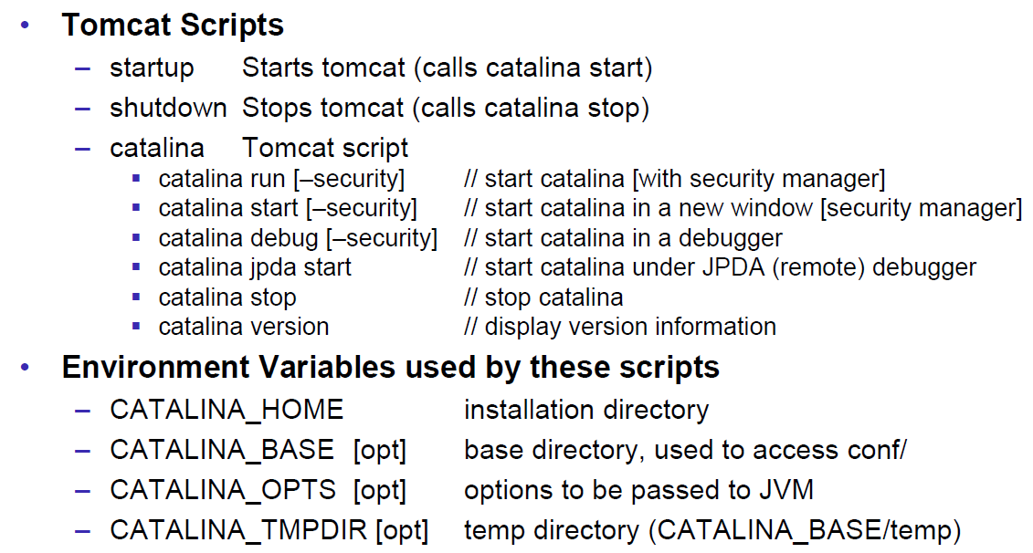

### Tomcat Startup Screen

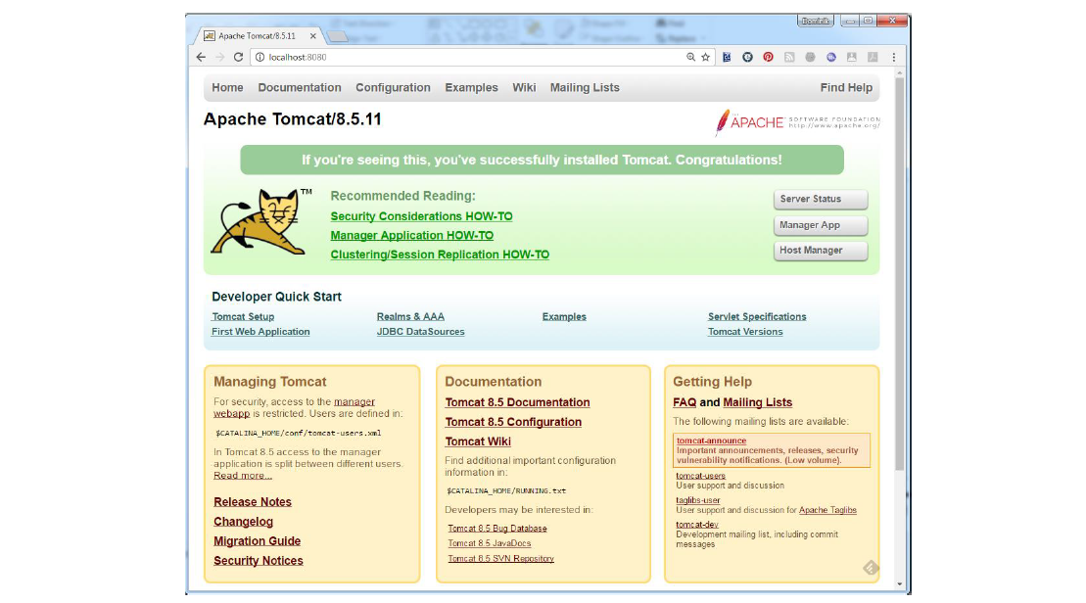

### Tomcat Managers

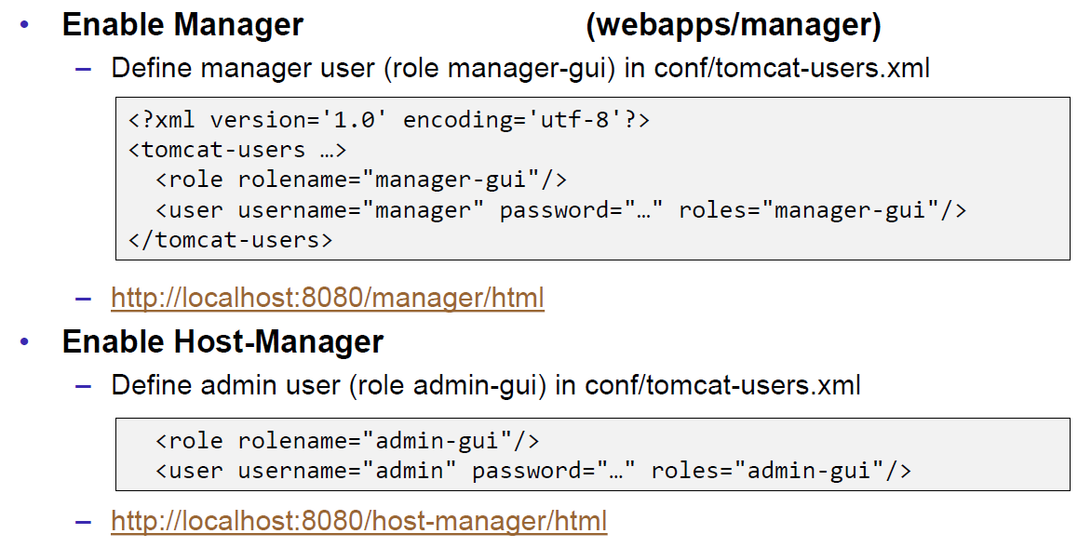

### Debugging

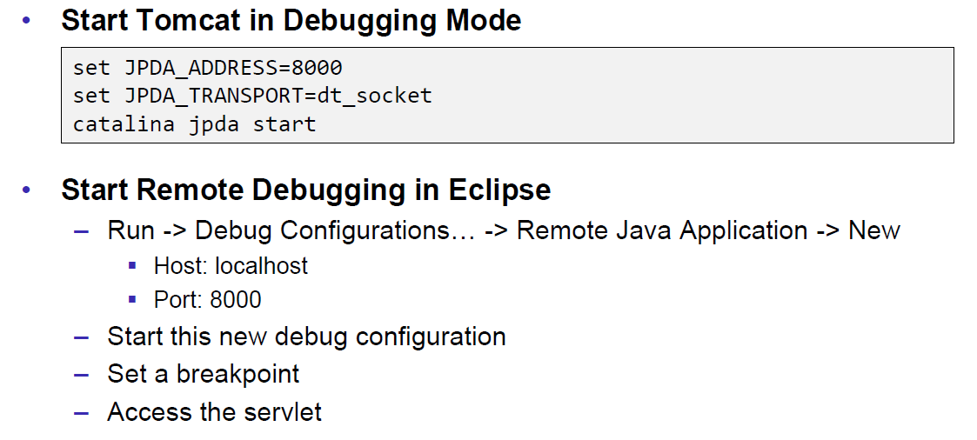

### Tomcat Architecture

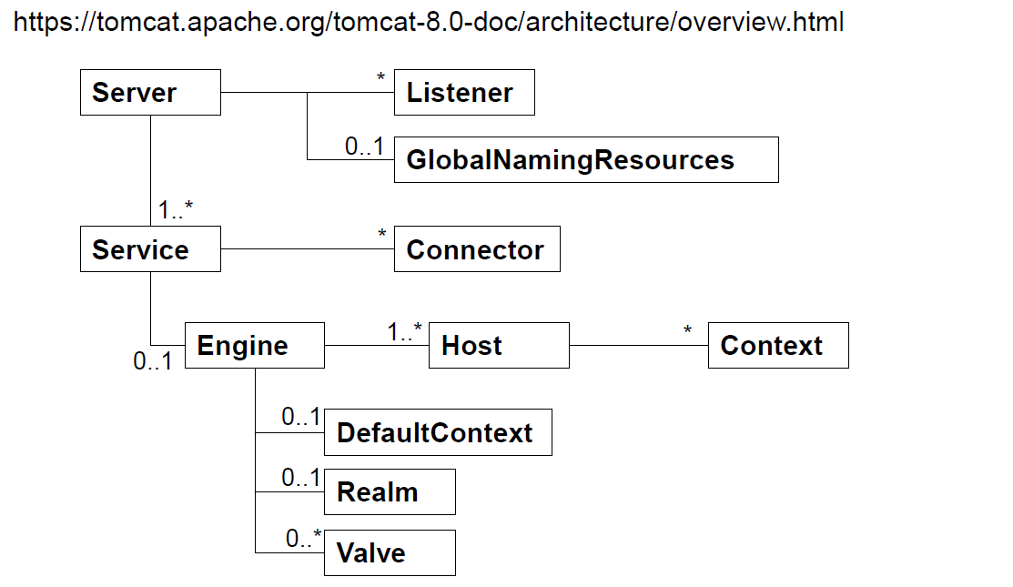

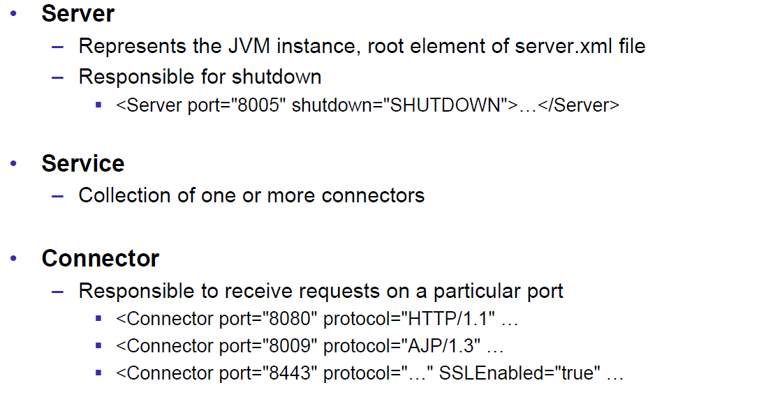

### Configuration of a Host

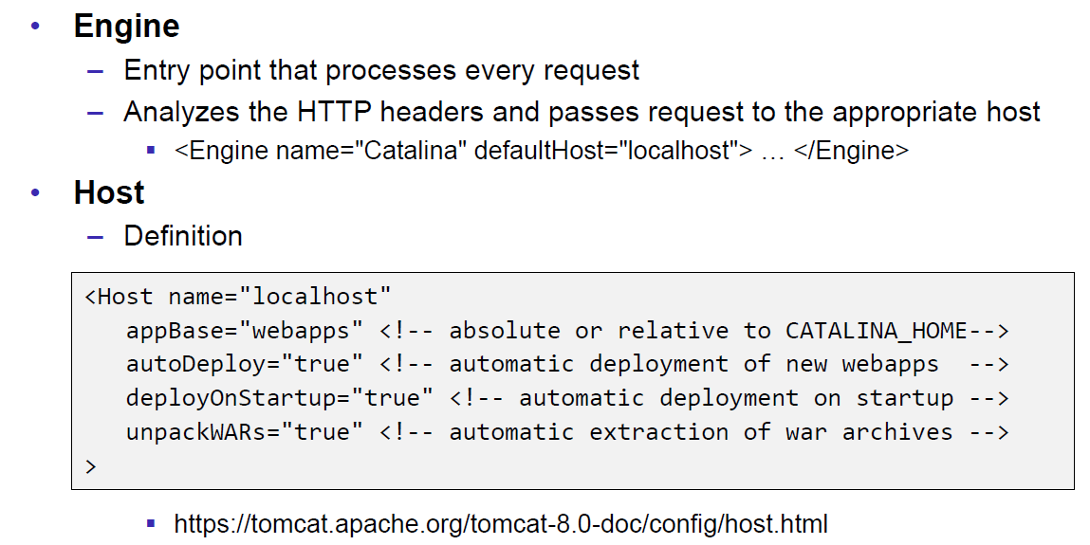

### Configuration of a Context

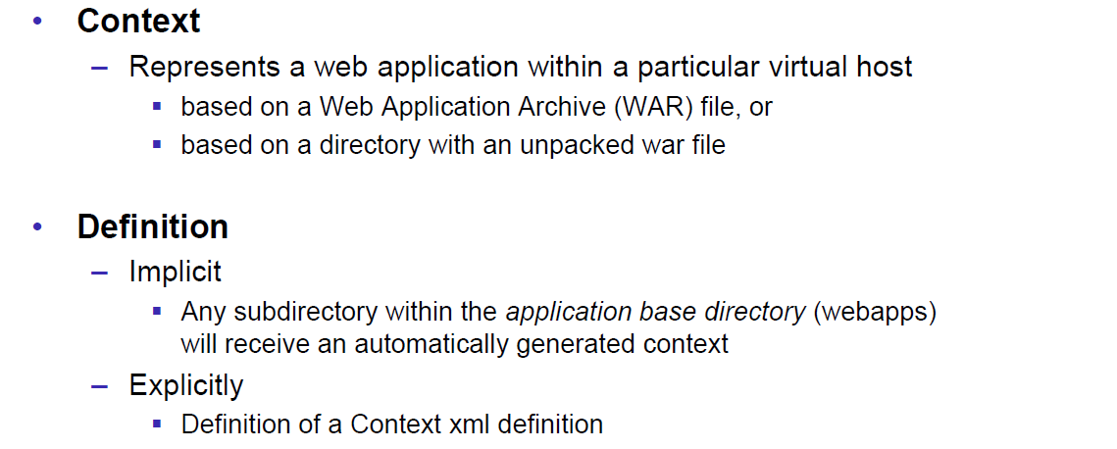

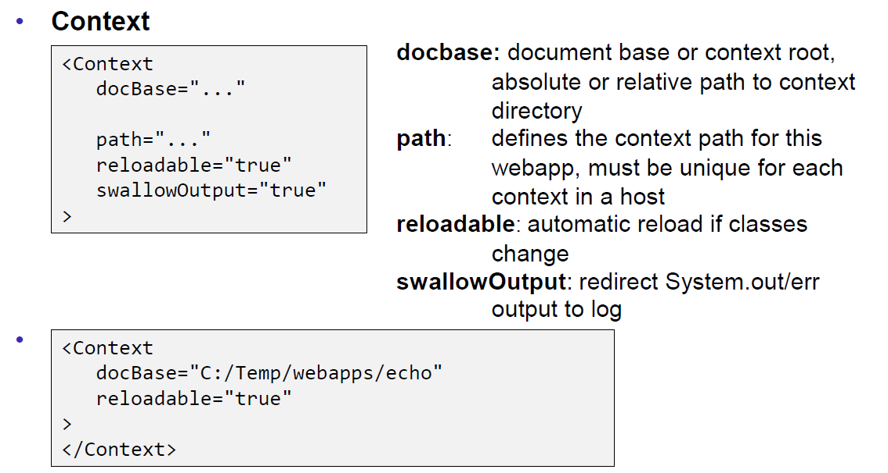

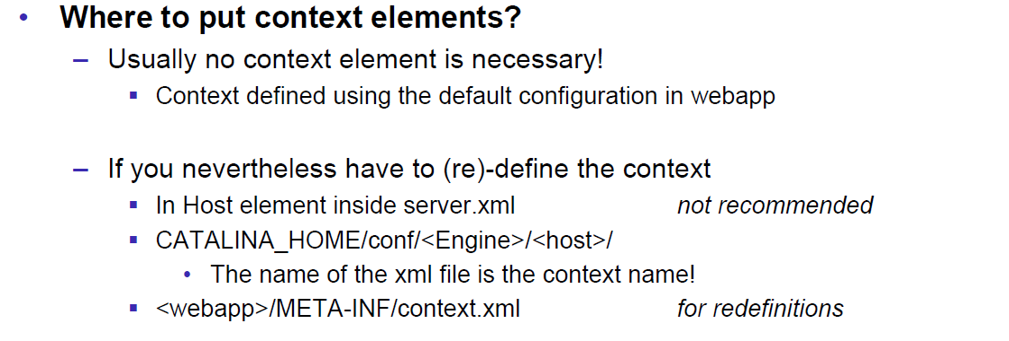

### Deployment while development

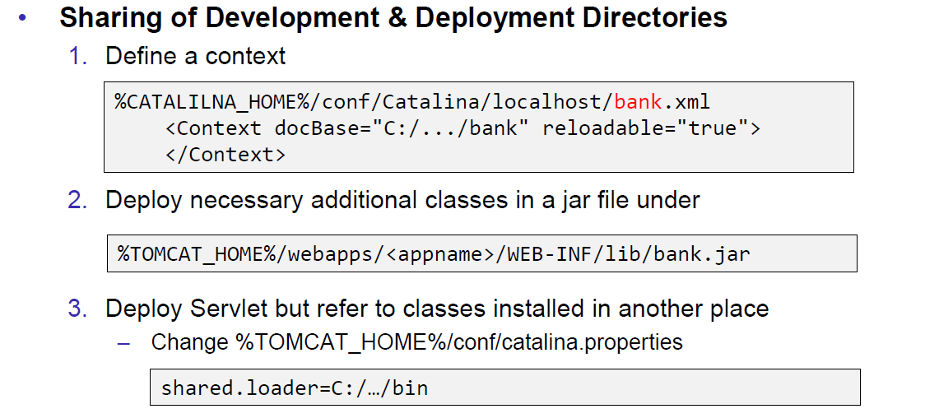

### Eclipse and Servlets (JEE Eclipse Version)

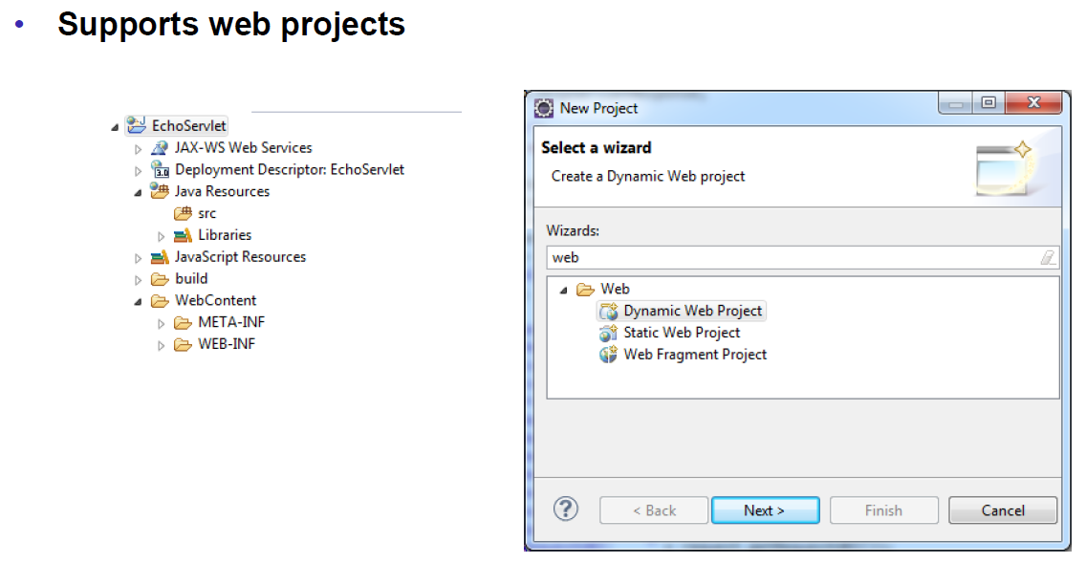

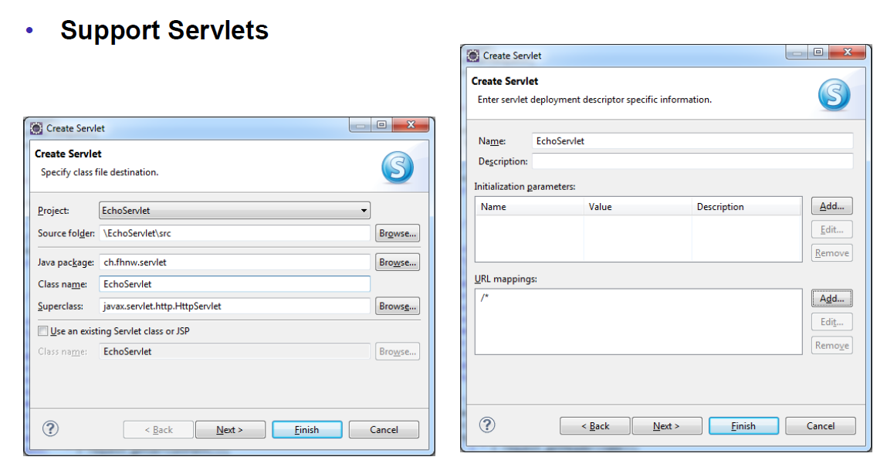

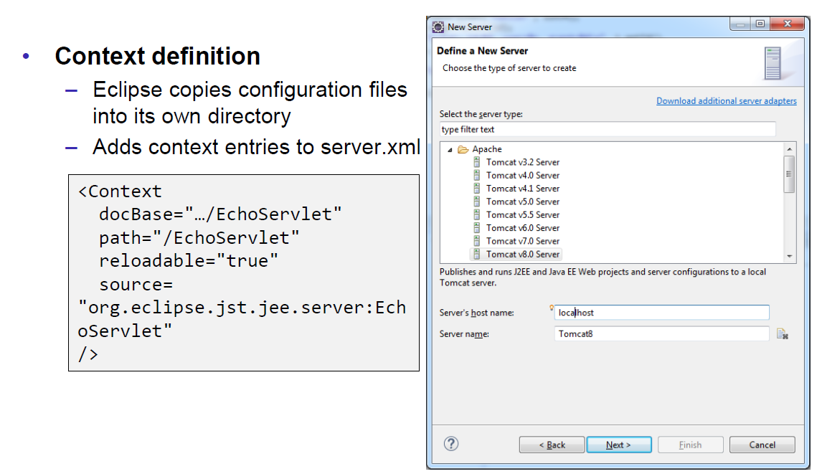

# Woche 5

## Motivation XML-RPX

### Services over HTTP (Currency Converter)

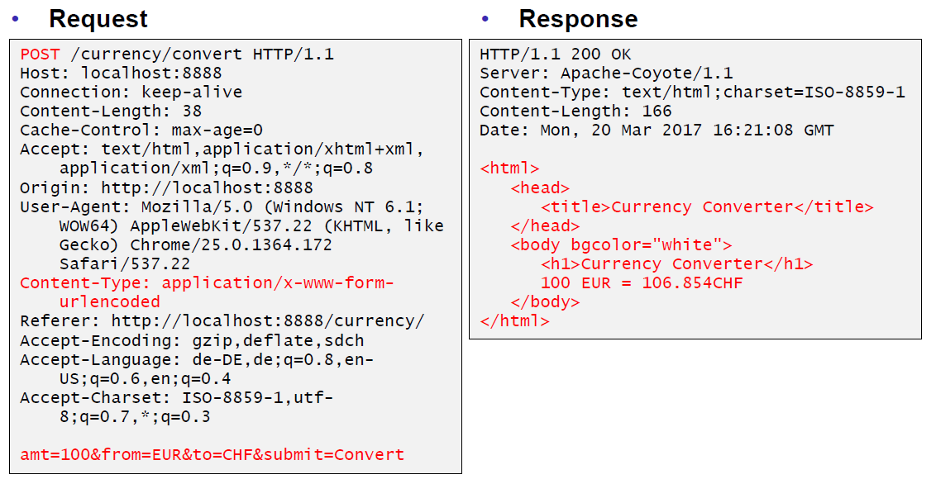

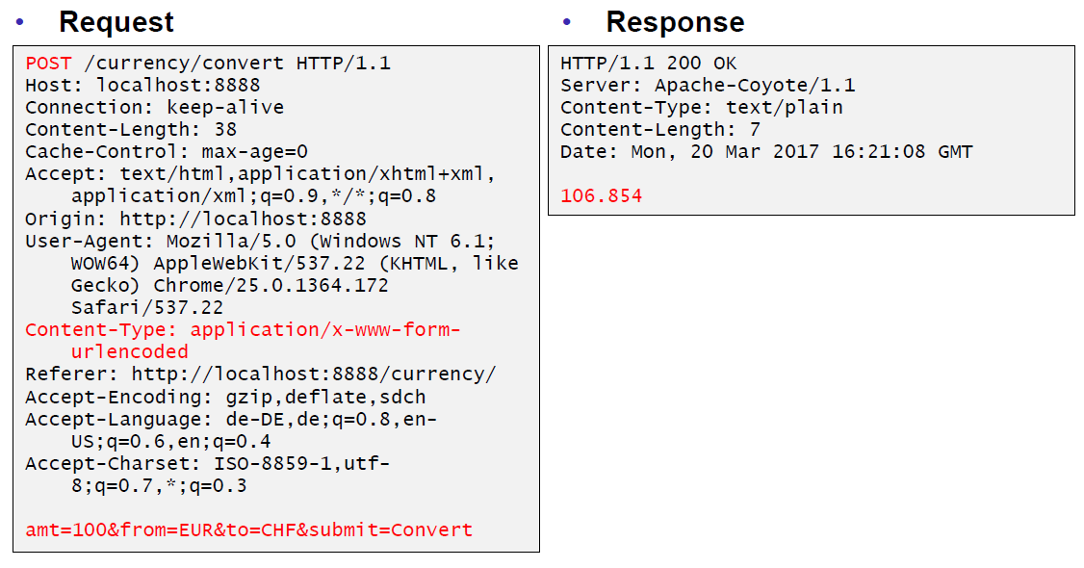

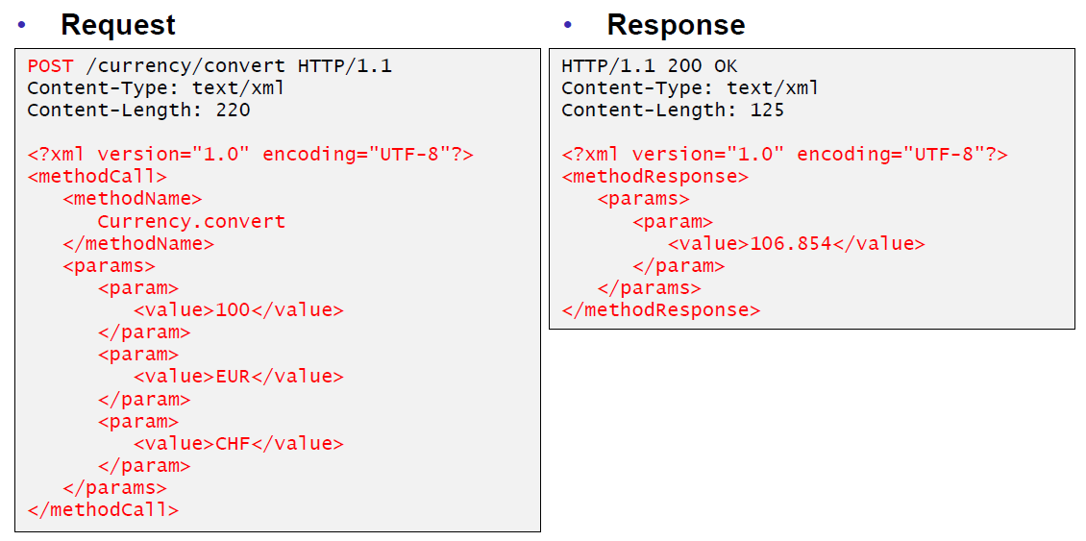

### XML-Remote Procedure Calls

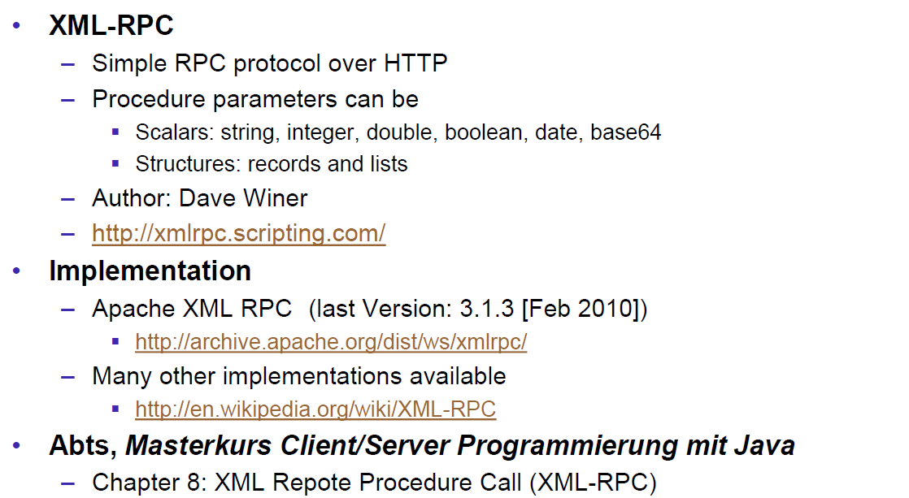

## SOAP und JAX-WS

### SOAP

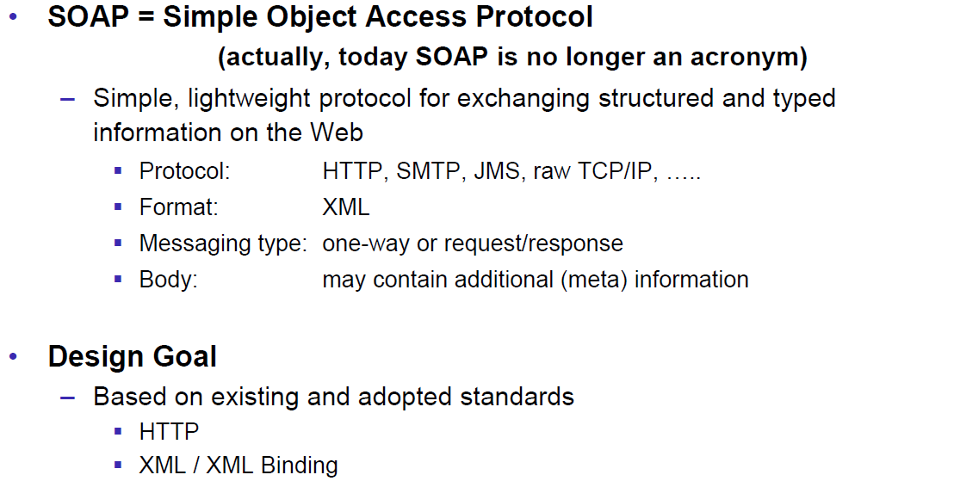

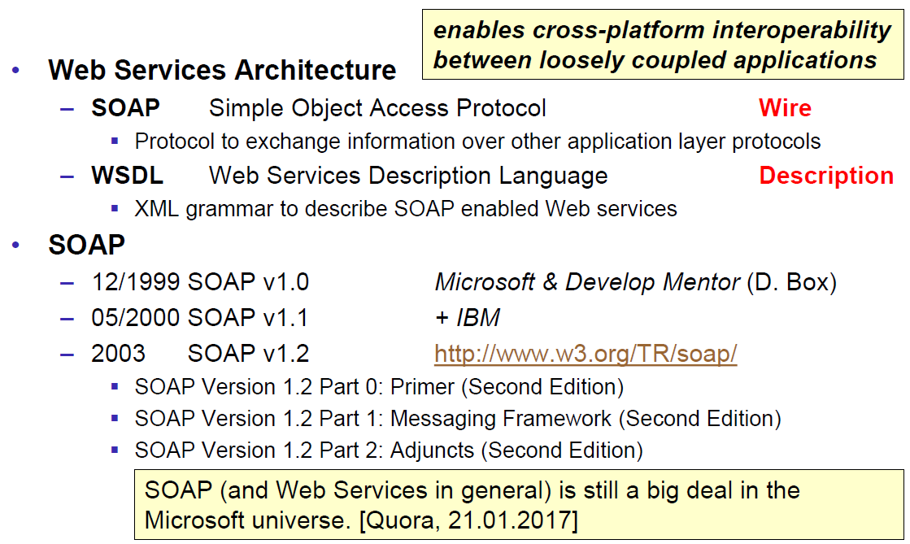

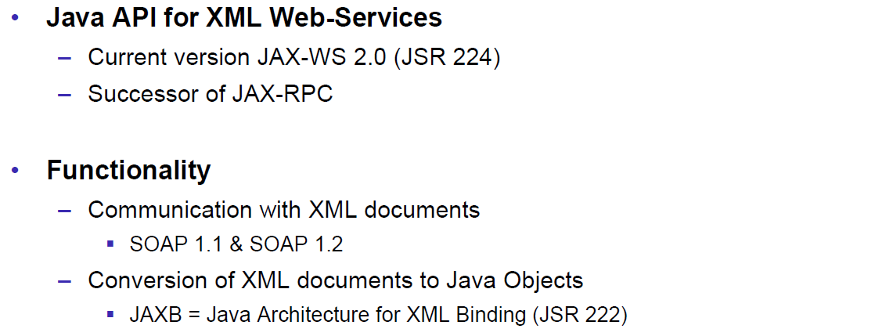

### JAX-WS

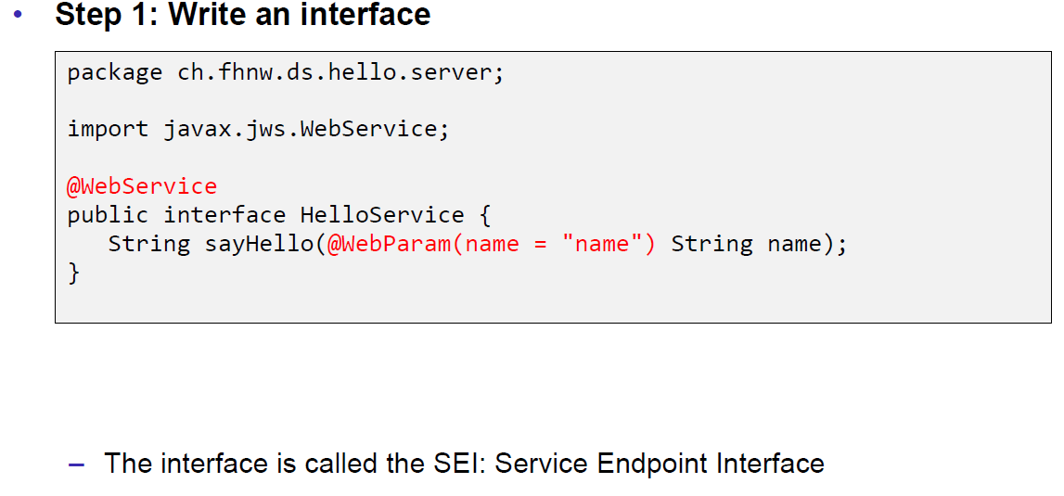

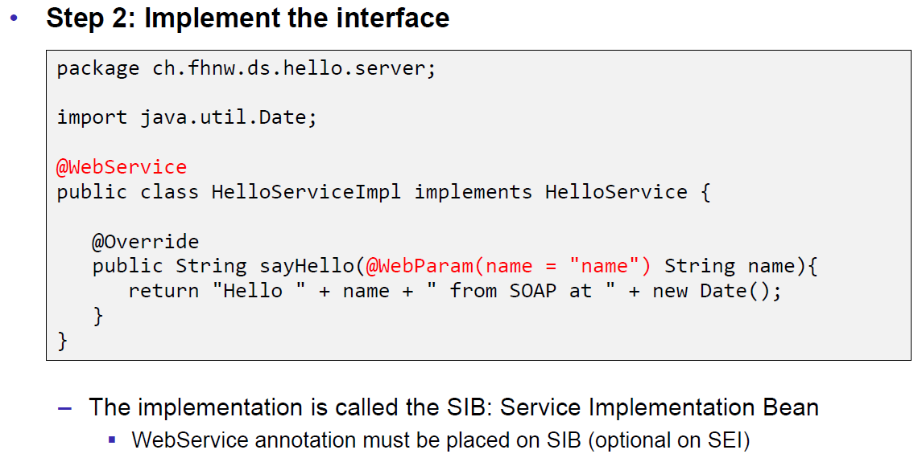

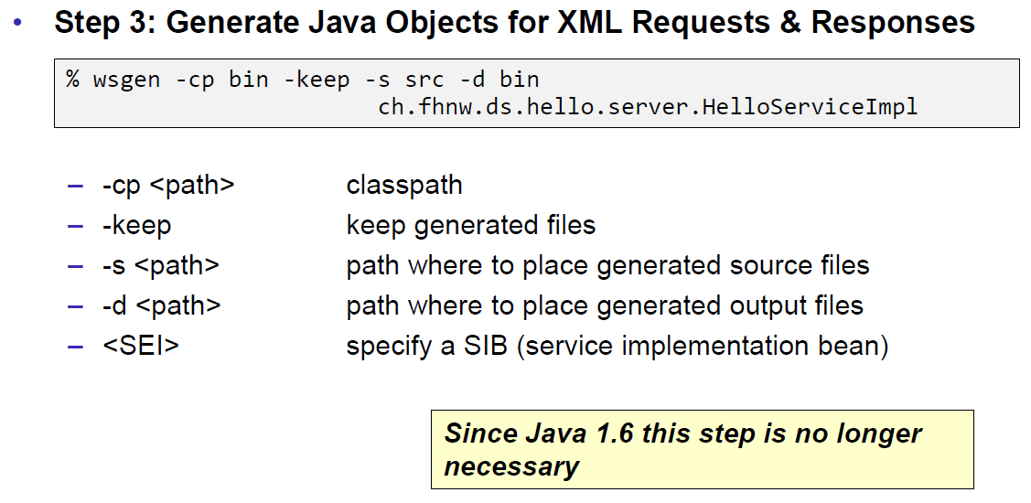

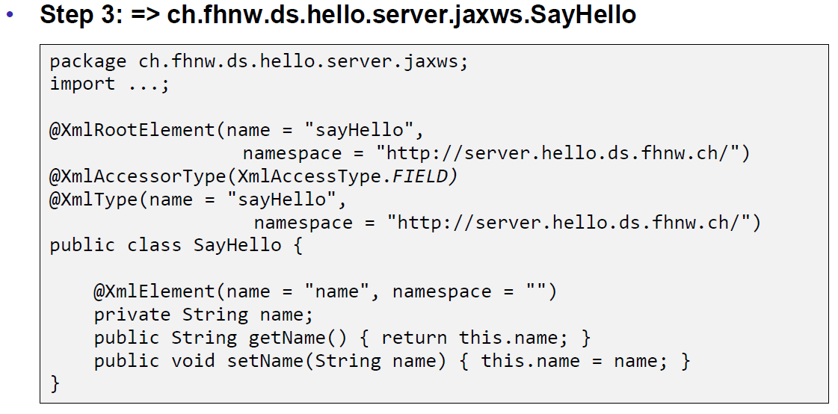

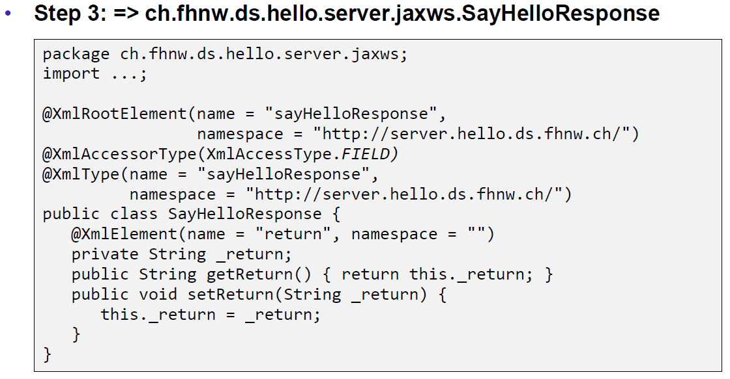

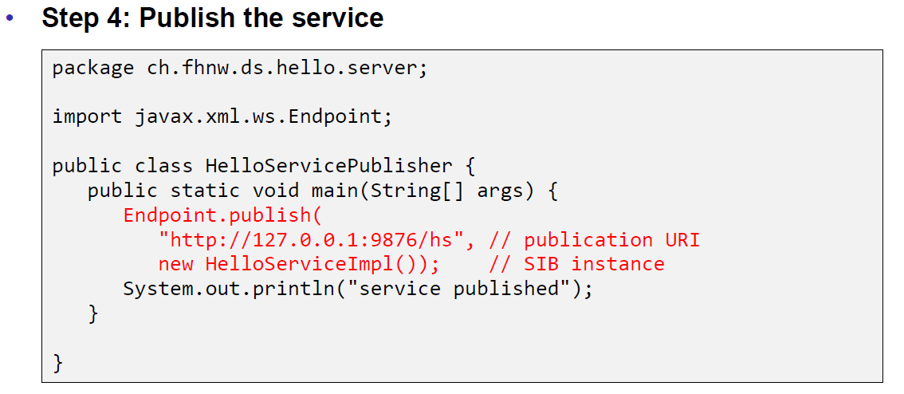

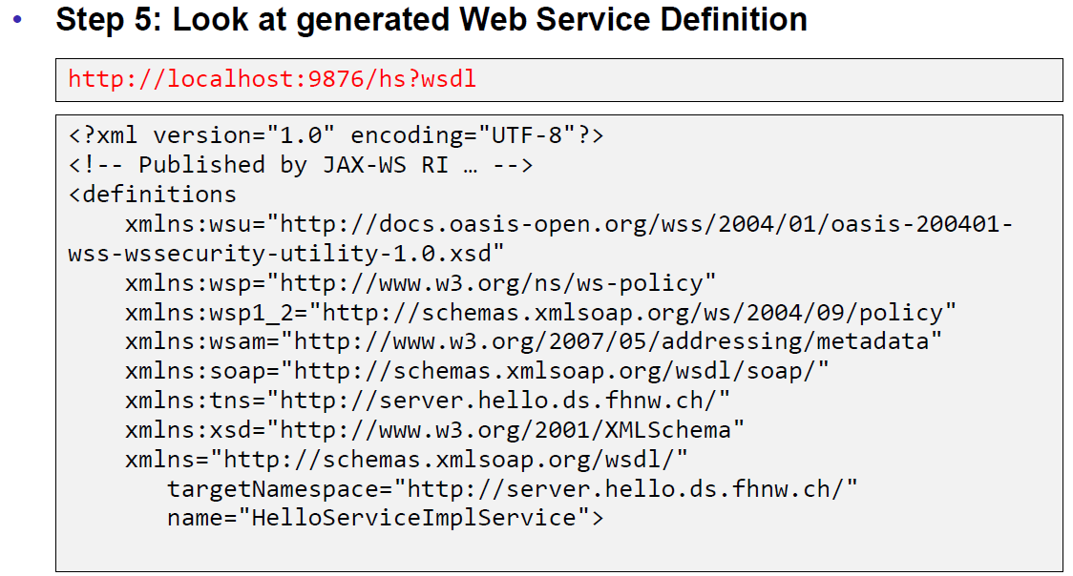

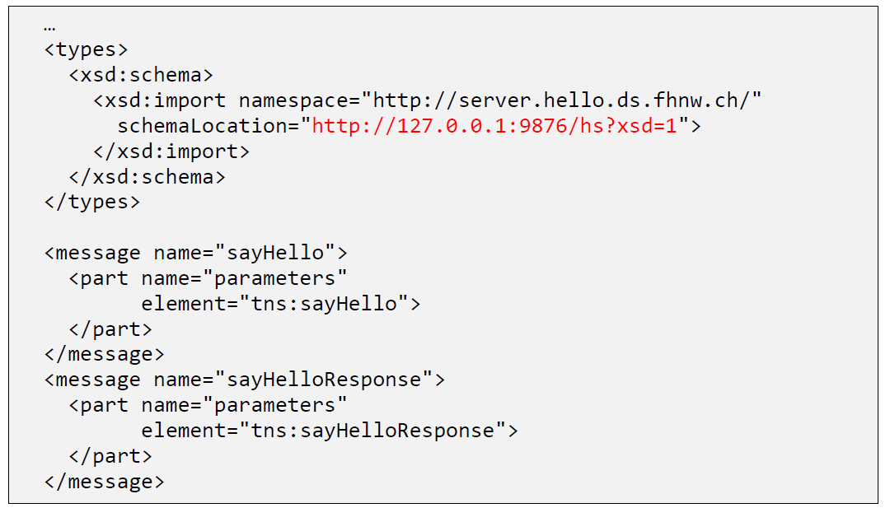

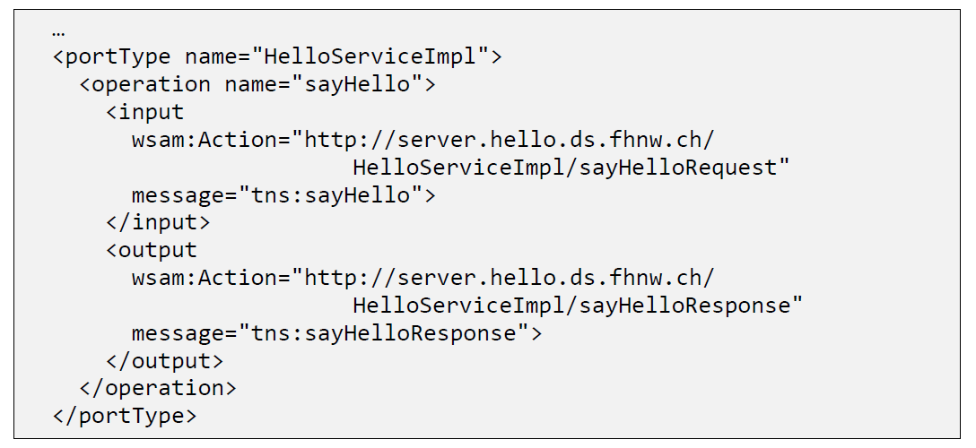

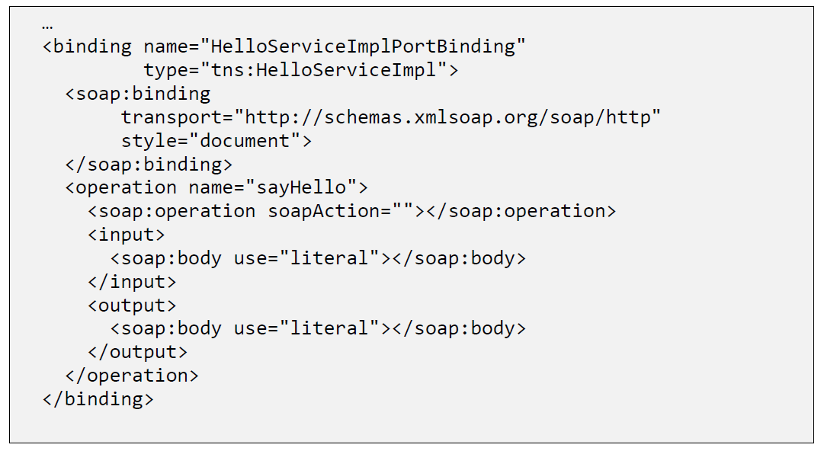

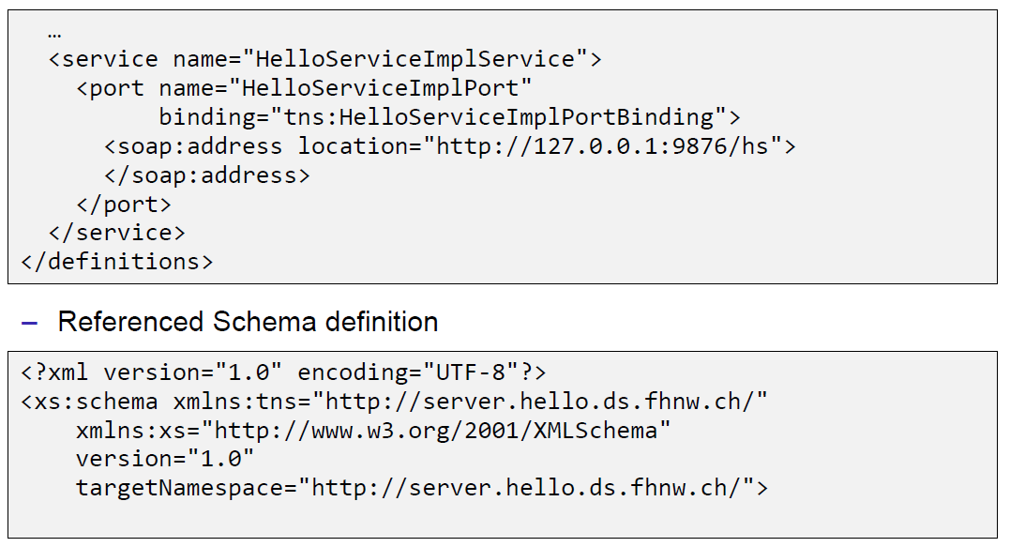

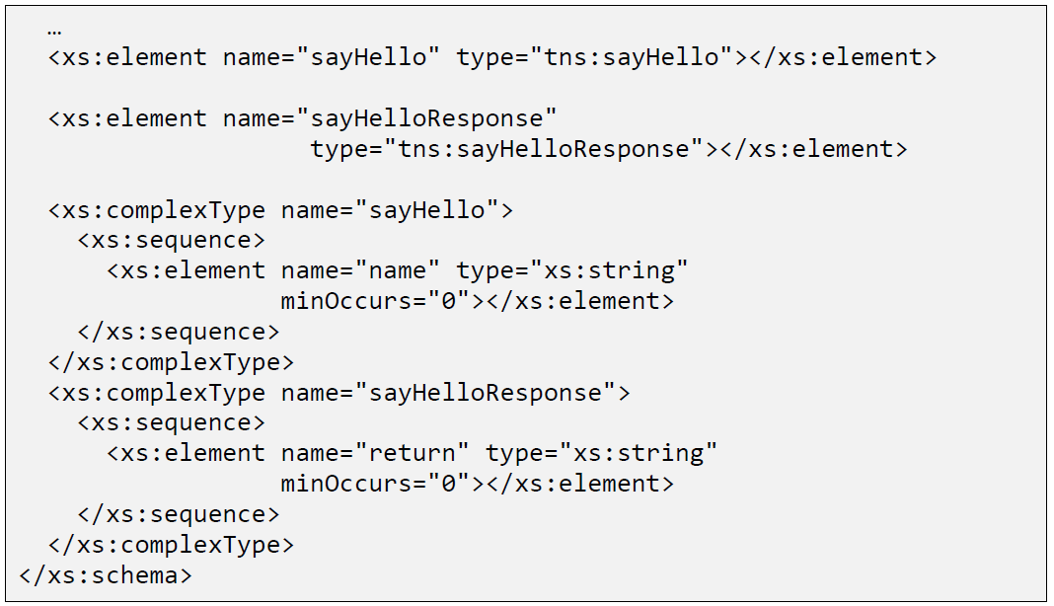

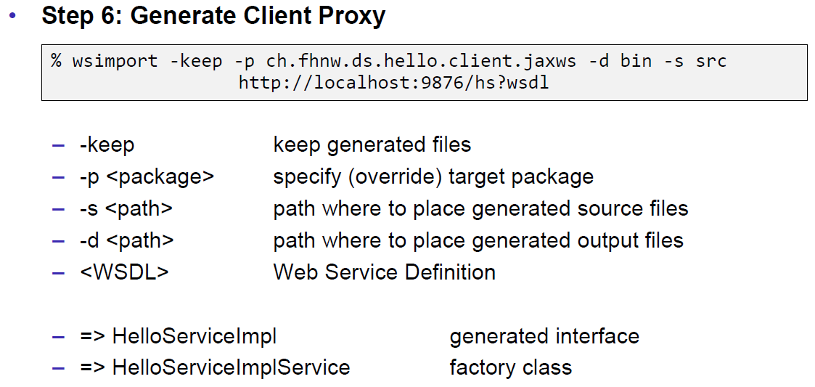

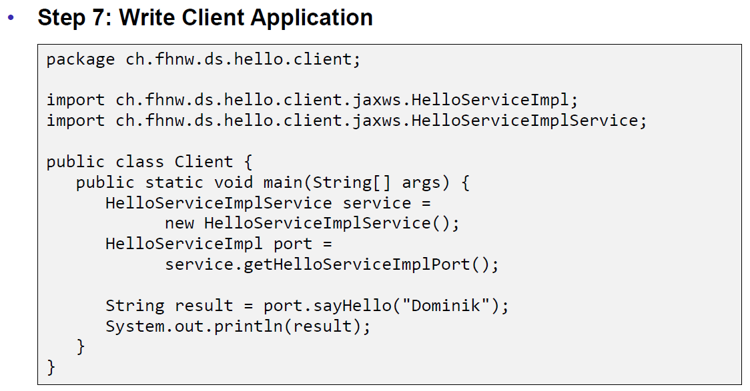

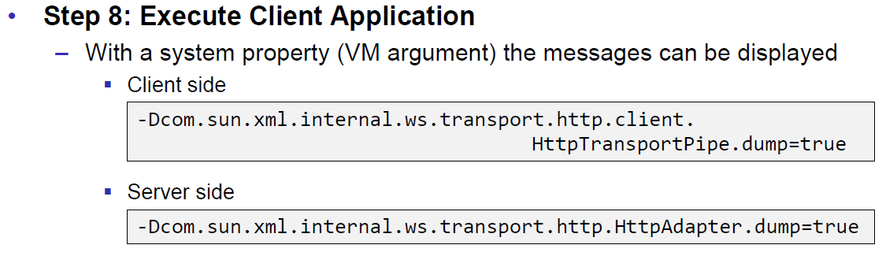

### JAX-WS HTTP Request

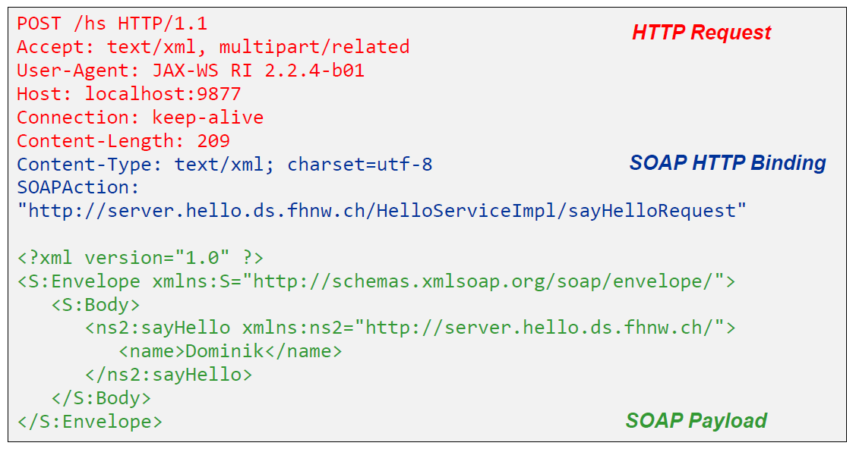

### JAX-WS HTTP Response

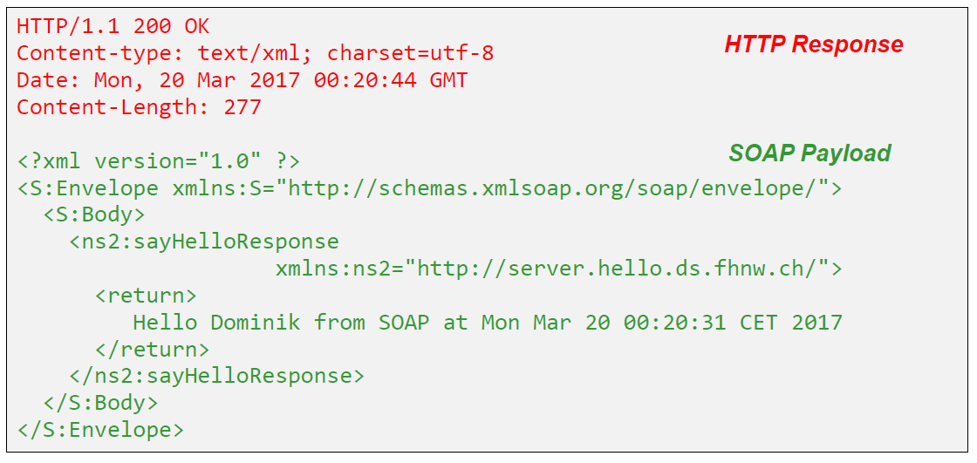

### SOAP Message Structure

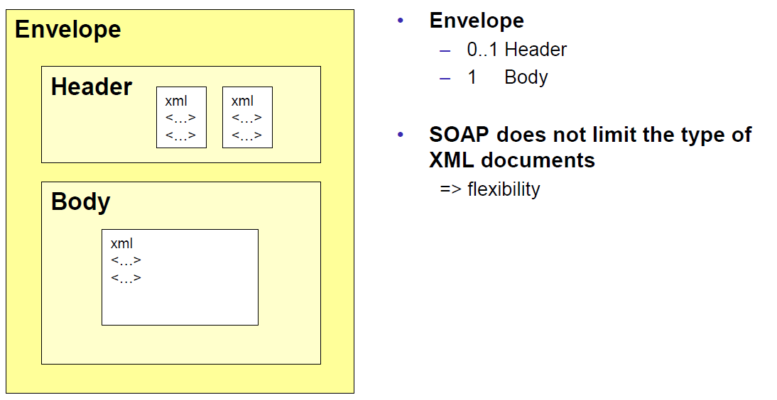

### Tools for SOAP

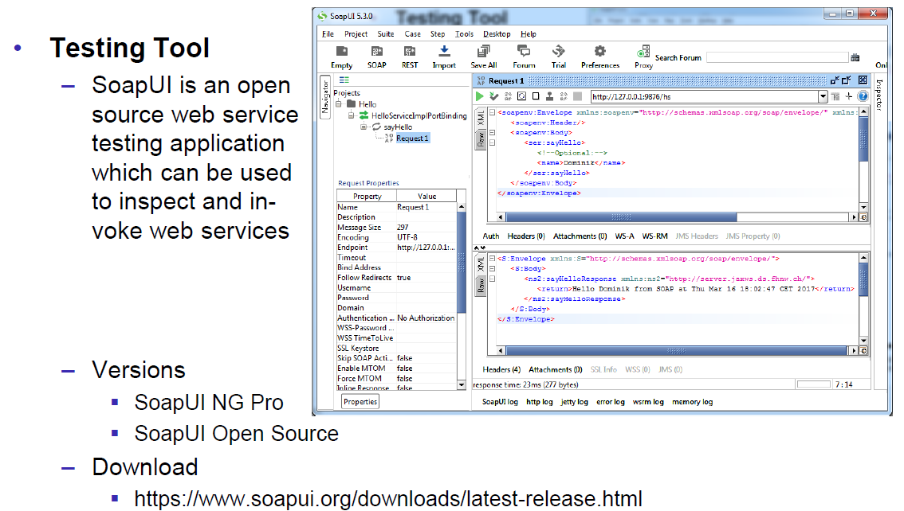

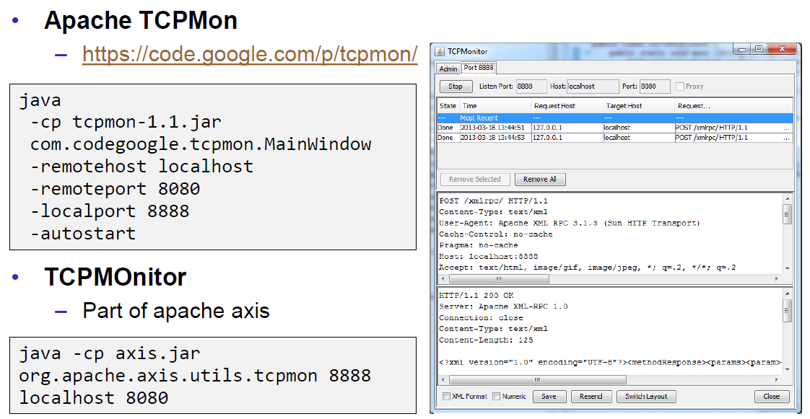

## WSDL

### WSDL

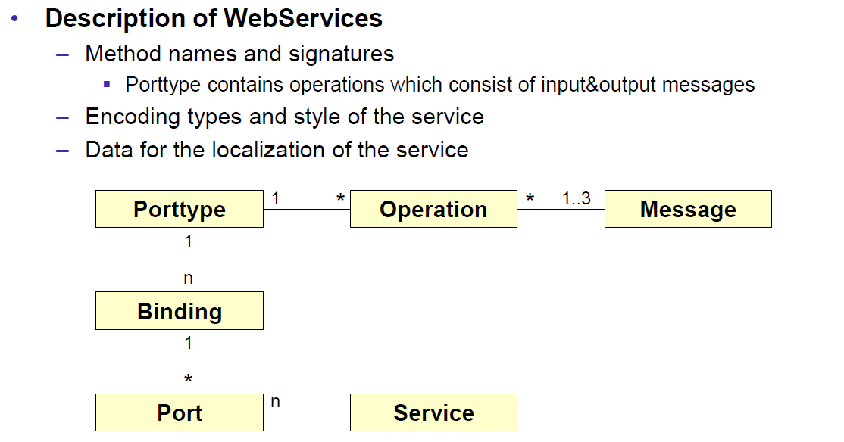

### WSDL Examples

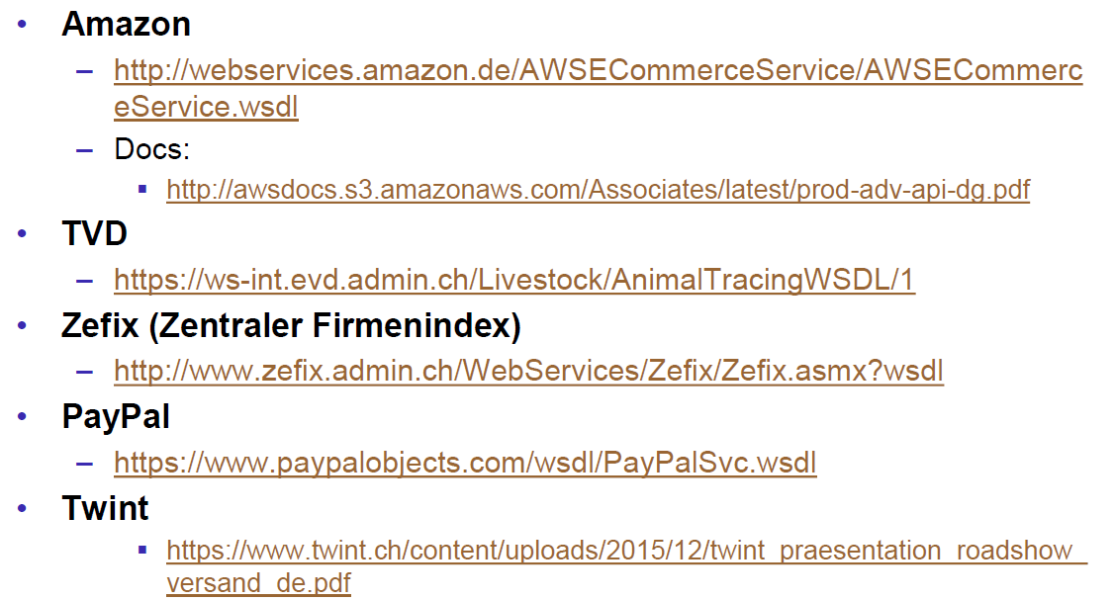

### WSDL Structure

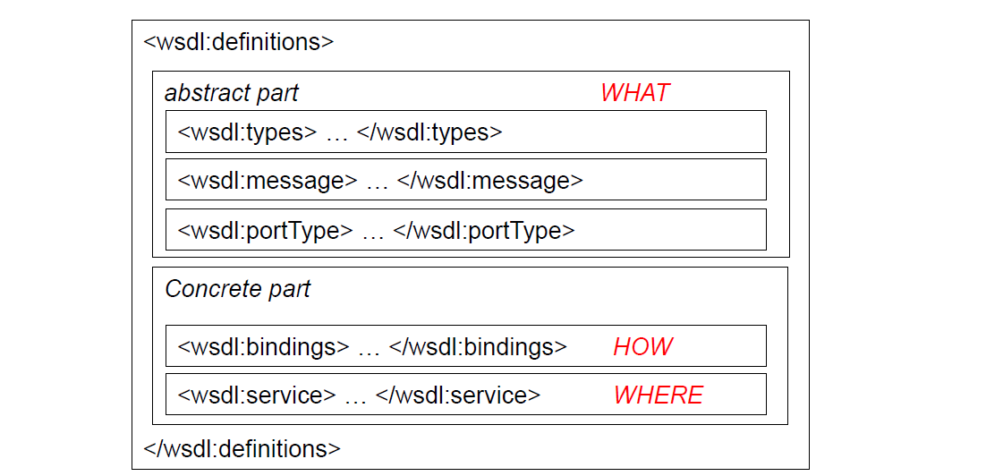

### WSDL Definitions

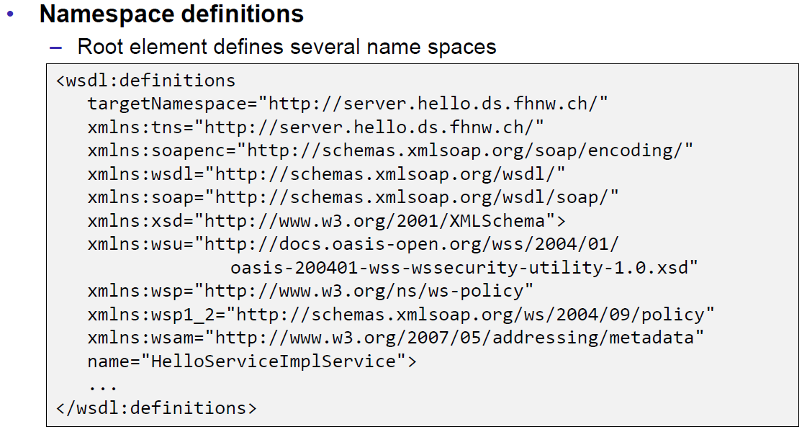

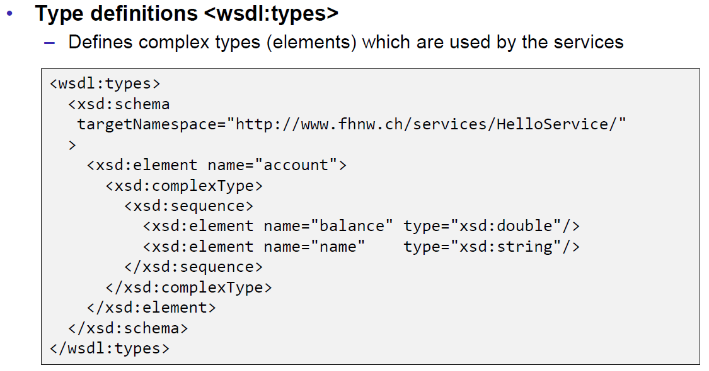

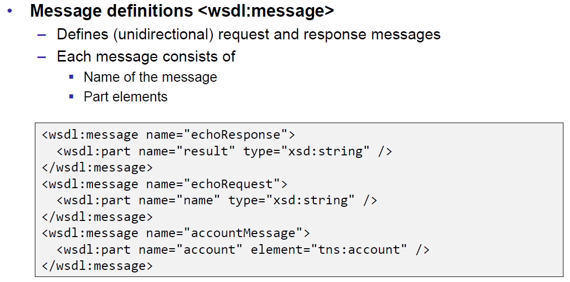

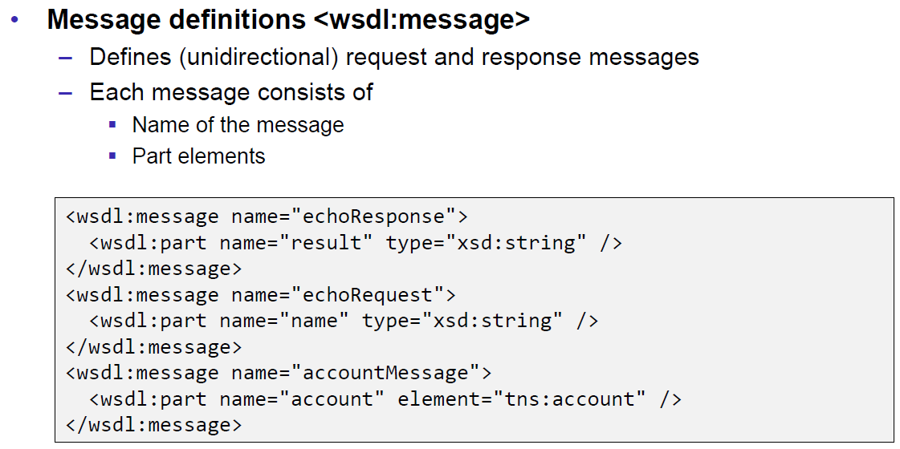

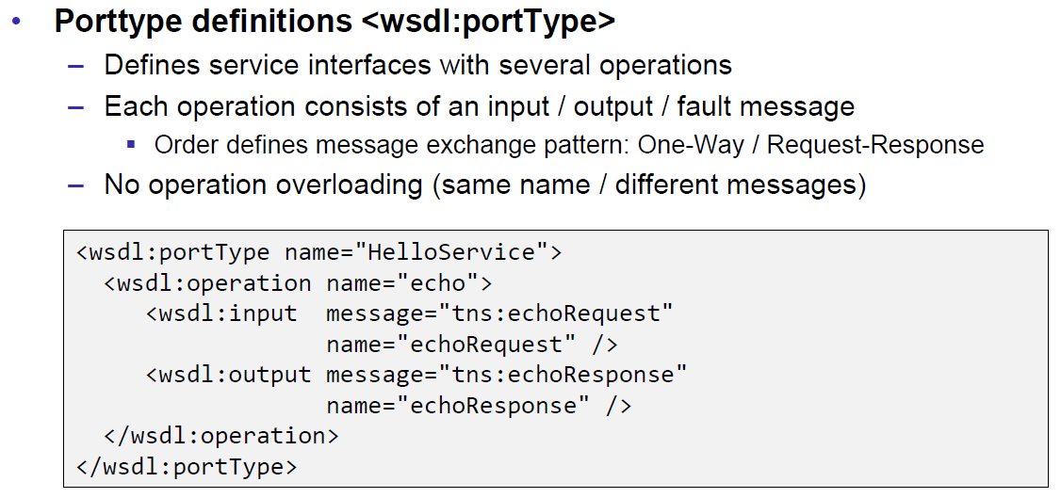

### Message Exchange Patterns (MEP)

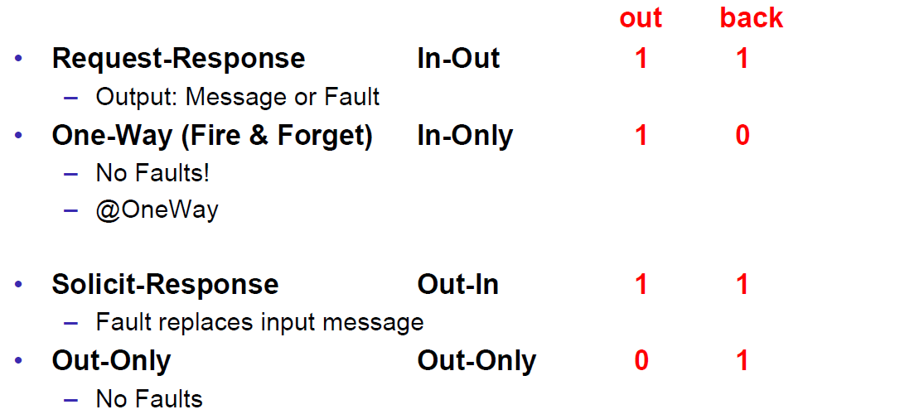

### WSDL Definitions

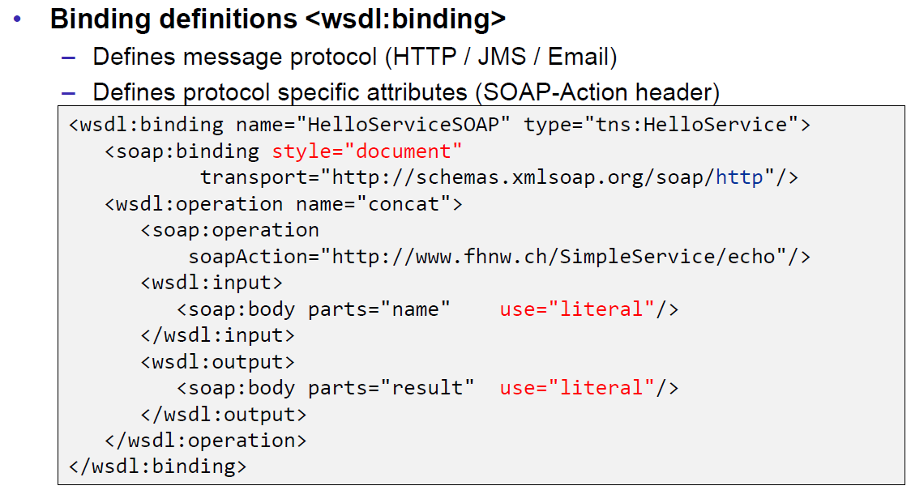

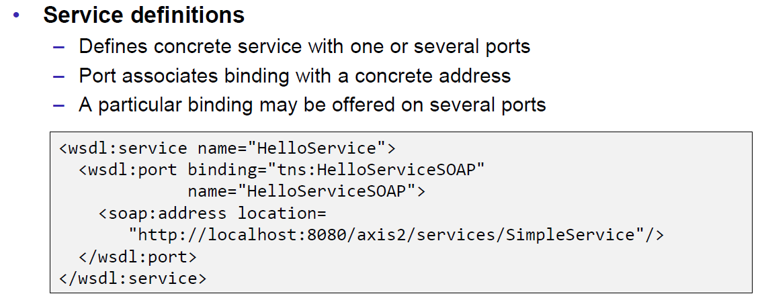

### Web Service Styles

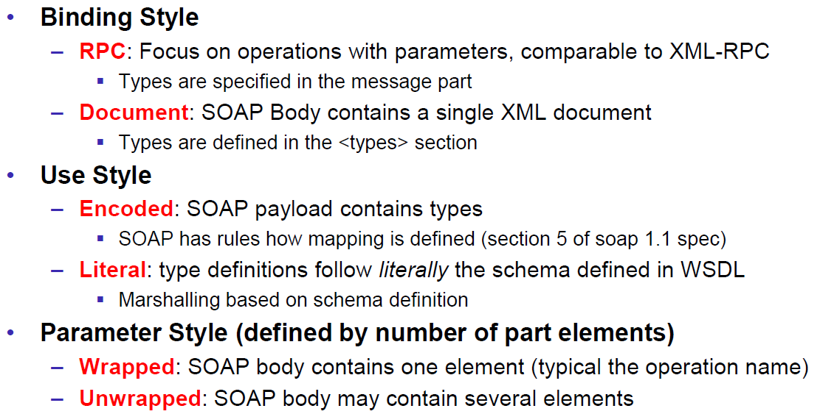

### RPC/Encoded

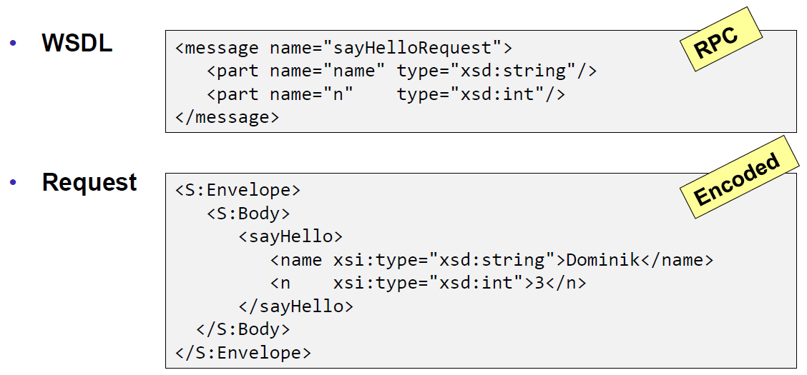

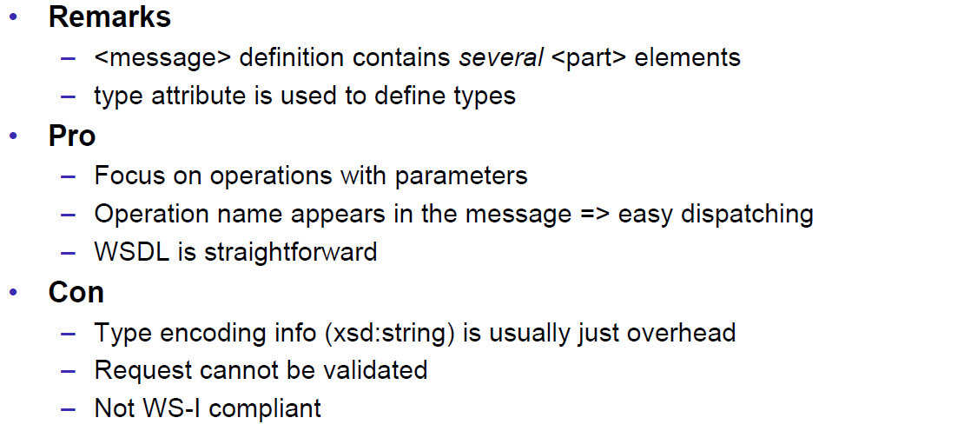

### RPC/Literal

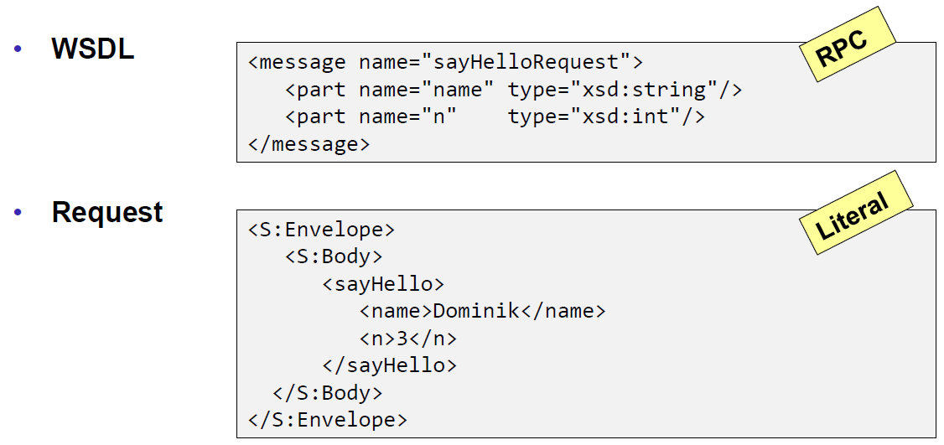

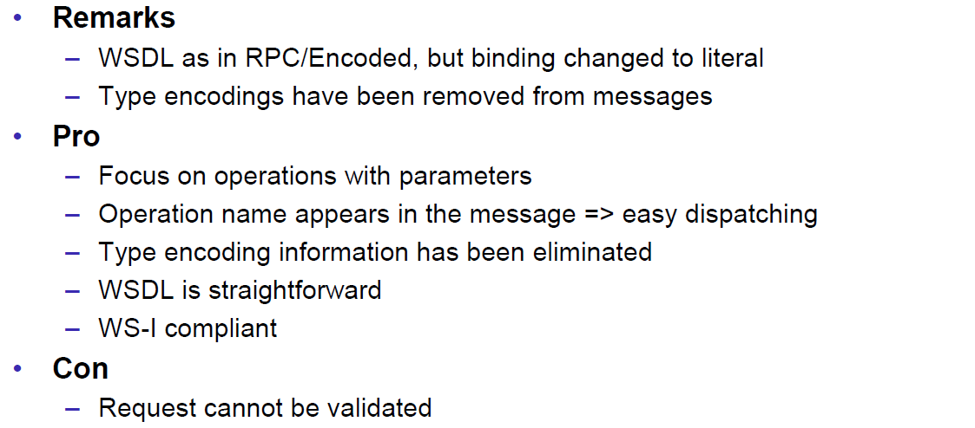

### Document/Literal/Bare

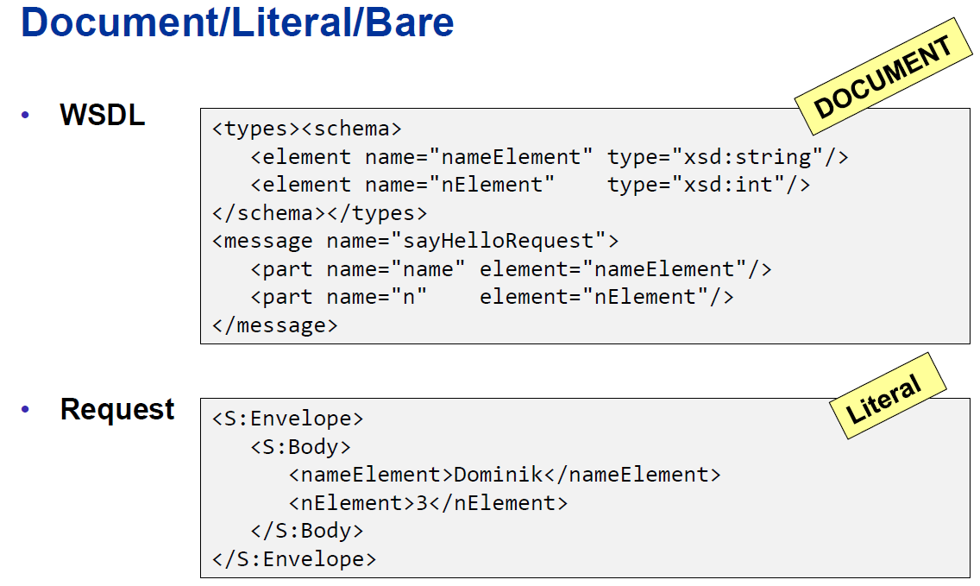

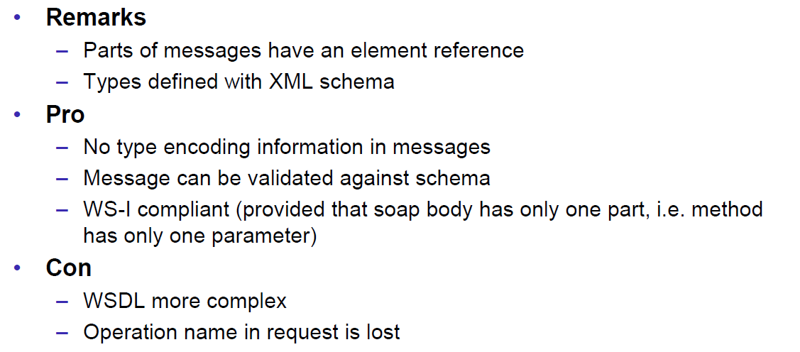

### Document/Literal/Wrapped

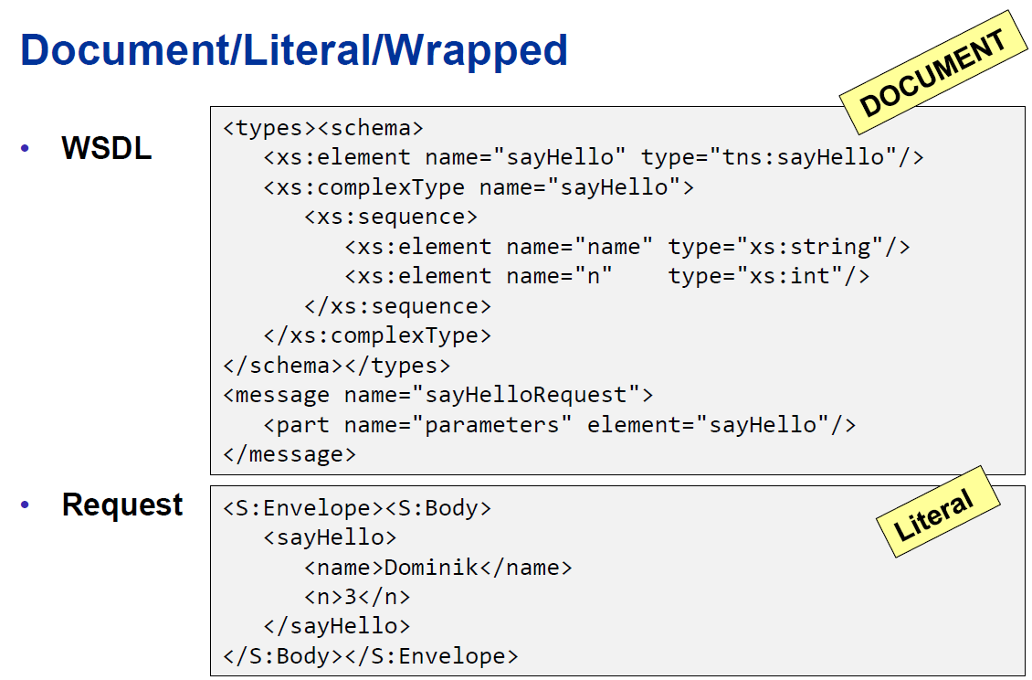

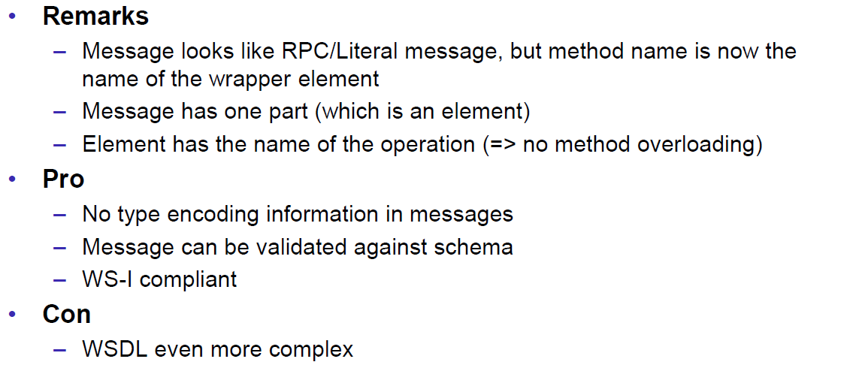

### Web Service Styles

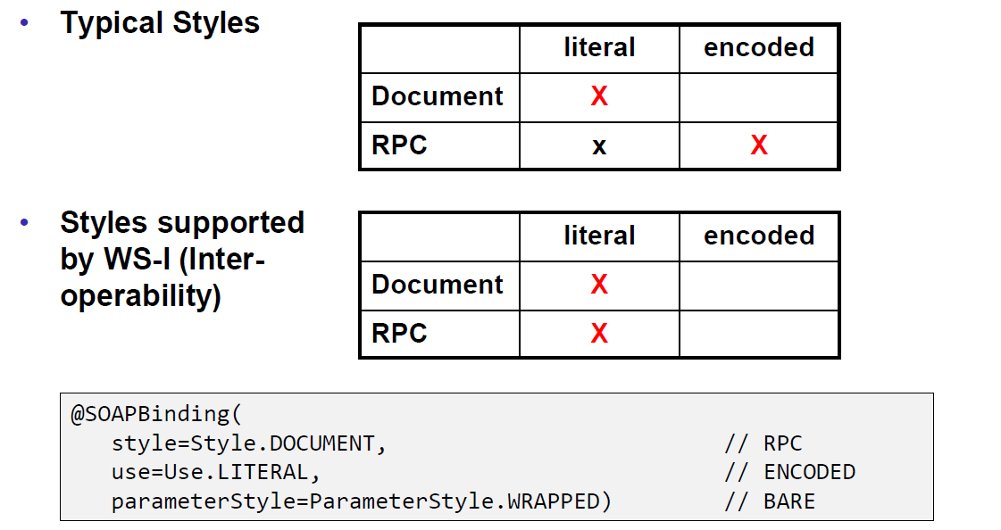

### Further References

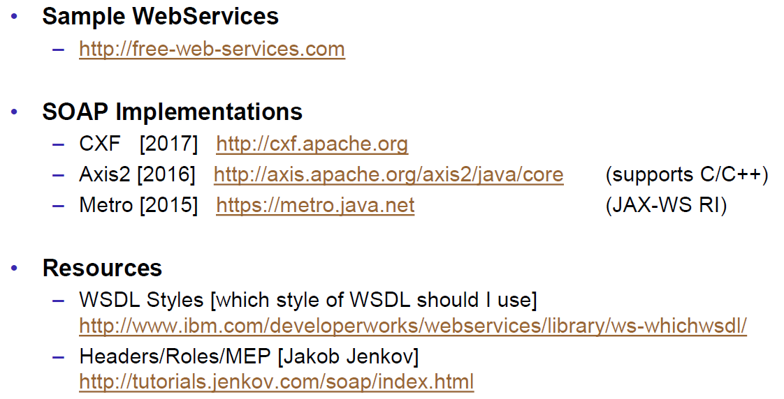

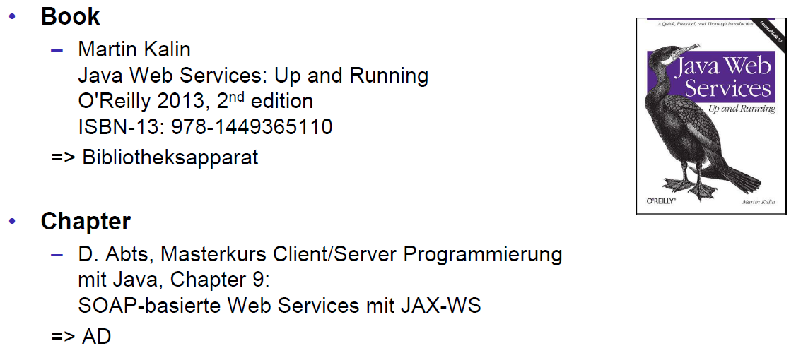

# Woche 6